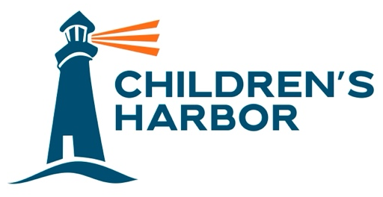
Media Contact
Maria Pierson
mpierson@piersongrant.com

Broward County Clerk of Courts Brenda D. Forman Joins Children’s Harbor Board
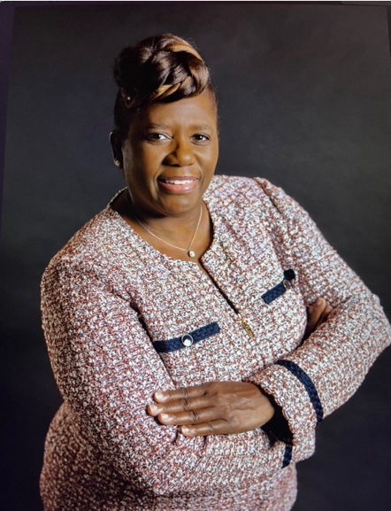
PEMBROKE PINES, Fla. (April 8, 2024) – Brenda D. Forman, the first African-American and first female to serve as Broward County Clerk of Courts, has joined the board of Children’s Harbor, the nationally accredited non-profit agency with a mission to help strengthen families who are struggling in our community, while providing safe shelter and support to teens in foster care so that they may grow into healthy, educated and productive adults.
“Brenda is both a role model for our kids and a hands-on mentor who has dedicated significant time and effort to provide real-world opportunities for them to gain much-needed experience thorough our annual Career Day program,” Children’s Harbor President and CEO Tiffani Dhooge said. “We’re so fortunate to have her join our board.”

Forman was first elected as Clerk in November 2016 and sworn into office on January 3, 2017. In August 2020, she was re-elected for a second term and sworn into office on January 5, 2021. As the official record-keeper for Broward County’s court system, she protects the public trust by performing her statutory and ministerial duties of ensuring all records are maintained in a timely and accurate manner.

“Children’s Harbor is a beacon of hope for kids who have endured the unfortunate experience of family-related trauma,” Forman said. “It’s an opportunity to give them a safe place to call home, as well as the guidance they often need to make sense of life as young adults.”

Forman’s prior work experience includes the Broward County Clerk of Courts Office, ChildNet and the State Attorney’s Office. She has also been a licensed real estate agent for 18 years.

A tireless advocate against domestic violence and human trafficking for several years, Forman is also a member of a Florida National University effort to combat human trafficking, domestic violence and the exploitation of missing children. Forman is also actively involved in a number of community organizations including the Broward County Bar Association, South Broward Bar Association, Caribbean Bar Association, Hispanic Bar Association, Kiwanis Club of Davie/West Hollywood, Broward County Police Chiefs Association, Ft. Lauderdale Black Police Officer Association, National Council of Negro Women, Tower Forum, South Florida Noble-Black Law Enforcement, South Broward Board of Realtors, Hollywood Chamber of Commerce, Fort Lauderdale Chamber of Commerce and the Florida League of Cities.

About Children’s Harbor
Established in 1996, Children’s Harbor is a nationally accredited non-profit agency with a mission to help strengthen families who are struggling in our community, while providing safe shelter and support to teens in foster care so that they may grow into healthy, educated and productive adults.
With the belief that children should feel safe, that family is worth fighting for and that cycles can be broken, Children’s Harbor provides a harbor of hope and healing for children who have been impacted by the trauma of child abuse. The main campus in Pembroke Pines provides a supportive family environment for teenagers in foster care and their younger siblings. The family strengthening program prevents kids from coming into foster care by providing in-home counseling and support to families who are struggling in the community. Young adults aged 18-23 who have aged out of foster care are provided with housing and the wrap-around support and independent living programs necessary to help them overcome their trauma and navigate through the early stages of adulthood.
Brown’s Harbor is a supportive housing community that offers on-site staff, training, and wrap-around support services for young adults who have aged out of the foster care system, ages 18-23, helping to bridge the gap from dependence to independence.
###

