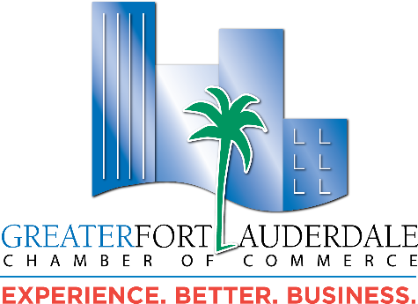

MEMBER OF THE MONTH APRIL 2024 – AUDRA DURHAM

When the Deerfield Beach Chamber of Commerce decided to consolidate and join forces with the Greater Fort Lauderdale Chamber of Commerce (GFLCC) in 2020 it brought a considerable number of resources from the north Broward region, including influential business leaders like Audra Durham, Director of Sales and Marketing of the award-winning Wyndham Deerfield Beach Resort. Originally from Providence Rhode Island, Army Veteran, and 30-year hospitality professional; Audra was appointed to the GFLCC Board of Directors as new Deerfield Beach Council (DBC) Chair in 2021. When asked about her greatest accomplishments in this role she said, “Connecting businesses together to do business, as well as developing friendships, and putting Deerfield Beach on the map within Broward County!”

Now serving as DBC Chair for a third year, Audra hosts an ongoing monthly Coffee & Connections networking breakfast at the Wyndham and collaborates with the City of Deerfield Beach on several measures, as most recently for the Level Up six-month educational program tailor-made specific to the Deerfield Beach’s minority women business owners and entrepreneurs. Fellow DBC member, Rick Tobin, shared, “Audra works tirelessly supporting members and potential member connections. She also spends countless hours organizing DBC programs, and the Wyndham generously donates space and employee time for a multitude of events. They are supportive of Audra’s efforts and DBC goals”.

Audra’s other community involvement include Broward County Sheriff’s, Kiwanis, First Responders Resilience Project, and sits on the Boca Chamber of Commerce Tourism Committee. In her spare time Audra enjoys Orange Theory Fitness, and Football. She has two amazing sons, Kyle and Sean, a wonderful fur baby named Lucy, and is engaged to be married in October to her fiancée Jonathan. Family is everything to her!

Please join us in recognizing Audra for her dedication to the Chamber organization and making a positive impact on our community. She can be reached at:

Audra Durham, Director of Sales and Marketing
Wyndham Deerfield Beach Resort
209 NE 2nd Street, Deerfield Beach, FL 33441
Email: adurham@wyndahamdeerfield.com
Phone: (954) 428-2850
Website: www.wynhamdeerfield.com
LinkedIn: www.linkedin.com/in/audra-durham-8a59a240

Coordinated by the Ambassador Committee, those selected for this Chamber recognition have gone above and beyond in assisting both the organization and its members. Anyone can submit a nomination; however the recipient must either conduct business with fellow members, refer prospective members or be actively involved on a Council, Committee, Leads Group, Board, Sponsor/Host an event. You can nominate a member here. For questions, please contact Member of the Month Committee Chair, Ann Mihaiu, at ann@fortlauderdalemedia.com.

