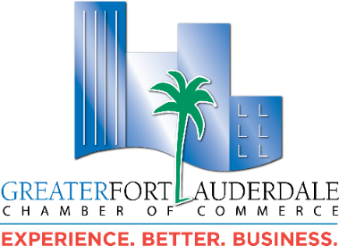
MEMBER OF THE MONTH FOR AUGUST 2024 – MAXENCE DOYTIER
When joining the Greater Fort Lauderdale Chamber of Commerce in September 2022, Maxence Doytier, Founder/Chief Public Art Curator of Twenty6North Productions, directly realized the value of how he could build his small business locally. “Being a member of the Chamber opens a wide range of opportunities to participate and network at your own pace.” Maxence shares his observation, “Initially, you can attend Council meetings and connect with other small businesses. As you become more engaged, you may join a Council as an active member, which could lead to an invitation to serve on a committee. By consistently supporting a Council's missions, you can eventually be nominated and elected to a Board position.”
Twenty6North Productions is a three-tier production company working with South Florida’s up-and-coming creatives. The brand’s name is a nod to Fort Lauderdale’s 26 degrees north latitude coordinate. Maxence is a visionary facilitator who collaborates with artists from concept to execution. Known for his exceptional contributions to the field of artwork design, Maxence has made an indelible mark on the artistic landscape of Broward County. Supported by his graphic design background and innovative organic approach, he consistently pushes boundaries and inspires others, fostering a vibrant and engaging artistic community with his hands-on approach.
The extent of Maxence contributions to the Chamber include participating in the Power Partners Leads Group and supporting the Marketing, Marine Advisory, Real Estate & Construction, Downtown and the Arts Business Councils. Additionally he balances his time between managing his productions company and his two nonprofits: Avenue of the Arts Festival, occurring annually the last weekend of January where local and international artists paint landmark murals, and The Local Octopus Foundation, which fosters environmental stewardship through education and preservation of local beaches and waterways in Broward County. Come out for World Clean Up Day on Saturday, 9/21/24 at B Ocean Resort Beach!
Let’s commend Maxence for his dedication to the Chamber and making a positive impact on our community. He can be reached at:

Maxence Doytier
Twenty6North Productions, Founder / Chief Public Art Curator
Email: maxence@twenty6north.com Phone: 954.648.1332
Website/PublicArtProjectsPortfolio: www.twenty6north.com/portfolio
Linkedin: www.linkedin.com/in/maxence-doytier-325204188/
Facebook: www.facebook.com/maxence.doytier/
Instagram: www.instagram.com/rundreadrun/
YouTube: www.youtube.com/@twenty6north

Accolades:
+ Front cover of 'FTL Connect' Spring 2024 for the City of Fort Lauderdale https://www.fortlauderdale.gov/government/departments-a-h/city-manager-s-office/strategic-communications/ftl-connect
+ "Maxence Doytier Is the Connector for the Local Art World" 2023 South Florida Business & Wealth https://sfbwmag.com/maxence-doytier-is-the-connector-for-the-local-art-world/
+ South Florida Digest "Transforming Ft. Lauderdale’s Shores Through Community Action " April 20, 2024 for The Local Octopus Foundation. https://southfloridadigest.com/transforming-ft-lauderdales-shores-through-community-action/
+ Proclamation in Recognition of Fort Lauderdale Beach Cleanup Day June 24, 2023 for The Local Octopus Foundation.

