**Media Contact**

Maria Pierson

[mpierson@piersongrant.com](mailto:mpierson@piersongrant.com)

**FirstService Residential Executive Stephanie Parker Named Chair of Children’s Harbor**

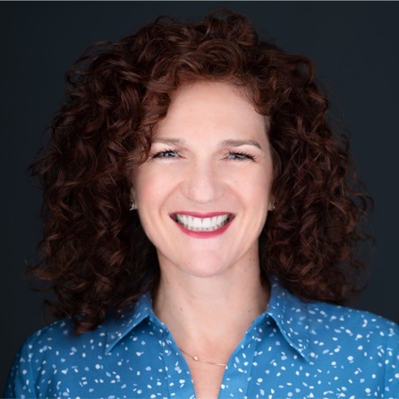

Stephanie Parker

Stephanie Parker, President of FirstService Residential’s South Florida Condo HOA Division, was named Board Chair at Children’s Harbor, a nationally accredited non-profit agency with a mission to help strengthen families who are struggling in the community, while providing safe shelter and support to teens in foster care so that they may grow into healthy, educated and productive adults.

“What I hope to accomplish is twofold. First, I want to help make lives of real humans in real situations better, and I also want to lead by example and show others that giving back is important and rewarding,” Parker said.

An organizational development and behavior specialist recently named among South Florida Business & Wealth Magazine’s Prestigious Women of 2024, Parker is also a veteran of the community association management business and has served in executive positions at FirstService Residential for nearly a decade.

“Stephanie is not just a leader. She's a compassionate force of passion and dedication, poised to make a lasting impact in the lives of those most marginalized in foster care,” Children’s Harbor President and CEO Tiffani Dhooge said. “Together, under her leadership, we're gearing up to create a community where every teenager in foster care is empowered to become a healthy, educated, productive adult!”

Parker remembers when her thought process around giving completely changed. “I’ll never forget the moment when Tiffani said, ‘Our kids deserve a pair of shoes and a hairstyle that they love for their first day of school.’ So often we give what we don’t need any more and expect people to appreciate it, but that’s not the approach we take at Children’s Harbor.”

For more information about Children’s Harbor, call (954) 252-3072 or visit [childrensharbor.org](http://www.childrensharbor.org/).

**About Children’s Harbor**

Established in 1996, Children’s Harbor is a nationally accredited non-profit agency with a mission to help strengthen families who are struggling in our community, while providing safe shelter and support to teens in foster care so that they may grow into healthy, educated and productive adults.

With the belief that children should feel safe, that family is worth fighting for and that cycles can be broken, Children’s Harbor provides a harbor of hope and healing for children who have been impacted by the trauma of child abuse. The main campus in Pembroke Pines provides a supportive family environment for teenagers in foster care and their younger siblings. The family strengthening program prevents kids from coming into foster care by providing in-home counseling and support to families who are struggling in the community. Those who have aged out of foster care are provided with housing, life skills and the wrap-around support necessary to overcome their trauma and navigate through the early stages of adulthood through independent living programs.

Brown’s Harbor is a supportive housing community that offers on-site staff, training, and wrap-around support services for young adults who have aged out of the foster care system, ages 18-23, helping to bridge the gap from dependence to independence.