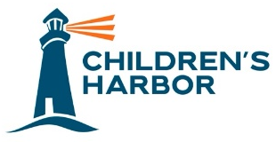

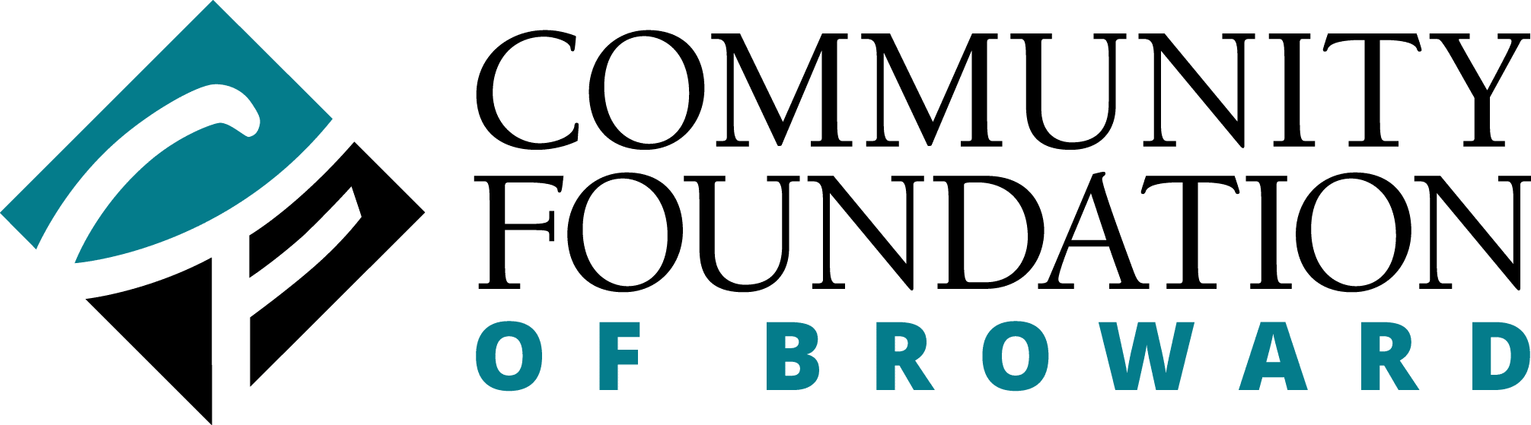

Media Contact:
Maria Pierson
mpierson@piersongrant.com

Children’s Harbor Students to Get Extra Education Assistance
From The Community Foundation of Broward

Pembroke Pines, Florida (April 2, 2024) – The Children’s Harbor Academic and Life Skills Program, which guides children on a structured path toward academic success and self-sufficiency, has received funding from The Community Foundation of Broward to assist youth ages 13 to 17 in completing their academic goals.

“We are so appreciative of the support we receive from the Community Foundation of Broward,” said Tiffani Dhooge, President and CEO of Children’s Harbor, a nationally accredited non-profit agency with a mission to help strengthen families who are struggling in the community, while providing safe shelter and support to teens in foster care. “With this generous donation, the Community Foundation will positively impact our teens who come to us having suffered from trauma and neglect, and who struggle in school. This will be life-changing for them.”

The Community Foundation of Broward is funding a full-time professional educator, as well as much needed technology to assist teen students at Children’s Harbor in completing their educational goals by helping them overcome gaps in their schooling. It will also assist youth who struggle with academics due to learning disabilities.

“Children’s Harbor Academic and Life Skills Program represents the very essence of empowerment and opportunity for our youth,” said Jennifer O’Flannery Anderson, President and CEO of the Community Foundation of Broward. “We believe in investing in programs that pave the way for academic achievement and equipping children with the skills and confidence they need to thrive in both their education and their lives. Children’s Harbor does an excellent job at providing a supportive environment that helps children on an individual level achieve their best.”

Children’s Harbor Academic and Life Skills Program aligns with the Community Foundation of Broward’s Education & Youth Enrichment, which helps local youth gain critical skills to shape their lives and future careers through opportunities to access and attain academic achievement, explore and pursue career paths, and develop interpersonal and life skills.

Through Children’s Harbor Academic and Life Skills Program, a life coach assesses each child’s academic and life skill levels and develops educational plans and interventions designed to improve school performance and facilitate self-sufficiency and job readiness. The life coach monitors each student’s grades, ensures they do their homework, arranges educational outings and conducts group sessions to teach youth a variety of life skills needed to be self-sustainable, ranging from communication and problem solving, to managing a household, and finding and keeping a job.

About Children’s Harbor
Established in 1996, Children’s Harbor is a nationally accredited non-profit agency with a mission to help strengthen families who are struggling in our community, while providing safe shelter and support to teens in foster care so that they may grow into healthy, educated and productive adults.

With the belief that children should feel safe, that family is worth fighting for and that cycles can be broken, Children’s Harbor provides a harbor of hope and healing for children who have been impacted by the trauma of child abuse. The main campus in Pembroke Pines provides a supportive family environment for teenagers in foster care and their younger siblings. The family strengthening program prevents kids from coming into foster care by providing in-home counseling and support to families who are struggling in the community. Young adults aged 18-23 who have aged out of foster care are provided with housing and the wrap-around support and independent living programs necessary to help them overcome their trauma and navigate through the early stages of adulthood.

About The Community Foundation of Broward
Founded in 1984, the Community Foundation of Broward partners with families, individuals and organizations to create personalized charitable funds that deliver game-changing philanthropic impact. 532 charitable funds represent more than $260 million in assets, distributing $175 million in grants over the past 39 years. The Community Foundation transforms our community through focused leadership that fosters collaboration, builds endowment, advances equity and connects people who care to causes that matter. The Foundation empowers visionaries, innovators and doers to create the change they want to see in the community – and to BE BOLD. www.cfbroward.org

###

