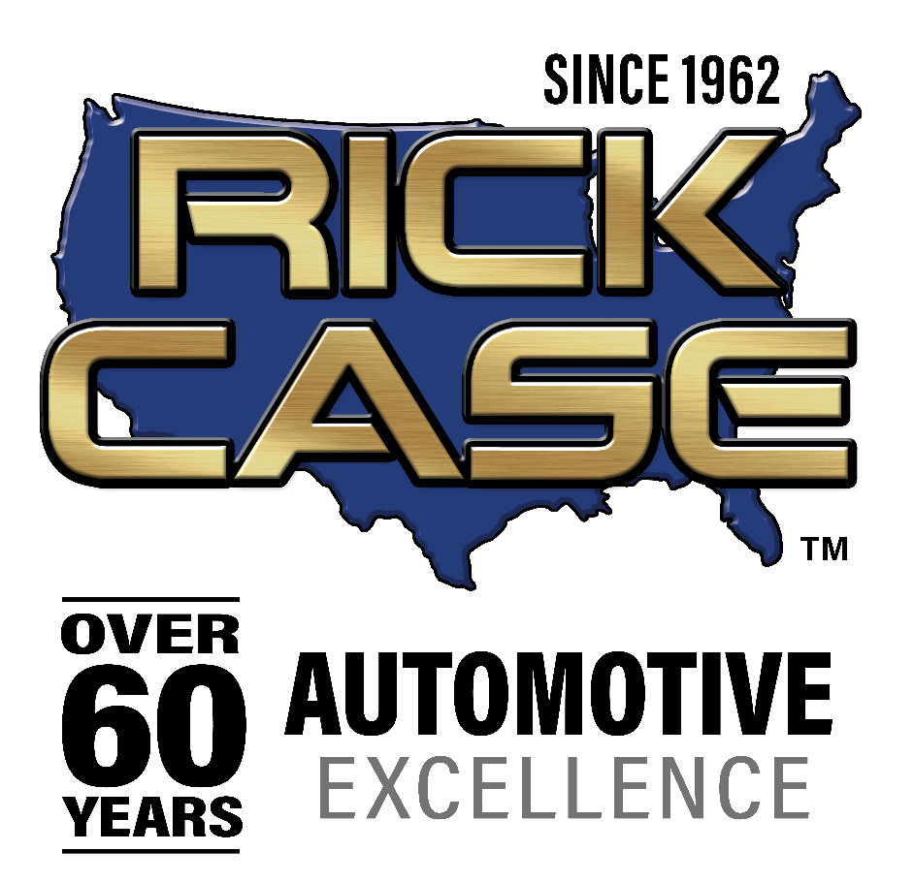

CUTLINE
Photo credit: Downtown Photo
(Left to right) Rita Case, President and CEO of Rick Case Automotive Group; Jonathan DeLuca, board director of the Frederick A. DeLuca Foundation; and Jennifer Dominguez, Vice President Development for the Broward, Greater Miami and Fort Lauderdale chapter of the American Heart Association

Rita and Rick Case Changemaker Award
Presented at 2024 South Florida Heart Ball
Jonathan DeLuca and the Frederick A. DeLuca Foundation
honored as a changemaker.

Hollywood, Florida (May 9, 2024) – Rita Case, President and CEO of Rick Case Automotive Group, presented the second annual Rita and Rick Case Changemaker Award to the Frederick A. DeLuca Foundation and Jonathan DeLuca, board director of the Foundation, during the 2024 South Florida Heart Ball, hosted by the American Heart Association (AHA).

In a rare move by a national organization to establish a perpetual recognition award, the Rita and Rick Case Changemaker Award was established last year. The award is now presented annually in perpetuity to an individual or organization that has made an impact, sets the tone, leads by example and inspires others to join the mission of the AHA. This is the first award of its kind in the AHA’s South Florida market.

“Jonathan also serves as one of the American Heart Association’s regional board members. When he was chair from 2017-2018, the AHA had a record-breaking fundraising year, hitting the $1 million mark," Case said. “The Frederick A. DeLuca Foundation is a valued supporter of the AHA’s mission, and Jonathan has played a crucial role in improving and ensuring the AHA is able to address important issues within the Broward County community.”

Over the years, Jonathan and the Frederick A. DeLuca Foundation has been a changemaker, funding several AHA initiatives, including Survivor Fashion Shows where survivors of cardiac and cerebrovascular events strut their way down the runway to celebrate life; Healthy Families, a six-week culinary and nutrition education course for single-parent families; an ongoing strategy for clinics in three counties to offer specialized telemedicine support to patients experiencing hypertension; and the AHA’s Target Blood Pressure (BP) initiative with the purchase of BP cuffs distributed to patients to monitor their blood pressure.

Rick Case Automotive Group’s Commitment to Heart Health
In addition to establishing the Rita and Rick Case Changemaker Award, Rita and her family have donated over one million dollars to the American Heart Association, joining the select group of philanthropists in the organization’s Heart and Torch Circle within the Cor Vitae Society. In the last decade, the Cases also have laid the foundation for the annual Broward Heart Walk, going above and beyond with their support to take the organization to new heights.

With the generous multi-year donation from Rita and the Rick Case Automotive Group, they joined the AHA’s Nation of Lifesaver Initiative and provided every underserved middle and high school in the Broward County public school system with a new, upgraded CPR, First Aid & AED in Schools Training Kits™. If performed immediately, CPR can double or triple a person’s chance of survival. The AHA wants all students and educators to learn CPR, to turn a nation of bystanders into a Nation of Lifesavers.

According to the AHA, cardiac arrest is a leading cause of death in the U.S., and approximately 90% of people who suffer out-of-hospital cardiac arrests die, which is why teaching lifesaving CPR skills is vital.

About The Rick Case Automotive Group
Founded in 1962, the Rick Case Automotive Group has been honored by Automotive News as the National All-Star Dealer and President and CEO Rita Case was named the 2024 TIME Dealer of the Year. Rick Case Automotive Group is the nation’s largest female owned and operated automotive dealer group in America, offering Honda, Hyundai, Genesis, Ioniq, Volkswagen, Kia, Acura, Audi, Mazda, Maserati, Fiat, Alfa Romeo, Honda Motorcycles and E-Z-Go golf carts. Celebrating more than 60 years in business, the Rick Case Automotive Group has 12 dealerships in Florida and Georgia. Those dealerships are known for holding national sales records, consistently ranking among the top performers in markets they serve. Rick Case Automotive Group is headquartered at 14500 W. Sunrise Blvd. in Sunrise, Florida. For more information, visit www.RickCase.com.

###

