
Media Contact: Jennifer J.H. Pierce
954-295-JJHP (5547) or jpierce@piersongrant.com

DRAFT—March 26, 2024

ArtServe to Unveil the “Florida Power & Light Company Gallery” on April 12

Ribbon-cutting ceremony coincides with free, public opening night reception for ArtServe’s new exhibit “Looking Forward — Healing Through Art”

ArtServe will name its main art gallery as the “Florida Power & Light Company Gallery” to honor FPL’s generous support of ArtServe’s many programs and artistic mission.

The naming will be officiated with a ribbon-cutting ceremony on Friday, April 12 at 5:30 p.m. in conjunction with the opening night reception for ArtServe’s new exhibit, “Looking Forward — Healing Through Art,” of which FPL is also a sponsor.
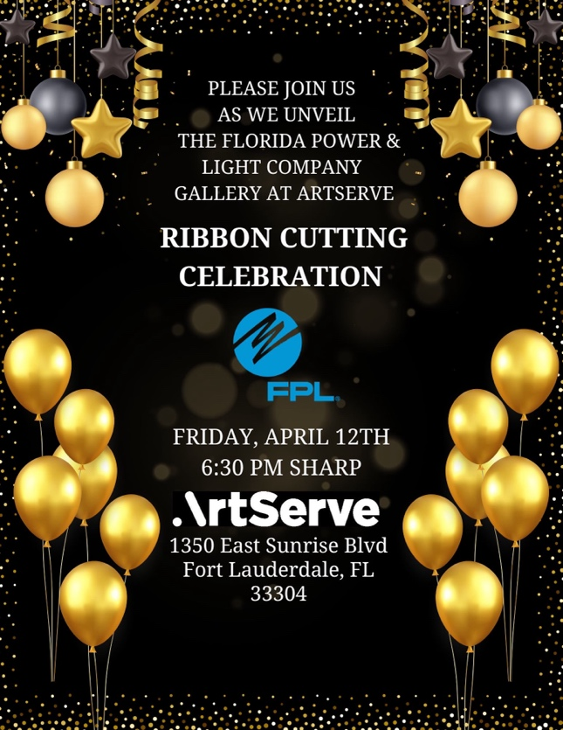
RSVPs are suggested for the events, both of which are free and open to the public.

“We’re pleased to help more people in our community realize their creative dreams through ArtServe,” NextEra Energy, Inc Director of Corporate Philanthropy and FPL Director of External Affairs Juliet Roulhac said. “We are powering strong communities, making them a better place to live, work and raise a family.”

The new “Florida Power & Light Company Gallery” comprises ArtServe’s main gallery space, which includes ample area for the display of all types of visual arts and performing arts vignettes, as well as room for gatherings such as meetings and receptions.

“We’re grateful to FPL for their leadership in being a conduit to the arts,” ArtServe CEO Jason Hughes said. “The Florida Power & Light Company Gallery is the first area people see when they come to ArtServe, and also where our ongoing exhibits provide the overarching inspiration to all the creativity happening here daily.”


In addition to the ribbon-cutting, the April 12 Healing Through Art opening reception will include a 5:30 p.m. panel discussion, “make and take” art stations, and live performances by local musical artists, improv artists and comedians.
Jill Sneidman’s "Sunlight of the Spirit" is among the artworks that will be displayed at ArtServe during the April 12 ribbon-cutting.

ArtServe is located at 1350 E. Sunrise Boulevard in Fort Lauderdale and open from 9 a.m. to 6 p.m. Monday through Friday and Saturdays from 10 a.m. to 6 p.m. Daily admission to Healing Through Art is also free.
Created through grants from Funding Arts Broward, The Community Foundation of Broward, Broward County Cultural Division and Florida Arts & Culture, with sponsorship by FPL and BrightStar Credit Union, Healing Through Art will feature artists who focus on mental wellness and healing, as well as those who create art despite physical or mental challenges.

ArtServe inspires, supports and advances its diverse members, artists and community by promoting artistic development, education and prosperity through the exploration and presentation of the visual and performing arts.

About ArtServe

Named a “Top-Rated Nonprofit” by GreatNonprofits, the leading provider of user reviews of charities and nonprofits, Fort Lauderdale-based ArtServe is an award-winning arts incubator that is advancing the arts for social good as a creative laboratory and hub for experimental artists committed to diversity, equity and inclusion. Now in its 35th year, ArtServe has won several awards for innovation in the arts and is supported in part by the Broward County Board of County Commissioners as recommended by the Broward Cultural Council and Florida’s Department of State and the Division of Cultural Affairs. Each year, ArtServe programs contribute tangibly to the region’s economy, helping 2,000+ artists sell their work, build businesses and engage the community. To do that, ArtServe secures financial support through donations, sponsorships and memberships.

###

