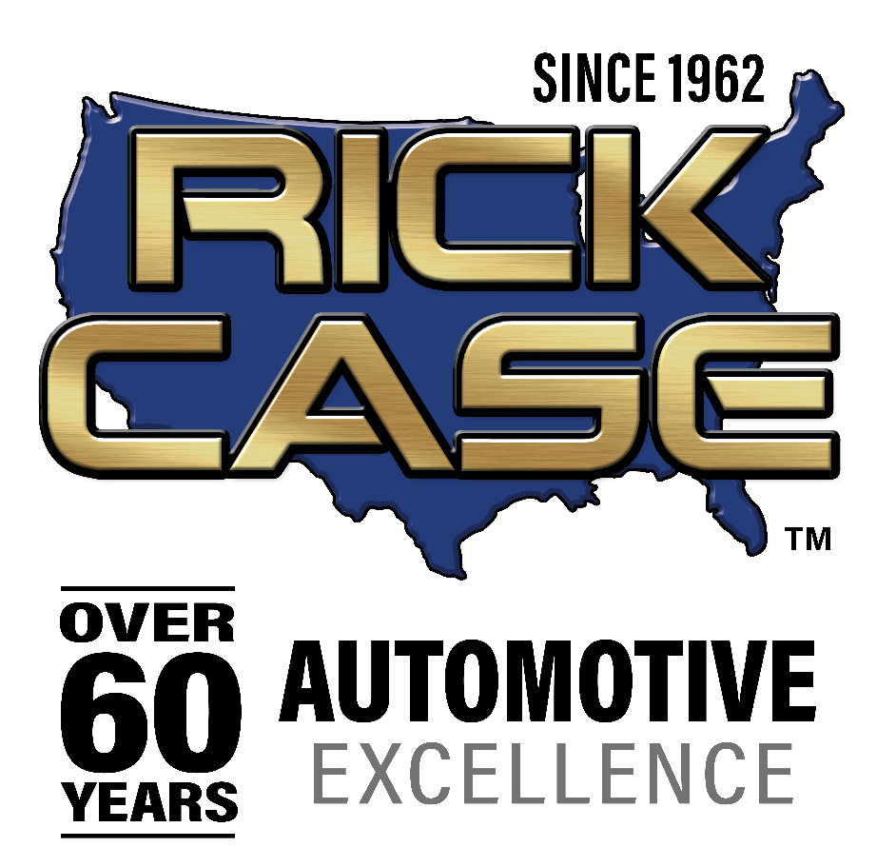

Cutlines
Click here to download photos.
Photo credit: Rick Case Automotive Group
(Left to right)
- Photo 1: Lance Woelfer, Assistant Vice President, Honda Auto Sales presents Rita Case with the award
- Photo 2: Rita Case with the Honda leadership team
- Photo 3: Rita Case congratulations associates
- Photo 4: Rita Case greets members of the Cypress Bay High School Band
- Photo 5: Outside Rick Case Honda

Rick Case Honda Recognized as the Most Awarded Volume Dealer
in American Honda History and the Largest Volume Honda Dealer in America
Dealership received the
Honda President’s Elite Award 16 consecutive years

DAVIE, Fla. (May 21, 2024) – Rick Case Honda was recognized as the most awarded volume Honda dealer in American Honda history and is the largest volume dealer in America for 2024. The celebration was led by Rick Case Automotive Group President and CEO Rita Case and attended by 400 associates and 12 America Honda Motor Company executives who came from around the country. They were welcomed to the celebration by the Cypress Bay High School marching band and dance team.

During the celebration, Rick Case Honda was awarded the President’s Elite Award for the 16th consecutive year which no other volume Honda dealer has ever accomplished. The award is based on the overall dealership performance including volume, operational excellence, customer satisfaction, and facility. President’s Award status is reserved for approximately 15% of Honda dealerships annually.

“These accolades are a testament to the commitment and dedication of our 400 associates, and I am so proud of all that they have accomplished as a great team,” Case said. “I appreciate our loyal customers, and we look forward to earning this recognition next year.”

Case’s family has a long legacy with Honda. Her dad was the first Honda dealer in the U.S. and her husband Rick was the world’s largest Honda motorcycle dealer in the 70’s. “I think I can safely say that the Rick Case Automotive Group has sold more Honda products than anyone in America,” she said.

In addition to being the largest volume Honda dealer in the entire country, Rick Case Honda holds the record for the most new Hondas sold in one month,1,222. The dealership is located at 15700 Rick Case Honda Way in Davie, Florida.

About The Rick Case Automotive Group
Founded in 1962, the Rick Case Automotive Group has been honored by Automotive News as the National All-Star Dealer and President and CEO Rita Case was named the 2024 TIME Dealer of the Year. Rick Case Automotive Group is the nation’s largest female owned and operated automotive dealer group in America, offering Honda, Hyundai, Genesis, Ioniq, Volkswagen, Kia, Acura, Audi, Mazda, Maserati, Fiat, Alfa Romeo, Honda Motorcycles and E-Z-Go golf carts. Celebrating more than 60 years in business, the Rick Case Automotive Group has 12 dealerships in Florida and Georgia. Those dealerships are known for holding national sales records, consistently ranking among the top performers in markets they serve. Rick Case Automotive Group is headquartered at 14500 W. Sunrise Blvd. in Sunrise, Florida. For more information, visit www.RickCase.com.

###

