
Media Contact: Jennifer J.H. Pierce
954-295-JJHP (5547) or jpierce@piersongrant.com

Second Annual ArtServe Impact Awards on a Mission to Show How Art Enriches the World

Fort Lauderdale, FL (January 17, 2024) – When ArtServe created the Impact Awards last year to formally recognize people and organizations making a difference in the South Florida community through arts and culture, the program was purposely designed to reach out beyond the ArtServe universe to identify unsung heroes most deserving of the honor.

With its second annual Impact Awards now set for Friday, April 19, 2024, ArtServe has assembled an inspiring, diverse slate of transformative, influential artists, and arts and culture supporters widely seen as long overdue for celebration.

The event, which takes place at ArtServe from 6 p.m. to 9 p.m., will include cocktails, a handcrafted international culinary feast prepared by 2023 Impact Award recipient Marc Martorana, a silent auction and entertainment. ArtServe is located at 1350 E. Sunrise Blvd., Fort Lauderdale. Tickets are $125 per person or $400 for four people.

To purchase tickets, click here or go to https://www.eventbrite.com/e/artserves-second-annual-impact-awards-tickets-796844562537?aff=oddtdtcreator

“Especially at this juncture in time, it’s more important than ever to clearly show how artists make an immense contribution to the economy that’s often overlooked,” ArtServe CEO Jason Hughes explained. “In fact, artists are everywhere we look, enriching our lives in valuable and unexpected ways.”

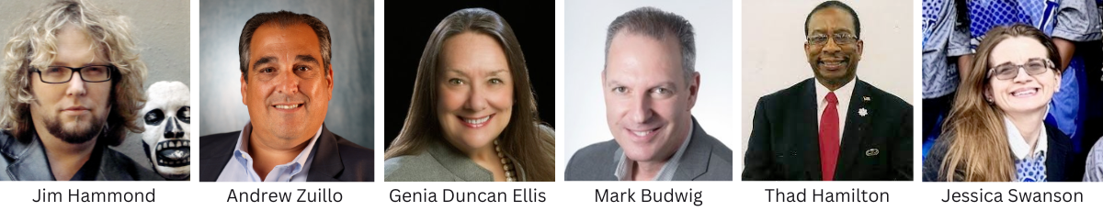

The 2024 Impact Award winners are:

Artist of Impact: Puppet Network Founder and Civic Leader Jim Hammond, best known for creating the beloved Florida Day of the Dead Celebration

Community Partner of Impact: Leadership Broward Foundation Executive Director Andrew Zullo

Media Advocate of Impact: Riverwalk Trust President and CEO Genia Duncan Ellis and Go Riverwalk Magazine Publisher Mark Budwig

Legacy of Impact: Thaddeus "THAD" Hamilton, Chair of the Tuskegee Airman of South Florida;
Also United Negro College Fund, South Florida Leadership Council Chair

Educator of Impact: Jessica Swanson, Master Teacher and Technology Magnet Program Coordinator; Dillard School for the Arts

ArtServe inspires, supports and advances its diverse members, artists and community by promoting artistic development, education and prosperity through the exploration and presentation of the visual and performing arts.

About ArtServe

Named a “2020 Top-Rated Nonprofit” by GreatNonprofits, the leading provider of user reviews of charities and nonprofits, Fort Lauderdale-based ArtServe is an award-winning arts incubator that is advancing the arts for social good as a creative laboratory and hub for experimental artists committed to diversity, equity and inclusion. Now in its 35th year, ArtServe has won several awards for innovation in the arts and is supported in part by the Broward County Board of County Commissioners as recommended by the Broward Cultural Council and Florida’s Department of State and the Division of Cultural Affairs. Each year, ArtServe programs contribute tangibly to the region’s economy, helping 2,000+ artists sell their work, build businesses and engage the community. To do that, ArtServe secures financial support through donations, sponsorships and memberships.

###

