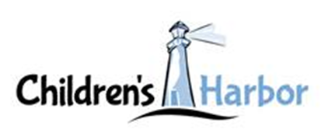
Media Contact
Maria Pierson
mpierson@piersongrant.com

Children’s Harbor Main Campus Administrative Building
Named in Honor of Martin J. Alexander
Holland & Knight partner is longstanding board member and former board chair

Link to More Photos (Cutlines Also Below):
Children's Harbor Names Administration Building For Martin Alexander

Pembroke Pines, Florida (Feb 2, 2024) – The administrative building at the Children’s Harbor main campus in Pembroke Pines has been named in honor of Martin J. Alexander, Esq., a member of the Children’s Harbor board since its founding in 1996, and former board chair.

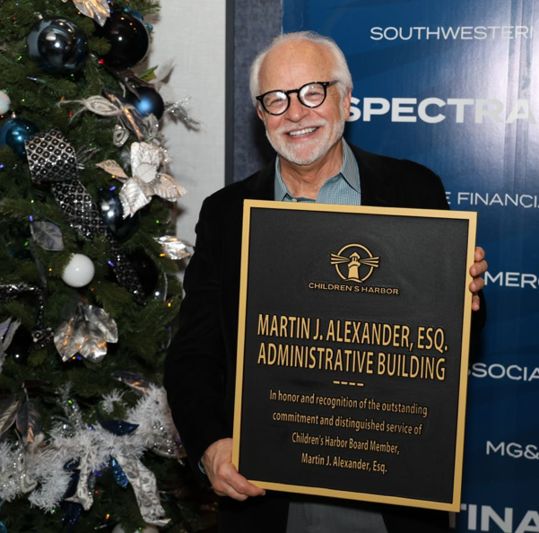
Alexander, a partner at Holland & Knight, was recognized for his contributions at Children’s Harbor annual Winterfest watch party event, and presented a plaque that will be mounted on the Children’s Harbor main office building identifying it as the “Martin J. Alexander Administrative Building.”
Martin J. Alexander, Esq.

“I believe that the most important part of our mission at Children’s Harbor is providing a place where there is love,” Alexander said. “I am most proud of the fact that we not only provide services, but we do it in a way that lets our kids know and their families know that we truly care about each and every one of them.”

Alexander represents corporate and individual clients in wide-ranging contractual, corporate, and business disputes. His practice includes the representation of life insurance companies in coverage issues, financial institutions in the enforcement of creditor rights, and developers and property owners in purchase and sale, leasing, easement, nuisance, land use, and environmental disputes.

Over the years, Alexander has provided assistance and guidance to Children’s Harbor and frequently solicits the pro bono assistance of Holland & Knight colleagues to provide the organization with specialized counseling in areas that include real estate, labor and employment, tax and non-profit organizations.

“We are thrilled to share this special moment of gratitude with Marty in recognition of his unwavering dedication to our mission, vision and the well-being of our children,” said Tiffani Dhooge, president and CEO of Children’s Harbor, a nationally accredited non-profit agency with a mission to help strengthen families who are struggling in our community, while providing safe shelter and support to teens in foster care so that they may grow into healthy, educated and productive adults.

About Children’s Harbor

Established in 1996, Children’s Harbor is a nationally accredited non-profit agency with a mission to help strengthen families who are struggling in our community, while providing safe shelter and support to teens in foster care so that they may grow into healthy, educated and productive adults.

With the belief that children should feel safe, that family is worth fighting for and that cycles can be broken, Children’s Harbor provides a harbor of hope and healing for children who have been impacted by the trauma of child abuse. The main campus in Pembroke Pines provides a supportive family environment for teenagers in foster care and their younger siblings. The family strengthening program prevents kids from coming into foster care by providing in-home counseling and support to families who are struggling in the community. Young adults aged 18-23 who have aged out of foster care are provided with housing and the wrap-around support and independent living programs necessary to help them overcome their trauma and navigate through the early stages of adulthood.

Brown’s Harbor is a supportive housing community that offers on-site staff, training, and wrap-around support services for young adults who have aged out of the foster care system, ages 18-23, helping to bridge the gap from dependence to independence.

###

Photo cutlines:

Photo 1

(L-R) Nicholas Sproul, Southwestern Real Estate; Manolis Alevropoulos, Celebrity Cruises; Lisa Mooney, Centennial Bank; Martin Alexander, Holland & Knight; Stephanie Parker, First Service Residential; Debra Lage, Mercer; Karen Ross; Palermo, Landsman & Ross PA; Paul Smith, 2023 Board Chair; Tiffani Dhooge, Children’s Harbor

Photo 2

Martin Alexander, Holland & Knight

Photo 3

(L-R) Tiffani Dhooge, President/CEO of Children’s Harbor; William E. Mahoney, Children’s Harbor Founder, Mahoney and Associates, LLC; Martin Alexander, Partner, Holland & Knight

Photo 4

(L-R) Lisa Mooney, SVP, Sr. Business Development Officer, Centennial Bank; Martin Alexander, Partner, Holland & Knight; Stephanie Parker, First Service Residential; Debra Lage, Mercer

Photo 5

(L-R) Erik Chafin, Chief Development Officer, Children’s Harbor; Martin Alexander, Partner, Holland & Knight

