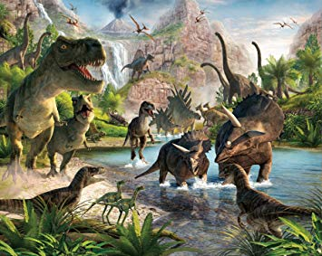
-------------------------------------

Be a part of the SRS

Paleo-knowledge Team
-------------------------------------
Meetings will be Tuesdays from 2/25– 4/8/20 in Rm: 15 from 3-3:30 pm
This team is open to students in grades 3-6 while only students in grades 4-6 can compete 3rd graders will help build a foundation for next year’s competition.
Do you know Dinosaurs?

What is Paleo-knowledge? It is the study of dinosaurs and early animal life during the 248,000,000-10,000 B.C. Students will be investigating different dinosaurs and animal life from the various eras of time and discoveries by Paleontologists during modern time.
Students selected to compete will be determined by a combination of various competitions during team meetings, participation, and student availability for the competition dates. If selected to compete families will be responsible for $10 towards the entry fee.  Please return this lower portion by: 2/14/20 if interested. | Student Name  Parent Contact (Name, Phone Number)  Are you available:  Saturday 4/11/20 for the research day at Hopkins School:  Are you available:  Saturday 4/19/20 for the competition at the Peabody Museum:

