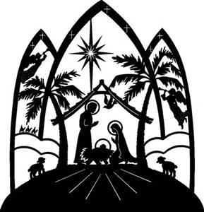

Divine Mercy Parish - St. Stephen Church
Christmas Eve 4:30 PM Family Mass
"She wrapped him in swaddling clothes and laid him in a manger,
because there was no room for them in the inn." Luke 2:7

When: Monday, December 24 at 4:30 PM at St. Stephen Church
Rehearsal: Sunday, December 23 at 10:00 AM following 9:00 AM Mass
at St. Stephen Church

School age children (ages 5 and above) are invited to participate in the Christmas Eve 4:30 PM Family Mass at St. Stephen Church! Please note the time and place. As we prepare to celebrate the birth of Jesus, the children will dress up like the people from the very first Christmas. They will help us remember the events of that miraculous night as we tell the story of our Savior's birth.

We are also looking for school age children (ages 10 and up) to participate as readers. Again, this year we will have a Children’s Choir at this Mass. More information on Children’s Choir practice dates will follow. Please sign up for the Choir by November 25.

Rehearsal
One adult needs to stay with your child(ren) during the rehearsal on December 23 at 10:00 AM at St. Stephen Church following 9:00 AM Mass.

Sign-Ups
If your family and/or child would like to participate in the Christmas Eve Family Mass, please sign up using Sign Up Genius link: https://www.signupgenius.com/go/30E0849AAAA2DA6FC1-divine. Please sign up by Sunday, November 25 (for the Choir) and all others by Tuesday, December 18 and remember to provide your child's name and age and best way to contact you.
If you have any questions please contact Suzanne Hamling (stritayouthgroup01@gmail.com) by email or phone (203-234-1597). We are in need of:

**Angels • Shepherds • Mary • Joseph • Animals

**Readers **Christmas Banner Family **Children’s Choir

