A Rare Opportunity with an Angel Quilt
This is a photograph of the very first Angel Quilt coming from St Luke’s Episcopal Church and little Jack Kensing with his quilt. Linda Leal was at the church on Sunday, May 5th when Karen and Gary Kensing asked for prayer for their little 1 year old grandson, Jack Kensing. Since the above photo was made in San Diego Jack has had an operation on his kidneys in San Diego and is home with his quilt
Jack and Karen Kensing are members of St Luke’s, and Linda Leal told them that she would have the first quilt with our St Luke’s Angel Quilts label in place for little Jack before they left for San Diego, and she was at St Luke’s on Wednesday, May 8th to give Gary Kensing the beautiful quilt with Jack’s own personal label on it. The Kensings left for San Diego the next day. Father Pierre told Linda Leal this week that he had received a photo of Jack after he returned home from the hospital with his loving family around him and his very special quilt! This is the label on Jack’s quilt.
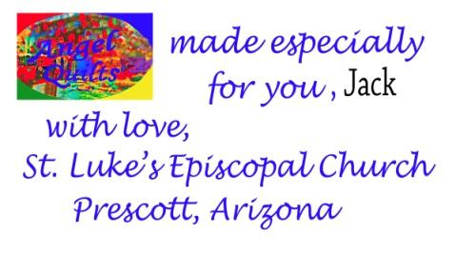
it is a wonderful opportunity for us all here at St Luke’s because all of the future Angel Quilts that go to Phoenix Children’s Hospital will not have a personalized label on them as they will be distributed at Phoenix Children’s Hospital by the hospital personnel, and we won’t know the children who receive them.
However, make no doubt about it, St Luke’s Episcopal Church families with ill children or grandchildren WILL BE OUR FIRST PRIORITY ALWAYS! Linda Leal told Father Pierre that we want to serve St Luke’s Episcopal Church families with our offerings. We are a family here and we love each other! And those St Luke’s children’s quilts will always have a personal label!
Jack is a very special little boy with a very special quilt. The Angel Quilts will all have the above label on each of the quilts, “made especially for you, with love, St Luke’s Episcopal Church, Prescott, Arizona.”

