The Twenty-Fourth Sunday after Pentecost

Proper 28

November 14-15, 2020

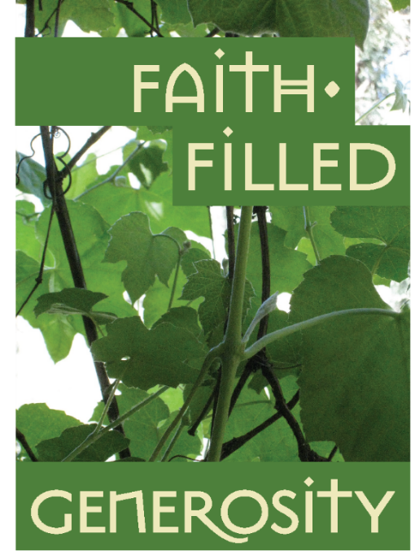
Faith is a gift, Christian community is a gift; worship, children’s energy and that moment when teenagers suddenly make a profound connection with their faith: These are all gifts. We could get caught up in the anxiety of paying for it all, or we could just say thank you and write the pledge that shows how grateful we are for all we have received. The Rev. Matthew Woodward

Our Mission: To know Christ and to make Christ known.
Our Vision: To follow Christ’s teaching in an atmosphere of love, joy, and healing.

All are welcome!
Be still and know that I am God! Psalm 46:10

Please, as you enter the Church, observe a sacred silence to prepare yourself to the encounter with the Lord, and to allow others to do the same.

O Almighty God, who pours out on all who desire it the spirit of grace and of supplication: Deliver us, when we draw near to you, from coldness of heart and wanderings of mind, that with steadfast thoughts and kindled affections we may worship you in spirit and in truth; through Jesus Christ our Lord. Amen. (Prayer No. 64, Before Worship; BCP, p. 833)

Prelude Faith of our Fathers Henri F. Hemi
The Word of God
Opening Hymn 551 vs.1-3 Rise up, ye saints of God
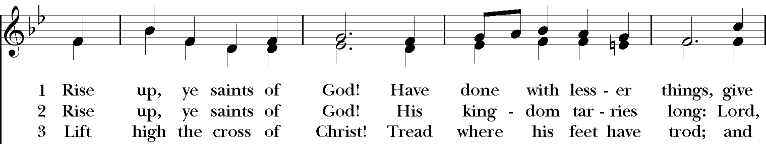
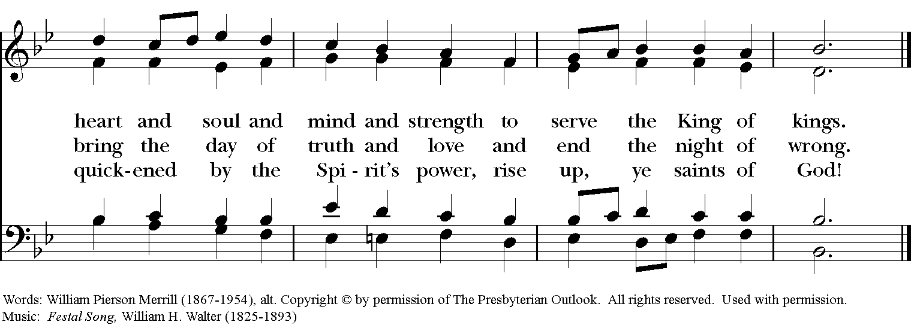

Opening Acclamation
Blessed be God: Father, Son, and Holy Spirit. And blessed be God’s kingdom now and for ever. Amen

Collect for Purity
Almighty God, to you all hearts are open, all desires known, and from you no secrets are hid: Cleanse the thoughts of our hearts by the inspiration of your Holy Spirit, that we may perfectly love you, and worthily magnify your holy Name; through Christ our Lord. Amen.

Glory to God
Glory to God in the highest, and peace to his people on earth. Lord God, heavenly King, almighty God and Father, we worship you, we give you thanks, we praise you for your glory. Lord Jesus Christ, only Son of the Father, Lord God, Lamb of God, you take away the sin of the world: have mercy on us; you are seated at the right hand of the Father: receive our prayer. For you alone are the Holy One, you alone are the Lord, you alone are the Most High, Jesus Christ, with the Holy Spirit, in the glory of God the Father. Amen.

The Collect of the Day
The Lord be with you. And also with you.
Blessed Lord, who caused all holy Scriptures to be written for our learning: Grant us so to hear them, read, mark, learn, and inwardly digest them, that we may embrace and ever hold fast the blessed hope of everlasting life, which you have given us in our Savior Jesus Christ; who lives and reigns with you and the Holy Spirit, one God, for ever and ever. Amen.

The First Reading Zephaniah 1:7,12-18A Reading from the book of Zephaniah
⁷Be silent before the Lord God! For the day of the Lord is at hand; the Lord has prepared a sacrifice, he has consecrated his guests. ¹²At that time I will search Jerusalem with lamps, and I will punish the people who rest complacently on their dregs, those who say in their hearts, “The Lord will not do good, nor will he do harm.” ¹³Their wealth shall be plundered, and their houses laid waste. Though they build houses, they shall not inhabit them; though they plant vineyards, they shall not drink wine from them. ¹⁴The great day of the Lord is near, near and hastening fast; the sound of the day of the Lord is bitter, the warrior cries aloud there. ¹⁵That day will be a day of wrath, a day of distress and anguish, a day of ruin and devastation, a day of darkness and gloom, a day of clouds and thick darkness, ¹⁶a day of trumpet blast and battle cry against the fortified cities and against the lofty battlements. ¹⁷I will bring such distress upon people that they shall walk like the blind; because they have sinned against the Lord, their blood shall be poured out like dust, and their flesh like dung. ¹⁸Neither their silver nor their gold will be able to save them on the day of the Lord's wrath; in the fire of his passion the whole earth shall be consumed; for a full, a terrible end he will make of all the inhabitants of the earth.
The Word of the Lord. Thanks be to God.

Psalm 90:1-8, (9-11), 12 Domine, refugium
¹ Lord, you have been our refuge from one generation to another.
² Before the mountains were brought forth, or the land and the earth were born, from age to age you are God.
³ You turn us back to the dust and say, "Go back, O child of earth."
⁴ For a thousand years in your sight are like yesterday when it is past and like a watch in the night.
⁵ You sweep us away like a dream; we fade away suddenly like the grass.
⁶ In the morning it is green and flourishes; in the evening it is dried up and withered.
⁷ For we consume away in your displeasure; we are afraid because of your wrathful indignation.
⁸ Our iniquities you have set before you, and our secret sins in the light of your countenance.
⁹ When you are angry, all our days are gone; we bring our years to an end like a sigh.
¹⁰ The span of our life is seventy years, perhaps in strength even eighty; yet the sum of them is but labor and sorrow, for they pass away quickly and we are gone.
¹¹ Who regards the power of your wrath? who rightly fears your indignation?
¹² So teach us to number our days that we may apply our hearts to wisdom.

Glory to the Father, and to the Son, and to the Holy Spirit: as it was in the beginning, is now, and will be for ever. Amen.

The Second Reading 1 Thessalonians 5:1-11

A Reading from the First Letter of Paul to the Thessalonians
¹Now concerning the times and the seasons, brothers and sisters, you do not need to have anything written to you. ²For you yourselves know very well that the day of the Lord will come like a thief in the night. ³When they say, “There is peace and security,” then sudden destruction will come upon them, as labor pains come upon a pregnant woman, and there will be no escape! ⁴But you, beloved, are not in darkness, for that day to surprise you like a thief; ⁵for you are all children of light and children of the day; we are not of the night or of darkness. ⁶So then let us not fall asleep as others do, but let us keep awake and be sober; ⁷for those who sleep sleep at night, and those who are drunk get drunk at night. ⁸But since we belong to the day, let us be sober, and put on the breastplate of faith and love, and for a helmet the hope of salvation. ⁹For God has destined us not for wrath but for obtaining salvation through our Lord Jesus Christ, ¹⁰who died for us, so that whether we are awake or asleep we may live with him. ¹¹Therefore encourage one another and build up each other, as indeed you are doing.
The Word of the Lord. Thanks be to God.

(8:00 & 10 a.m.) Hymn 490 vs. 1 I want to walk as a child of the light
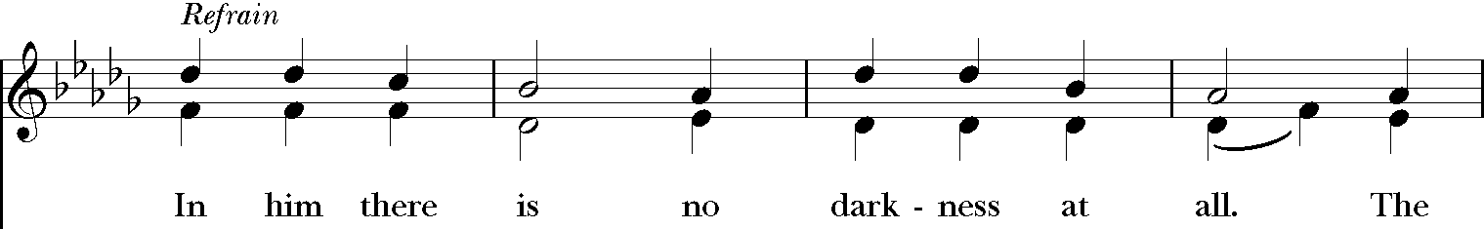
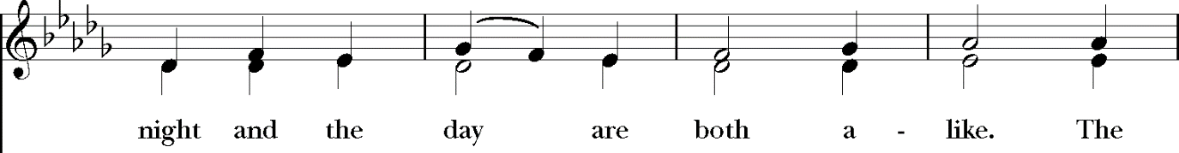
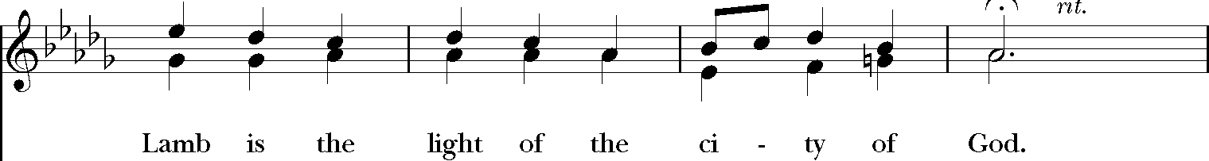

The Gospel Matthew25:14-30
The Holy Gospel of Our Lord Jesus Christ According to Matthew Glory to you, Lord Christ.
Jesus said, ¹⁴“It is as if a man, going on a journey, summoned his slaves and entrusted his property to them; ¹⁵to one he gave five talents, to another two, to another one, to each according to his ability. Then he went away. ¹⁶The one who had received the five talents went off at once and traded with them, and made five more talents. ¹⁷In the same way, the one who had the two talents made two more talents. ¹⁸But the one who had received the one talent went off and dug a hole in the ground and hid his master’s money. ¹⁹After a long time the master of those slaves came and settled accounts with them. ²⁰Then the one who had received the five talents came forward, bringing five more talents, saying, ‘Master, you handed over to me five talents; see, I have made five more talents.’ ²¹His master said to him, ‘Well done, good and trustworthy slave; you have been trustworthy in a few things, I will put you in charge of many things; enter into the joy of your master.’ ²²And the one with the two talents also came forward, saying, ‘Master, you handed over to me two talents; see, I have made two more talents.’ ²³His master said to him, ‘Well done, good and trustworthy slave; you have been trustworthy in a few things, I will put you in charge of many things; enter into the joy of your master.’ ²⁴Then the one who had received the one talent also came forward, saying, ‘Master, I knew that you were a harsh man, reaping where you did not sow, and gathering where you did not scatter seed; ²⁵so I was afraid, and I went and hid your talent in the ground. Here you have what is yours.’ ²⁶But his master replied, ‘You wicked and lazy slave! You knew, did you, that I reap where I did not sow, and gather where I did not scatter? ²⁷Then you ought to have invested my money with the bankers, and on my return I would have received what was my own with interest. ²⁸So take the talent from him, and give it to the one with the ten talents. ²⁹For to all those who have, more will be given, and they will have an abundance; but from those who have nothing, even what they have will be taken away. ³⁰As for this worthless slave, throw him into the outer darkness, where there will be weeping and gnashing of teeth.’”
The Gospel of the Lord. Praise to you, Lord Christ.

(10 a.m.) Hymn 490 vs. 3 I want to walk as a child of the light (see page 3)

Sermon The Rev Pierre-Henry Buisson

The Nicene Creed
We believe in one God, the Father, the Almighty, maker of heaven and earth, of all that is, seen and unseen.
We believe in one Lord, Jesus Christ, the only Son of God, eternally begotten of the Father, God from God, Light from Light, true God from true God, begotten, not made, of one Being with the Father. Through him all things were made. For us and for our salvation he came down from heaven: by the power of the Holy Spirit he became incarnate from the Virgin Mary, and was made man. For our sake he was crucified under Pontius Pilate; he suffered death and was buried. On the third day he rose again in accordance with the Scriptures; he ascended into heaven and is seated at the right hand of the Father. He will come again in glory to judge the living and the dead, and his kingdom will have no end.
We believe in the Holy Spirit, the Lord, the giver of life, who proceeds from the Father and the Son. With the Father and the Son he is worshiped and glorified. He has spoken through the Prophets. We believe in one holy catholic and apostolic Church. We acknowledge one baptism for the forgiveness of sins. We look for the resurrection of the dead, and the life of the world to come. Amen.

A Litany for Stewardship

Deacon: Let us pray for the wisdom and courage to make stewardship a way of life with God. (pause)
Because of our faith in You, 0 Lord, we acknowledge You as the source of all that we have and all that we are.
Help us to place You, our loving Creator, first in our lives, by becoming more prayerful and more focused on loving and caring for our families and our neighbors in need, and by becoming less preoccupied with material things.
Help us, Lord, to find the true source of happiness and fulfillment that we all seek, and that You, alone, can provide.
Help us to hear Your call to be good stewards of all Your gifts…by sharing them for Your purposes.
Help us make Your priorities…our priorities.
Help us challenge each other, as disciples of Jesus Christ, to put our faith into action.
Let us pray that as good stewards we will plan our sharing. As we plan the things in our lives that are most important to us, Lord, help us plan our sharing of time with those in need.
Help us plan how to '"give back" the talents with which we have been blessed.
Help us plan how to share our treasure to do Your work.
Our planning and sharing demonstrates the great importance that You and the truth of the Gospel has in our lives.
Help us plan to serve our church, our community, and our world with Your Gifts.
Let us pray that we will share in proportion to what has been given us.
Help us, Lord, return a portion of all You have given us.
We do this, 0 Lord, as a sign of our love, and in thanksgiving for the many blessings we have received.
We offer not only the "first fruits" of our financial resources, but a generous portion of our time and talents as well.
Giving proportionately means it is equal for all of us, according to what You have given us. You ask the same of each of us.
As we give proportionately help us to put our trust, security and faith in You.
As good Christian Stewards, we pray we have a joyful spirit of mind and heart. AMEN. Adapted From the Anglican Diocese of Ottawa 2010 Conference website
(5:30pm & 8am) Let us confess our sins against God and our neighbor.
Most merciful God, we confess that we have sinned against you in thought, word, and deed, by what we have done, and by what we have left undone. We have not loved you with our whole heart; we have not loved our neighbors as ourselves. We are truly sorry and we humbly repent. For the sake of your Son Jesus Christ, have mercy on us and forgive us; that we may delight in your will, and walk in your ways, to the glory of your Name. Amen.

Almighty God have mercy on you, forgive you all your sins through our Lord Jesus Christ, strengthen you in all goodness, and by the power of the Holy Spirit keep you in eternal life. Amen.

(10am) EfM Graduation
Celebrant: Sisters and brothers in Christ, we are all baptized by the one Spirit into one Body and given gifts for a variety of ministries for the common good. Today we celebrate the graduation of three persons who spent four years in the Education for Ministry Program, studying the scriptures, church history, and theology in a
learning community, reflecting on living their beliefs in their daily lives, and
purposefully seeking where God is calling them to minister in the world.

The EfM graduates come forward.

Mentors: We present to you Steven Dear, Trampus Tribbey, and Lynne Wells who have completed the Education for Ministry program:

Present and past students of Education for Ministry are invited to join in the celebration of this graduation by standing now.

Laying of hands I lay my hands upon you as a sign that God has called you to ministry. May God who has chosen you, guide your service, strengthen you in weariness, and enlighten you in times of doubt. May the Lord bless you that you may continue to
grow and to serve the Lord each day of your life. Amen.
Presentation of Certificates by Mentors

The Peace: The peace of the Lord be always with you. And also with you.

Birthday and Anniversary Prayer
O God, our times are in your hands: look with favor, we pray, on your servants as they begin another year; for the birthays of Betty, Dorcas, Brenda, John, Jean, Jameson, Rich and Colter and for the anniversaries of Charles & Linda, David & Karen, Jerry & Carol, Kelly & Sue, Robert & Anna and Herb & Ann. Grant that they may grow in wisdom and grace. Send your blessings upon them, that their homes may be a haven of peace; through Jesus Christ our Lord. Amen.

Announcements

The Holy Communion

Offertory Sentence O Lord our God, you are worthy to receive glory and honor and power; because you have created all things, and by your will they were created and have their being. Revelation 4:11

(5:00 pm) All things come to thee, O Lord, and from your own are we given Thee.

(8:00 & 10:00 am) The Presentation Hymn 380, vs. 3
The Great Thanksgiving Prayer B
The Lord be with you. And also with you.
Lift up your hearts. We lift them to the Lord.
Let us give thanks to the Lord our God. It is right to give him thanks and praise.
It is right, and a good and joyful thing, always and everywhere to give thanks to you, Father Almighty, Creator of heaven and earth. For you are the source of light and life; you made us in your image, and called us to new life in Jesus Christ our Lord. Therefore we praise you, joining our voices with Angels and Archangels and with all the company of heaven, who for ever sing this hymn to proclaim the glory of your Name:

Sanctus:
Holy, Holy, Holy Lord, God of power and might,
heaven and earth are full of your glory.
Hosanna in the highest.
Blessed is he who comes in the name of the Lord.
Hosanna in the highest.

We give thanks to you, O God, for the goodness and love which you have made known to us in creation; in the calling of Israel to be your people; in your Word spoken through the prophets; and above all in the Word made flesh, Jesus, your Son. For in these last days you sent him to be incarnate from the Virgin Mary, to be the Savior and Redeemer of the world. In him, you have delivered us from evil, and made us worthy to stand before you. In him, you have brought us out of error into truth, out of sin into righteousness, out of death into life.
On the night before he died for us, our Lord Jesus Christ took bread; and when he had given thanks to you, he broke it, and gave it to his disciples, and said, "Take, eat: This is my Body, which is given for you. Do this for the remembrance of me."
After supper he took the cup of wine; and when he had given thanks, he gave it to them, and said, "Drink this, all of you: This is my Blood of the new Covenant, which is shed for you and for many for the forgiveness of sins. Whenever you drink it, do this for the remembrance of me."
Therefore, according to his command, O Father, We remember his death, We proclaim his resurrection, We await his coming in glory;
And we offer our sacrifice of praise and thanksgiving to you, O Lord of all; presenting to you, from your creation, this bread and this wine.
We pray you, gracious God, to send your Holy Spirit upon these gifts that they may be the Sacrament of the Body of Christ and his Blood of the new Covenant. Unite us to your Son in his sacrifice, that we may be acceptable through him, being sanctified by the Holy Spirit. In the fullness of time, put all things in subjection under your Christ, and bring us to that heavenly country where, with Luke and all your saints, we may enter the everlasting heritage of your sons and daughters; through Jesus Christ our Lord, the firstborn of all creation, the head of the Church, and the author of our salvation.
By him, and with him, and in him, in the unity of the Holy Spirit all honor and glory is yours, Almighty Father, now and for ever. AMEN.

The Lord’s Prayer
As our Savior Christ has taught us, we now pray,
Our Father, who art in heaven, hallowed be thy Name, thy kingdom come, thy will be done, on earth as it is in heaven. Give us this day our daily bread. And forgive us our trespasses, as we forgive those who trespass against us. And lead us not into temptation, but deliver us from evil. For thine is the kingdom and the power, and the glory, for ever and ever. Amen.

The Breaking of the Bread
Alleluia. Christ our Passover is sacrificed for us; Therefore let us keep the feast. Alleluia.

The Communion
The gifts of God for the people of God. Take them in remembrance that Christ died for you, and feed on him in your hearts by faith, with thanksgiving.

All who are baptized are invited to share in the banquet of the Lord’s Supper. Gluten-free wafers are available; please make your need known to the minister. Respond to receiving Communion by saying "Amen." If you prefer to receive a blessing instead, please indicate your choice by crossing your hands across your chest.

(10 am) A spiritual communion is a personal devotion that anyone can pray at any time to express their desire to receive Holy Communion at that moment, but in which circumstances impede them from actually receiving Holy Communion.

The presider invites the following prayer to be said by all:

(10 am) My Jesus, I believe that you are truly present in the Blessed Sacrament of the Altar. I love you above all things, and long for you in my soul. Since I cannot now receive you sacramentally, come at least spiritually into my heart. As though you have already come, I embrace you and unite myself entirely to you; never permit me to be separated from you. Amen. (St. Alphonsus de Liguori, 1696-1787)
(8 & 10 a.m.) Communion Anthem Wondrous Love Fletcher
Emily Spencer, Soprano

The Prayer of Thanksgiving
Let us pray.
Almighty and everliving God, we thank you for feeding us with the spiritual food of the most precious Body and Blood of your Son our Savior Jesus Christ; and for assuring us in these holy mysteries that we are living members of the Body of your Son, and heirs of your eternal kingdom. And now, Father, send us out to do the work you have given us to do, to love and serve you as faithful witnesses of Christ our Lord. To him, to you, and to the Holy Spirit, be honor and glory, now and for ever. Amen.

Blessing: The peace of God, which passes all understanding, keep your hearts and minds in the knowledge and love of God, and of his Son Jesus Christ our Lord; the blessing of God Almighty, the Father, the Son, and the Holy Spirit, be upon you and remain with you for ever. Amen.

Dismissal: Let us bless the Lord. Thanks be to God.

Postlude O Savior Come Fred B Biwekes
You may enjoy the Postlude offered by our gifted organist or quietly leave the sanctuary.

People may leave after dismissal but Ushers please do not start escorting people out until after the Postlude.
Please observe social distancing when leaving the worship space.
Thank You

Altar Flowers – Cynthia Moreno –
In Honor and Recognition of our Veterans
and our Veterans Family.

Congratulations to the EfM Graduating Class of 2020
Steven Dear
Trampus Tribbey
Lynne Wells
Every baptized person is called to ministry. The EfM program, offered as an education-at-a-distance course by the School of Theology at the University of the South at Sewanee, TN, provides Episcopalians and others with the education to carry out that ministry. This diocese is a sponsoring diocese of the EfM program.

As the Church continues to emphasize the importance of lay ministries, many people feel that they need a theological education that supports their faith and teaches them to express that faith in day-to-day events. EfM is one way for them to gain that knowledge.

EfM is a 4-year course, covering the basic subjects of a theological education: the Hebrew scripture, New Testament, Church history and the study of theological movements in the church. Participants register for one year at a time, meeting weekly in a seminar of 6-12 students with trained mentors. We meet on Thursday evenings from 5:30 – 8:00. (beginning in mid-September). Right now with the Covid issue we will be using Zoom. We did that to finish up in the spring and it worked quite well.

There are weekly assignments to study with the help of resource guides. All years meet together, which leads to very meaningful discussions. (We have 5 participants returning next year for years 2-4.) We really need some 1st year students to round things out!

A recent Tucson graduate had this to say – “EfM is a safe, supportive place to learn, explore new ideas, and wrestle with the big questions in the company of others who are doing the same. You will be welcomed, encouraged, and challenged as you do the readings and participate in weekly discussions. The friendships developed along the way are truly special. A wild ride, but worth every inch!”
If you think EfM might be for you, please contact
Leanne Bryan at (928-713-4014, bryanfamily@cableone.net) or
Kathy Pessin at (928-771-2707, 928-899 0986, jimpes@cableone.net)

Special Dates this Week
Birthdays

November 15 Betty Phillips, Dorcas Lawn
November 16 Brenda Schwartz
November 17 John Evans
November 18 Jean Messick, Jameson Parker
November 20 Rich Schwartz, Colter Donovan
Anniversaries:
November 16 Charles & Linda Kaul, David White & Karen Benson
November 18 Jerry & Carol Sweeden, Kelly & Sue Hodge-Parker,
Robert & Anna Johnson
November 20 Herb & Ann Reynolds

For Those In Need We Pray:
November Thanksgiving & Healing Prayers
To all members, family, friends of St. Luke's during this pandemic
Brandon & Nikki Reynolds.; Alicia; Alex; Sharon, Dave & Nancy C.; Larie & Wife; Carol; Darrell C.; Dominica Coppola & Marty Dane; Max J.; Carol Glover; Gil & Cheri Lattimer's mother & Good Samaritan Staff; Cathy Hoaglund; Gary & Kathy MacCauley; Robert McCaulley; Jean Messick; Etta Parson; Linda Schwab; Sue; Ileen Szelka; Mark Tuttle; Patty; Ron Miller; Beth Wingate; Kate Carroll; Carl Dekemper; Sara Wiliman; Barbara Harber; Vera Mulnix; Rich Staudt; Steven; Glenn J.; Joan Hedger; Erni Frazier; Ruth Visclo, Vicki Casacchia; Ian Snider; Jerri Wheeler; Joe & Linda, Glen Gregor; Jim Casacchia; Scott Menke; Jeff Bernatz; Doug Ogburn; Yoland Jr; Steve; Glenn Johnson, Adria Tropel; Kyle Forslund,; Thurlow; Hank Martin

For those in our Armed Forces: Echo, Brian, Lopez, Dante’, Florian
In the Anglican Cycle of Prayer: The Church of Ceylon
In Diocesan Cycle of Prayer: Trinity Cathedral in Phoenix St. Andrews in Nogales
For the Yavapai-Apache Nation
For Bishop Zak and Amagoro Junior Academy

For Our Companion Diocese of Western Mexico Resolution 2020-1, of the 60th Diocesan Convention

We acknowledge the living culture of the Yavapai-Apache nation, the traditional custodians of the land we stand on, and pay tribute to the role they play in the life of this region. Resolution #2016-3, of the 56th Diocesan Convention

