How to Use This Toolkit
Use these graphics and sample posts to show how the state budget impasse is impacting your organization and community. Choose one or more to share on your social channels. Tag @BucksMontCollab and your local legislators, use the hashtags below, and link to the legislator letter and impact snapshot PDFs.

Hashtags & Tags
Primary Hashtags: #EndTheImpasse #NonprofitsCantWait
Optional Hashtags: #PABudget2025 #PAHousing #CommunityImpact
Tag: @BucksMontCollab and your local legislators.

Post Options | Data Graphics
Link to all graphics to download high-quality images.
Stat Post 1 | Caption  Organizations like ours are already hurting. 78% of local nonprofits have been forced to delay payroll, reduce staff, or cut programs. The need hasn’t gone away—but our funding has.  #EndTheImpasse #NonprofitsCantWait | 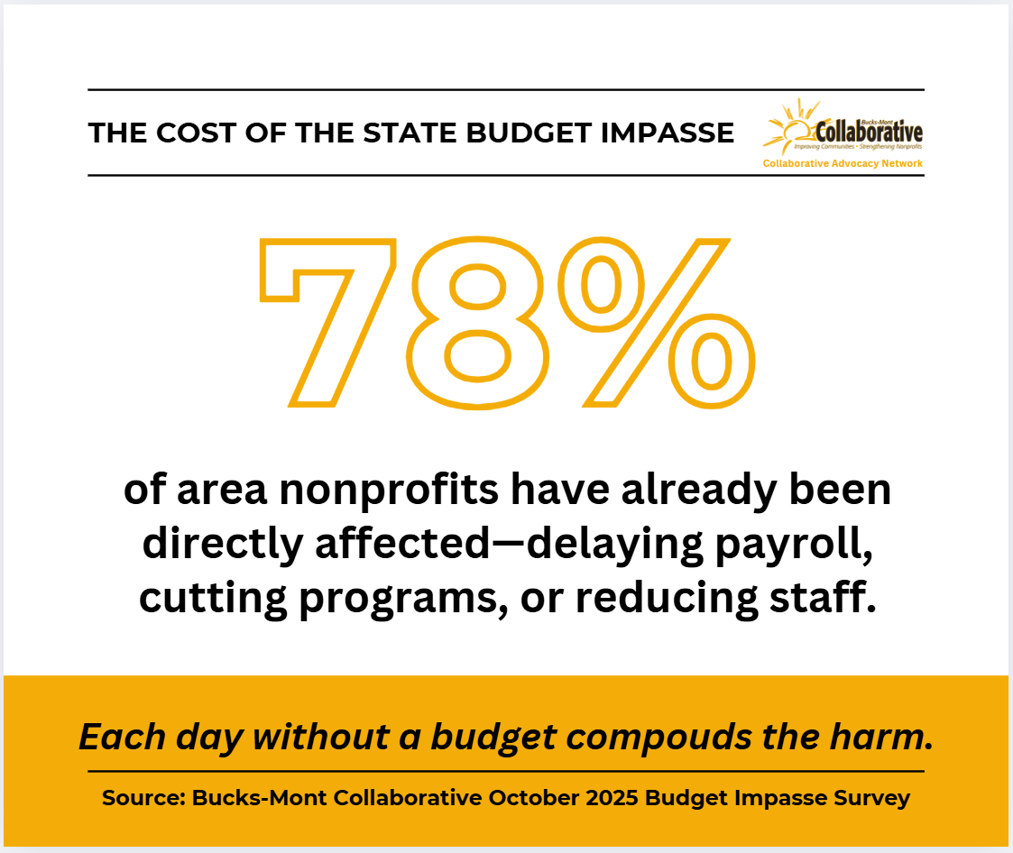
Stat Post 2 | Caption
Nine in ten nonprofit workers are burning out as state funding stalls. 57% of organizations have already cut staff or services. This is unsustainable—end the budget impasse now.
#NonprofitsCantWait #PABudget2025

Post Options | Quote Graphics
Quote Post 1 | Caption  For families waiting on rental assistance or shelter beds, the budget impasse is a lifeline issue—not a line-item one. Organizations like ours are already hurting. End the impasse now.  #EndTheImpasse #NonprofitsCantWait | 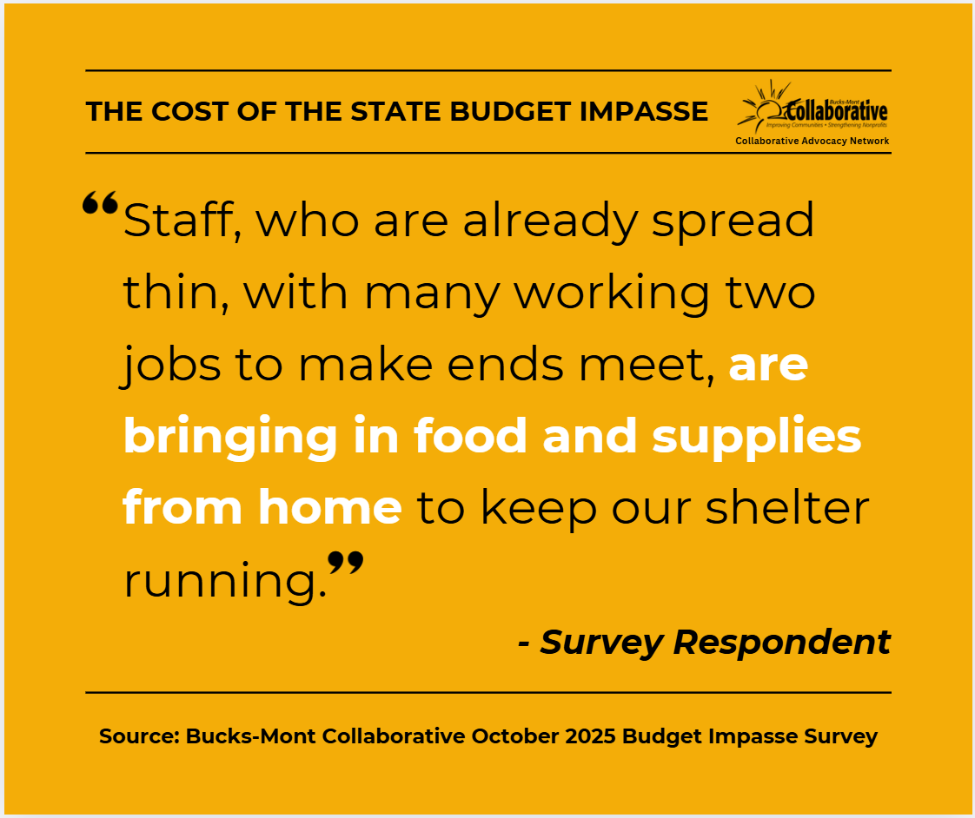
Quote Post 2 | Caption  Our staff shouldn’t have to choose between paying their bills and feeding the people we serve. Each day without a budget compounds the harm. End the impasse now.  #EndTheImpasse #PABudget2025 | 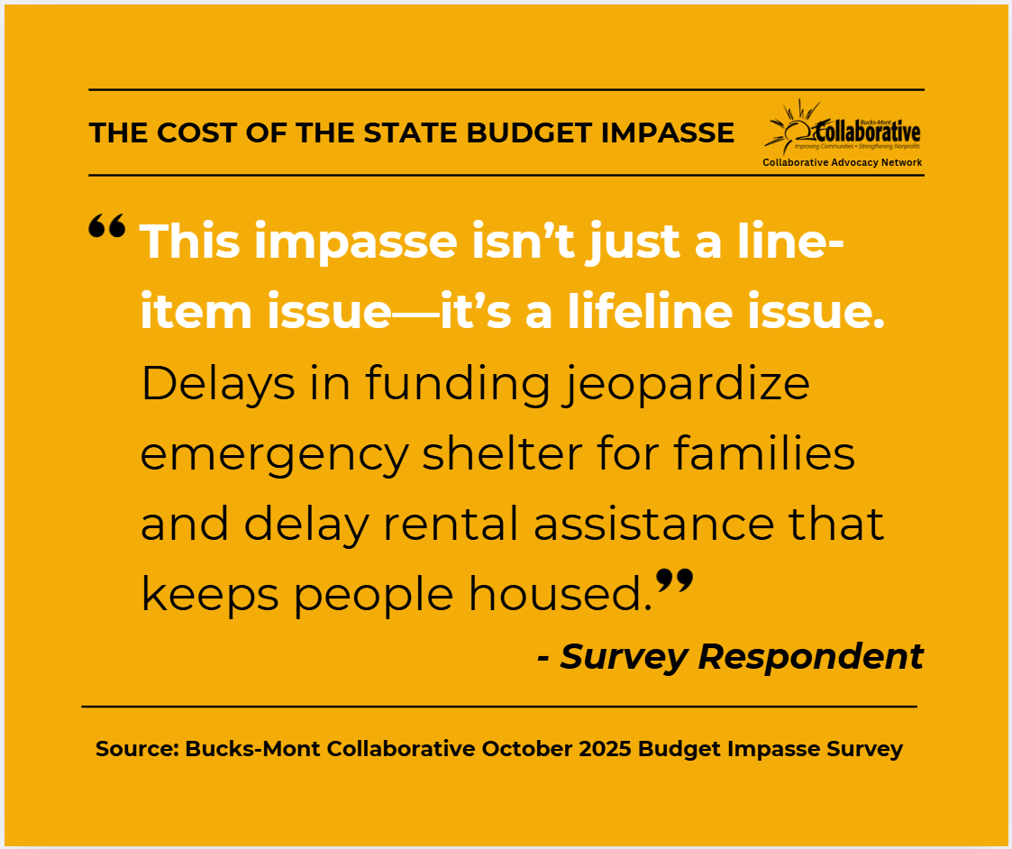
Call to Action & Shareable Links
📄 Legislator Letter (PDF)
📊 Impact Snapshot (PDF)
🗳️ Find My Legislator Tool
🌐 bucksmontcollab.org

