FREE Naloxone
Naloxone, or Narcan, is a life-saving medication that can reverse the effects of an opioid overdose. Many community organizations offer free Naloxone and training to administer the medication.
Name | Type | How to Access
Naloxone for All | Online/By Mail | nextdistro.org/michigan
Families Against Narcotics | Online/By Mail | FamiliesAgainstNarcotics.org/narcan
Harm Reduction Michigan | By Mail or Personal Delivery | Text/call (231) 493-5124 or visit their Facebook page and send a message through Messenger  facebook.com/HarmReductionMI
For additional resources or to contact a NMORC team member, please visit https://nmorc.org/
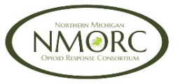 Northern Michigan Opioid Response Consortium
FREE Naloxone
Naloxone, or Narcan, is a life-saving medication that can reverse the effects of an opioid overdose. Many community organizations offer free Naloxone and training to administer the medication.
Name | Type | How to Access
Naloxone for All | Online/By Mail | nextdistro.org/michigan
Families Against Narcotics | Online/By Mail | FamiliesAgainstNarcotics.org/narcan
Harm Reduction Michigan | By Mail or Personal Delivery | Text/call (231) 493-5124 or visit their Facebook page and send a message through Messenger  facebook.com/HarmReductionMI
For additional resources or to contact a NMORC team member, please visit https://nmorc.org/
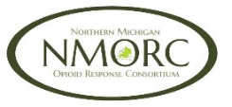 Northern Michigan Opioid Response Consortium
FREE Naloxone
Naloxone, or Narcan, is a life-saving medication that can reverse the effects of an opioid overdose. Many community organizations offer free Naloxone and training to administer the medication.
Name | Type | How to Access
Naloxone for All | Online/By Mail | nextdistro.org/michigan
Families Against Narcotics | Online/By Mail | FamiliesAgainstNarcotics.org/narcan
Harm Reduction Michigan | By Mail or Personal Delivery | Text/call (231) 493-5124 or visit their Facebook page and send a message through Messenger  facebook.com/HarmReductionMI
For additional resources or to contact a NMORC team member, please visit https://nmorc.org/
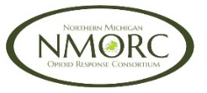 Northern Michigan Opioid Response Consortium

