A Hastings Public Library Book Club for 4th-6th Grade Students

Ten-year old, Mia Tang, has lots of secrets and lots of responsibilities. Let’s read

Front Desk by Kelly Yang

And find out how Mia Manages to down the fort at school, at the motel and with her family.

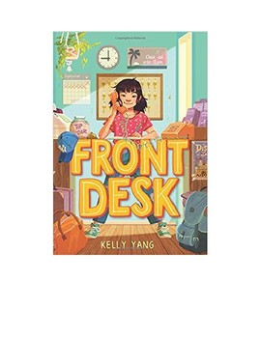

Join us via Zoom on Tuesday, March 23rd at 3:30 p.m.

Copies of Front Desk are available at the Circulation Desk. Call the library (914) 478-3307 to reserve
your copy. We will check the book out to you and place it on the cart inside the front door.

Request the Zoom link at: hastingslibrary@gmail.com

