Family
University
Wednesday, April 20, 2022
6:00 to 9:00 PM* virtual
An evening of education for parents & high school students
6:00-6:40 PM: Youth Drug & Alcohol Survey Results
6:50-7:50 PM: Choice of Adult and Student Workshops
8:00-9:00 PM: Choice of 2nd Adult Workshop
Workshop Topic Choices Include:
- Drugs & the Brain: Using Science to talk to Teens
For Adults For Adults

- Building Resilience in Children & Ourselves
- When Mental Health and Substance Use Collide
- Teens & Tech: What to do when Devices Rule

- Cannabis: What Your Friends Aren’t Telling You
For Students
- Even Superheros Get the Blues: An Honest Conversation About Mental Health
- Anxiety, Procrastination & Perfectionism
- Mindfulness for Peak Performance

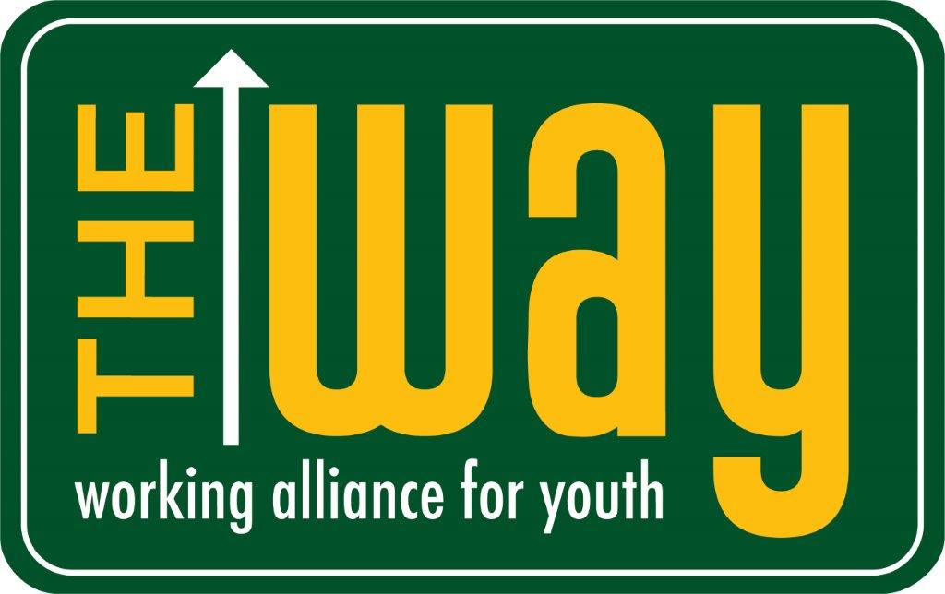
Sponsored by:
and the Hastings-on-Hudson School District, PTSA & SEPTA
*Please come to all or part of the evening as your schedule permits

