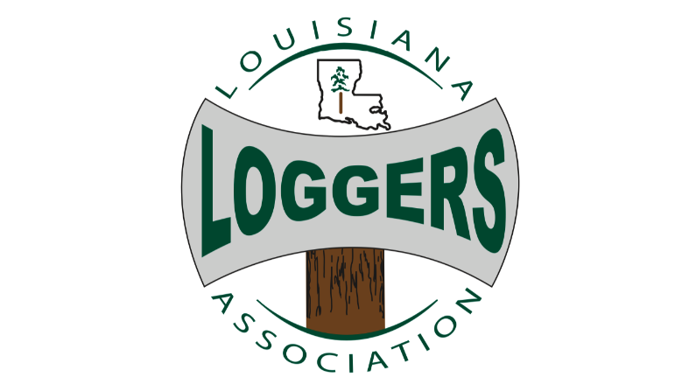

Sponsorship
Annual Sponsorship Platinum Level $10,000.00
- Baton Rouge Legislative Day Luncheon
- LLA gala
- Monthly Newsletter sponsor (24 online)
- LLA Website
- Annual Membership
- Promotional Media on website
Annual Sponsorship Gold Level $7,500.00
- Baton Rouge Legislative Day Luncheon
- LLA gala
- Monthly Newsletter sponsor (12 online)
- LLA Website
- Annual Membership
- Promotional Media on website
Annual Sponsorship Silver Level $5,000.00
- Baton Rouge Legislative Day Luncheon
- LLA gala
- Monthly Newsletter sponsor (6 online)
- LLA Website
- Annual Membership

Annual Sponsorship Bronze Level $2500.00
- Baton Rouge Legislative Day Luncheon
- Monthly Newsletter (online)
- LLA Website
- Annual Membership
Baton Rouge Legislative Day Luncheon
- Platinum Level $1,500.00
- Gold Level $1,000.00
- Silver Level $750.00
Social Media Promotion (will have to provide information for website promotion)
- Quarterly $750.00 (4X a year)
- Biyearly $375.00 (2X a year)
- Year $1250.00

LLA Website
- 6 months $750.00
- Year $1250.00

** please print form out to designate which package you are purchasing.
Make checks payable to “The Louisiana Loggers Association”

