Call for Presentations
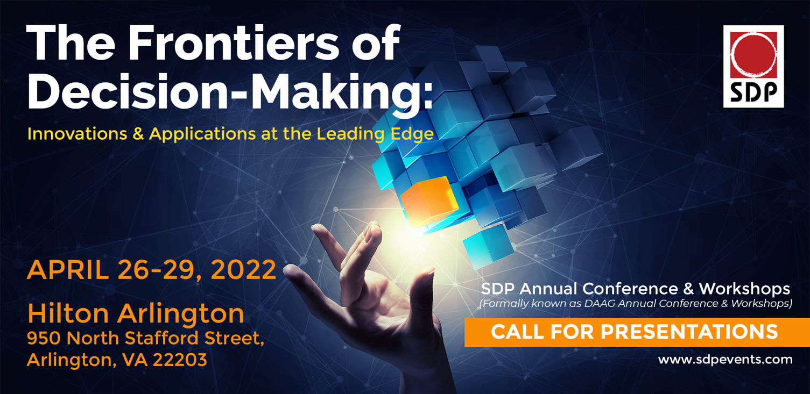
The Society of Decision Professionals cordially invites you to attend the Annual SDP Conference & Workshops to be held on April 26-29, 2022 in Arlington, Virginia. The conference theme is "The Frontiers of Decision-Making: Innovations & Applications at the Leading Edge".﻿
The SDP ANNUAL CONFERENCE & WORKSHOPS is in its 28th year and is known for bringing together decision professionals and decision makers from multiple industries from all around the globe to share ideas, successes and failures. We are proud to offer the conference with an OPTION to attend in-person in Arlington, VA or participate virtually. Either way, being part of the conference gives you an opportunity to build on your personal portfolio and thrive as a Decision Professional in a rapidly emerging discipline.
SDP will sponsor a full slate of online workshops prior to the conference (dates to be announced) as well as the traditional in-person workshops on April 26-27, 2022 ahead of the main SDP conference on April 28-29, 2022.
We are now issuing a call for presentations for next April’s conference. Do you have a talk to share that can fit into one of our sessions? Would you be willing to co-chair or participate as a panelist in one of our sessions? If so, we invite you to contact one of the session chairs listed below by November 5, 2021.
We look forward to your participation!

William Leaf-Herrmann and Gary Summers
SDP Annual Conference Co-chairs

THE SESSIONS LISTED BELOW ARE THOSE THAT ARE ACTIVELY SEEKING SPEAKERS/PANELISTS

Innovations in Eliciting, Representing, and Combining Expert Opinion
Chair | Contact Info: Tom Keelin (tomk@keelinreeds.com)
Description: While eliciting, representing, and combining expert opinion has been a hallmark of decision analysis theory and practice for more than 50 years, new innovations are making it faster, easier, and more practical. New continuous probability distributions (metalogs and J-QPD’s) are available to quickly convert elicited quantiles into smooth continuous distributions. New tools are available to assess expert opinion and provide real-time feedback to the expert on the shape of their distribution. New methods are available to weight the opinion of multiple experts and express the combined opinion as a closed form quantile-parameterized distribution that’s easy to simulate. This session will explore such innovations and provide practical tools for implementation.

To automate or not to automate? How to blend analytics, BI, and AI technology into your decision processes
Chair | Contact Info: Tracy Allison Altman (tracy@museumof.ai) and Steve Stein (shlomstein@yahoo.com)
Description: Deep dive into the rapid rise of technology that augments human decision making: Tools for decision science, analytics, business intelligence, and artificial intelligence. Presenters offer practical ways to identify which decisions can/should be automated, and which should not. The session addresses how to integrate machine learning, KPIs, and robotic process automation into decision steps, and will illustrate the many nuances of human-machine collaboration.

Energy Transition: Innovation in the Path to Net-Zero Decision-Making
Chairs | Contact Info: Ellen Coopersmith (ellencoopersmith@decisionframeworks.com) and Lindsay Oyola (lindsay.oyola@shell.com)
Description: There is a global effort to shift toward renewable energy sources, with the goal of zero-carbon emissions sometime in the second half of this century. To achieve this goal, all economic enterprises, both those which produce or consume energy, must consider the impact of their strategic choices on their carbon footprint and address the critical need for innovative alternatives. This session will focus on pioneering applications of decision science to stimulate creative alternatives to approach net-zero and provide insight into the tradeoffs across near-term and long-term goals. We invite speakers from all industries who are working on creative ways to address the carbon conundrum in a decision quality manner.

Probability of Success (POS): From Medicines to Energy | Different Industries - Similar Issues
Chairs | Contact Info: Shaun Comfort (comfort.shaun@gene.com) and Bart Willigers (bartholomeus.willigers@astrazeneca.com)
Description: Estimating the probability of success to guide investment decisions spans multiple industries and technologies. This is true whether a company is contemplating investing in developing new molecular treatments for unmet medical needs or investing in assets to meet a future demand for energy. This session presents example approaches in use today and compares/contrasts these approaches in a panel discussion with Q&A from audience. The presenters illustrate how combining classical decision analysis, probability elicitation, and advances in `discussion that cuts across disciplines and industries and illustrates the value of combining DA and Data Science.

Decision-Making Frameworks for Early-Stage Pharmaceutical Development
Chair | Contact Info: Julia Varshavsky (varshavsky.julia@occampoint.com) Co-chair: Open
Description: It could take over a decade and more than $2.5B to bring a pharmaceutical product to market. Contributing to the cost, timeline and risk burden are many decision-making forks along the development path that impact probability of technical and regulatory success, value to patients, and size of the market. Decision-making paradigms in early-stage development are order of magnitude more complicated because they encompass broader uncertainties of the proof of concept from drug discovery through the early clinical development stage. Moreover, these decisions have to be made with restricted expertise pool and scarce funding. In such an environment, the efficiency of the risk-informed decision-making process, clarity in setting development milestones, optimizing access to expertise, and laser-focus on execution are vital. This session will encompass discussions of the risks and opportunities involved in early-stage pharmaceutical development from the founder, investor and drug development expert point of view. It will also showcase approaches and examples for management of these risks and the return on investment.

Case Studies
Chairs | Contact Info: Jay Andersen (jay17andersen@gmail.com) and Leslie Lippard (llippard@gmail.com)
Description: This session will feature speakers who will share actual applications of Decision Analysis in the form of case studies. The speakers will endeavor to summarize their work and highlight the insights gained, giving particular emphasis to any lessons learned that span multiple situations or industries. The presentations may also include discussion of the approaches used which enabled robust decision maker dialog leading to decision clarity.

Working Title: Innovation in Decision-Making in Public Policy and the Military
Chairs | Contact Info: Sought; contact William Leaf-Herrmann (wleaf@post.harvard.edu) and Gary Summers (gary.summers@PipelinePhysics.com)
Description: We seek co-chairs and presentations/speakers to share their experiences applying decision analysis to military and public policy decision-making. The presentations might highlight the challenges faced and benefits produced when forging alignment and commitment from multiple stakeholders representing diverse goals/interests, while managing tradeoffs among multiple objectives and gleaning insight into uncertain, complex systems. We envision a session with three speakers, plus questions and answers.

Working Title: Decision-Making in the Time of COVID
Chairs | Contact Info: Sought; contact William Leaf-Herrmann (wleaf@post.harvard.edu) and Gary Summers (gary.summers@PipelinePhysics.com)
Description: COVID-19 has wracked our world. Few historical precedents (bubonic plagues, 1918’s influenza pandemic, and HIV/AIDS) exceeded the current death toll. We seek co-chairs and presentations/speakers to share innovative approaches and lessons learned from applying DA to decisions influenced by COVID. Instead of focusing on how these decisions should be made, this session focuses on how decisions were made, including lessons learned for personal, business, public policy, and global healthcare choices, addressing multiple objectives and stakeholders’ varying values. We envision a session with three speakers, perhaps including a panel discussion, plus questions and answers.

