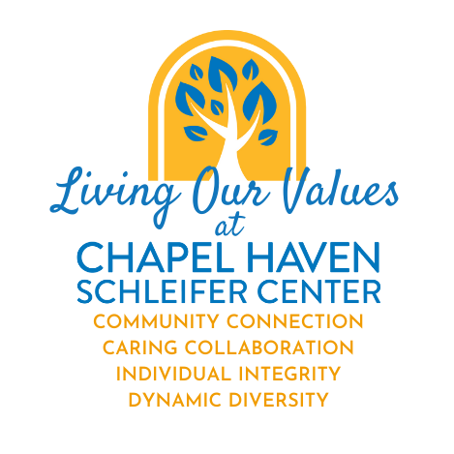

Living the Values at CHSC

Nomination Form

Thank you for taking the time to nominate a CHSC staffer who you have observed “living the core values” at CHSC. We are indebted to the Diversity Council for developing our vision and values and undertaking this staff recognition program to recognize all the good work our staff are doing. Please use this form to make your nomination and return it to Catherine Sullivan-DeCarlo at cdecarlo@chapelhaven.org.

Your Name (nominator) Click or tap here to enter text. Job Title Click or tap here to enter text.

Department Click or tap here to enter text. Phone Ext: Click or tap here to enter text.

Name of the staff member you are nominating Click or tap here to enter text.
Their Job Title Click or tap here to enter text.
Their Department Click or tap here to enter text. Their phone Ext: Click or tap here to enter text.

With this form, you are nominating a co-worker who you have observed “living” the core values at CHSC in a way that stands out as exemplary. Below we list the four core values. You can read specifics about each value here: https://www.chapelhaven.org/core-values/

We look forward to recognizing our amazing staff and spreading the word about the good work you do!

Looking at the Core Values described below, please list the core value that most embodies this individual’s actions and provide a short description of why you feel this was exemplary.
Click or tap here to enter text.
CHSC CORE VALUES

- Dynamic Diversity - We strive to continually create an inclusive community that is equally accessible to all.
- Seeking out staff & students who have varying experiences and abilities and honoring these differences
- Developing programs to educate and inform our students about diverse cultures and backgrounds.
- Taking the time to learn about different cultures, races, religions and backgrounds represented by your colleagues.

- Caring Collaboration - Together, we work hard compassionately.
- Tackling work challenges as a team, bringing people together to solve problems
- Applying efficiency, trust, empathy, positivity, clarity to a challenge
- Honoring requests for the individuals we serve
- Empowering individual served to live independent and self-determined lives

- Individual Integrity - We consistently do the right thing regardless of who is watching.
- Showing patience and flexibility, even when unexpected obstacles show up
- Creating a culture where it is safe for people to make mistakes and grow
- Demonstrating dedication to your work
- Respecting the views of others, even when you disagree

- Community Connection - We build connections within the Chapel Haven campus and beyond.
- Creating networks & partnerships in our host community that benefit all
- Creating bridges to community resources so that our adults may live a well-rounded life

