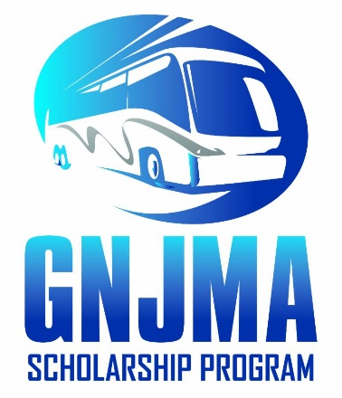
2022 Greater New Jersey Motorcoach Association Scholarship Program Application

The Greater New Jersey Motorcoach Association (GNJMA) Scholarships will be awarded to full-time employees, or the dependent children of full-time employees of GNJMA Operator Member companies. Also eligible are the employees of GNJMA Allied Members companies, or the dependent children of the Allied Member companies. The award will go to whom best meet the requirements set forth by the Scholarship Committee. Scholarship awards are limited to cover tuition and fees. Two annual scholarships will be awarded; one for GNJMA Operator Members and one for GNJMA Allied Members.

The Scholarship Committee will be authorized to review the applications blindly, i.e. without names, and make the selections. The Scholarship Committee will be appointed by the Board of Directors and will serve at the discretion of the Board. Our Executive Director, Pattie Cowley, will be the point-of-contact.

Criteria for Eligibility:
Those eligible to apply must:
- Have been employed for at least one year by January 1 in the year in which the scholarships are awarded.
- Already be registered to a full-time college, professional school or trade school in the previous fall or at the time of application.
- Hold a minimum Grade Point Average (GPA) of 3.0 or if a professional school, the equivalent of a B grade.
- The winners, or the parents of the winners, must still be employed at the member's company at the time the winners are selected.
(NOTE: Dependent applicants that will be first year students may apply. Enrollment will need to be validated before the award is given in October and final high school GPA will be requested.)

Application & Selection Timeframe:
- The Scholarship Committee will accept applications between January 1 and March 1.
- The applications will be reviewed by the Scholarship Committee before the Annual Association Member Meeting.
The winners will be invited to the Annual Association Member Meeting in the fall. While they may not be able to be present, a representative from the member company must be present to receive the scholarship.

Please mail or email completed applications to:

Patricia A. Cowley, Executive Director
Greater New Jersey Motorcoach Association
PO Box 186, Washington, NJ 07882
Phone: 908-750-4538
Email: pcowley@gnjma.com

2022 GNJMA Scholarship Application Form
1. | Choose which type of GNJMA Company you are applying from:
Operator companies that own or operate motorcoaches (employee or dependent child)
Allied companies that do not own or operate motorcoaches (employee or dependent child)

2. | GNJMA Member Organization Name:
If you are a dependent of a GNJMA Member organization employee, please let us know who referred you by answering questions 3 and 4 below. If you are an employee, you can skip these two questions.
3. | First and Last Name of the person who referred you:
4. | Work email address of the person who referred you:
5. | Scholarship Applicant Name:
6. | Scholarship Applicant  Street Address  City, State, Zip Code:
7. | Scholarship Applicant Phone Number:
8. | Scholarship Applicant Email Address:
9. | Are you a U.S. Citizen? |  | Yes |  | No
10. | If you are not a U.S. Citizen, are you a permanent resident? |  |  |  |  |  | Yes |  | No |  | N/A I am a U.S. Citizen
11. | What is your cumulative GPA based on 4.0 weighted scale?
12. | Extracurricular Activities: (Include sports, clubs, offices held in school.)
13. | Community Activities: (Include church and community activities.)
14. | What is your degree plan AND why did you choose this plan?
15. | Anticipated date of Graduation (mm/dd/yyyy):
Applicant’s Signature/Date:

All spaces must be filled in. Use N/A if appropriate. DEVIATION FROM INSTRUCTIONS MAY RESULT IN DISQUALIFICATION!

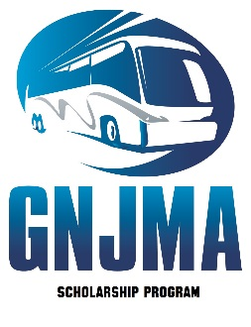
Scholarship Applicant’s Name: ___________________________________________________

Essay: What are your goals and objectives in college, and what are your career plans after college or trade program? Please print legibly.

Goals and Objectives:
Career Plans after College or Trade Program:

