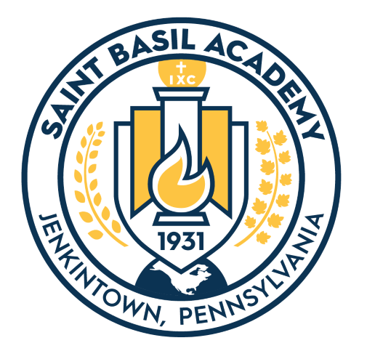

September 26, 2019
Dear Freshmen and Freshman Parents/Guardians:
We are very happy that you have joined our SBA family, and hope the school year is developing nicely for you!
Every year, the first Sunday in October is dedicated to the Annual Pilgrimage to the Mother of God on the grounds of the Sisters’ Motherhouse across the street from our school.
This year’s annual Pilgrimage will be held on Sunday, October 6, 2019. We are asking the Freshmen to attend one part of this Pilgrimage: the Moleben, to be held at 4:00 pm at the Grotto. It is a beautiful service to the Blessed Mother. This gives the Freshmen an opportunity to become acquainted with the Sisters and with the rituals of the Eastern rite of the Ukrainian Catholic Church. It also gives the community an opportunity to see the wonderful girls that are part of Saint Basil Academy.
Enclosed is a schedule for the day. We welcome all families who would like to spend more of the day with us, but particularly ask the freshmen to come on Sunday, October 6 for the Moleben. All freshmen should meet, in SBA uniform with blazer, by the Convent, near the statue of Saint Basil, at 3:30 pm. We will process down to the grotto and take part in the service. (After the service, it would be great if the girls could stay for 10 more minutes to just help fold up the chairs – that usually goes quickly).
Please contact me if you have any questions. We look forward to seeing you on Sunday, October 6.
Best regards,
Alexandra Penkalskyj
Alexandra Penkalskyj
Assistant Principal 215-885-3771 ext. 113 apenkalskyj@stbasilacademy.org

