

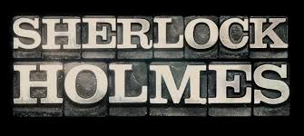

Come watch Drama Club’s Winter Production of Sherlock Holmes!

When: Friday, Dec. 1st- 6pm
Saturday, Dec. 2nd- 6pm
Doors open at 5:30

Where: Cicero Prep Gym


Tickets: For sale the week of Nov. 27-Dec. 1 during lunch and lyceum (for a discount), and at the door


