

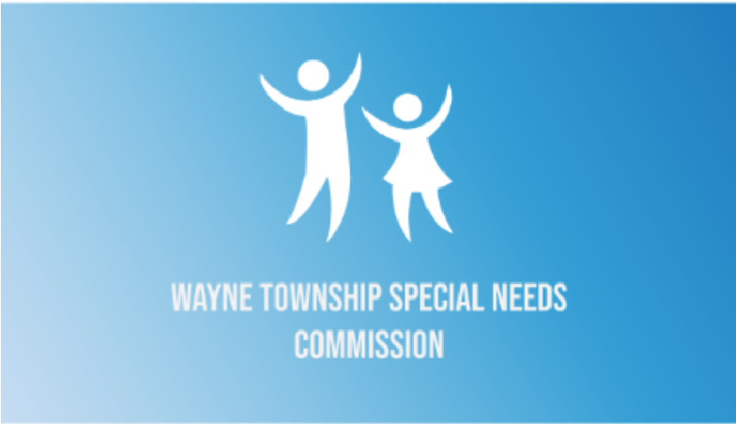
WAYNE TOWNSHIP MAYOR CHRISTOPER VERGANO
AND WAYNE TOWNSHIP SPECIAL NEEDS COMMISSION
Invite

Families of loved ones with
Intellectual and Developmental Disabilities (I/DD)
to meet

Lisa Montalbano, NJ Ombudsman

Ombudsman’s roles include severing as a source of information for individuals with I/DD and their families, supporting navigation of the process for obtaining services and supports from the Department of Human Services and the Department of Children and Families, educating and acting neutrally and objectively to support dispute resolutions, and identifying patterns complaints and relevant improvement strategies and more.
Ms. Montalbano served as the Chief Executive Officer of Employment Horizons, focused on employment opportunities for individuals with intellectual and developmental disabilities.
During this time, Ms. Montalbano cultivated relationships across the I/DD community and with families throughout the state.

When: Wednesday, October 28, 2026
Time: 7 P.M.
Where: Wayne Community Center
1 Pike Dr. Wayne, N.J. 07470

The Special Needs Commission seeks to create a more inclusive community for individuals in
Wayne with special needs and their families by promoting acceptance and awareness through advocacy, creating social and educational programs, and providing access to local resources to enhance their quality of life.

