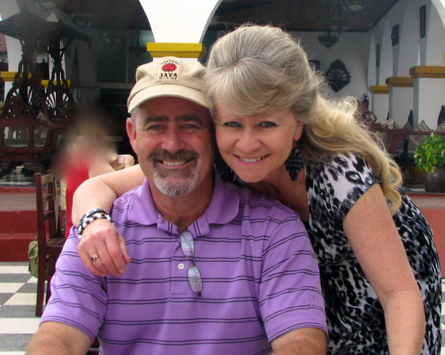
Vernon and Mary Smith
P.O. Box 15178; Arusha
Tanzania, East Africa
vsmithtanz@gmail.com

--------------------------------------------------------------------------------------------------- Greetings A-Town readers March 1, 2021

Hello Everyone,
Greetings once again from Arusha Tanzania! We trust that you are well and safe. THANK YOU for your prayers and thoughts for us in the ministry here. While there are always challenges to consider, please rejoice with us for the answers to prayer listed below.

1 - Oloirien Community Clinic - unjust tax situation. After paying the initial fees of $20,600.00, the Tax people demanded another $20,600 before our case could even be heard. The answer to prayer is that this has been put on hold. The second part of the answer to prayer is that we have had the opportunity to breathe from an administrative point of view, AND the clinic has continued to operate without interruption. In fact, beginning the third week of January, the clinic has been inundated with people seeking good medical care...and they have received it!
*Please continue to pray that "when" our case is heard, that it will be received with favor, and that "reason" will win concerning the unjust tax liability placed upon the clinic.

2 - We are rejoicing that my (Vernons) final year work permit was approved. Mary's was deferred, meaning that they wanted a few more documents from us for her. That has been done, and we are now waiting for the answer, hopefully approval. In the event that hers would not be approved, it means that she would have to be my dependent and therefore not be as visible in the leadership of womens and childrens ministries of our churches.
*Please continue to pray that the "Exemption request" would be granted, which would allow us to stay beyond the final one year."

3 - Sunday after Sunday we continue to travel to churches and minister. Yesterday, we had the privilege of being in a church in "the bush." Widson and Flora have labored faithfully under the harshest of conditions. There were 32 adults and as many kids. For where they are...this is like a mega church! ha. At the invitation time, one young lady of 18 years of age, accepted Christ as her Savior.
*Please continue to pray for the door of the Gospel to remain open, and for our pastors and leaders to be diligent in the great commission of evangelism and discipleship.
"We couldn't do what we do, if you didn't do what you do!"
God bless you and give you a wonderful week.
Vernon and Mary

“We couldn’t do what we do, if you didn’t do what you do!”
The Smiths

