Candidates for
Independent Nuclear Expert Panel
Panel Biographies

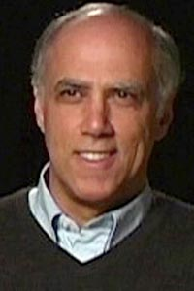
Daniel Hirsch, UCSC Director of Nuclear Policy
Daniel Hirsch is currently Director for the Program on Environmental and Nuclear Policy at UC Santa Cruz. His lifelong work has been aimed at revealing and correcting government misconduct in the control of nuclear and related hazardous materials that pose significant threats to public health and security if not carefully regulated. He has been exposing the cozy relationship between government and polluter, in the process creating significant public pressure to alter the associated policies that place the public’s health at a very low priority. And he has been winning, victory after victory in these fights – wins that have national implications.

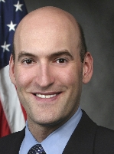
Gregory Jaczko, Former Chairman of the Nuclear Regulatory Commission
Mr. Jaczko was first sworn in as a Commissioner of the U.S. Nuclear Regulatory Commission (NRC) on January 21, 2005. On May 13, 2009, President Obama designated him the organization's Chairman. During the Fukushima crisis, Chairman Jaczko recommended that Americans evacuate 50 miles outside Fukushima. He cast the dissenting vote on plans to build the first new nuclear power plant in more than 30 years. He cited safety concerns stemming from Japan's 2011 Fukushima nuclear disaster, stating, "I cannot support issuing this license as if Fukushima never happened.” His pro-safety stance caused much friction with the other commissioners, resulting in his departure from the NRC.

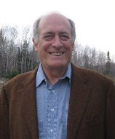
Peter A. Bradford, former Commissioner on the NRC
Peter Bradford served on the NRC during the Three-Mile-Island Nuclear Accident. He is the former chair of the Maine and New York utility commissions. He teaches energy policy and law at the Vermont Law School and has taught at Yale School of Forestry and Environmental Studies. Mr. Bradford argues that nuclear power is not a magic-bullet answer to climate change. In an early-2010 interview, with President Barack Obama's fresh budget proposal to triple available loan guarantees, to $54 billion, for nuclear power plants, Mr. Bradford made clear he was not a total opponent of more nuclear.

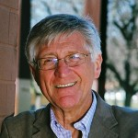
Arnie Gundersen, Chief Engineer, Fairewinds Associates
Arnold "Arnie" Gundersen is chief engineer of energy consulting company, Fairewinds Associates. Arnie Gundersen has 40-years of nuclear power engineering experience. He attended Rensselaer Polytechnic Institute (RPI) where he earned his Bachelor Degree cum laude while also becoming the recipient of a prestigious Atomic Energy Commission Fellowship for his Masters Degree in nuclear engineering. Arnie holds a nuclear safety patent, was a licensed reactor operator, and is a former nuclear industry senior vice president. During his nuclear power industry career, Arnie also managed and coordinated projects at 70-nuclear power plants in the US.

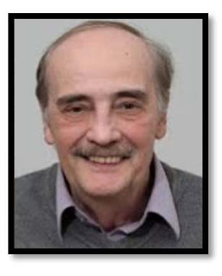
Bob Alvarez, a senior scholar at the Institute for Policy Studies
Robert Alvarez served as senior policy adviser to the Energy Department's secretary and deputy assistant secretary for national security and the environment from 1993 to 1999. During this tenure, he led teams in North Korea to establish control of nuclear weapons materials. He also coordinated the Energy Department's nuclear material strategic planning and established the department's first asset management program. Alvarez helped found and direct the Environmental Policy Institute, a respected national public interest organization. He also helped organize a successful lawsuit on behalf of the family of Karen Silkwood, a nuclear worker and active union member who was killed under mysterious circumstances in 1974.

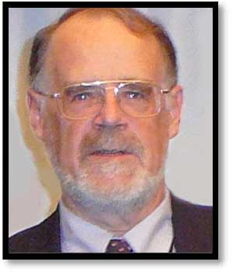
Gordon Thompson, Executive Director of the IRSS
Gordon Thompson is the executive director of the Institute for Resource and Security Studies (Cambridge, Massachusetts) and a senior research scientist at the George Perkins Marsh Institute, Clark University (Worcester, Massachusetts). He studied engineering at the University of New South Wales, practiced engineering in the electricity industry in Australia, and then received a doctorate in applied mathematics from Oxford University in 1973, for analyses of plasma undergoing thermonuclear fusion. His professional interests encompass a range of technical and policy issues related to sustainability and global human security. He has conducted numerous studies of commercial and military nuclear facilities, addressing environmental and social impacts, security, economics, and other issues.

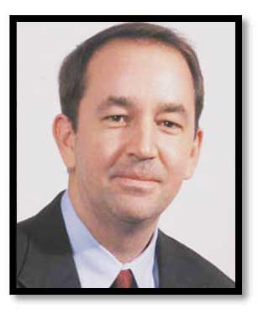
Geoffrey H. Fettus, NRDC Senior Project Attorney, Nuclear Program
Geoffrey H. Fettus is a senior project attorney for NRDC's nuclear program. His litigation and advocacy work focuses on the beginning and end of the nuclear fuel cycle, including issues associated with uranium mining and radioactive waste disposal. A graduate of the University of Wisconsin Law School and Haverford College, Geoff worked as an assistant attorney general in New Mexico and for a public interest law firm in New Mexico before joining NRDC in 2001.

