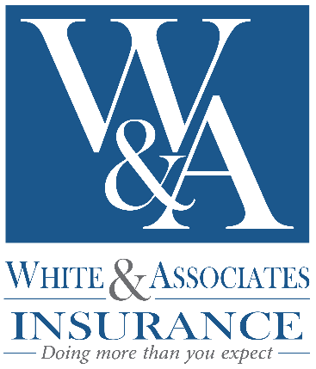
Media Contact:
Cate Robertson
White & Associates Insurance
731-288-3534
cate.robertson@whiteins.net

FOR IMMEDIATE RELEASE

White & Associates Insurance Named in Business Insurance’s Annual

Best Places to Work in Insurance
Award Recognizes Outstanding Employers in the Insurance Industry

UNION CITY, TENNESSEE, November 13, 2017 – White & Associates Insurance (www.whiteandassociates.net) today announced it has been named the 28th Best Place to Work in the annual Best Places to Work in Insurance program, which recognizes employers for their outstanding performance in establishing workplaces where employees can thrive, enjoy their work and help their companies grow.

“With an estimated over 38,000 independent insurance agencies in the country, it is truly an honor to be named one of the Best Places to Work,” said White & Associates chief executive officer Larry White. “We are fully committed to creating a company culture that is employee centric and customer driven. I believe this recognition is a direct result of our commitment to the success, health and well-being of our employees and their families.”

“Being named to Business Insurance’s list of the Best Places to Work in Insurance for 2017 demonstrates that White & Associates has built a culture in which employees are supported and engaged, which benefits their customers and the employers’ financial performance,” says Business Insurance Publisher Peter Oxner.

White & Associates offers a variety of programs to encourage employee community involvement, peer collaboration, career development and healthy living. The company has developed rewards programs for both serving in the community and living a healthy lifestyle. White & Associates most recently created a community program, Referrals for a Cause, which allows the employees of White & Associates to select local nonprofits to support throughout the year. The agency donates ten dollars to the selected nonprofit for every customer insurance referral an employee receives. The employees of White & Associates have raised more than $7,000 for local organizations that are important to them.

Best Places to Work in Insurance is an annual sponsored content feature presented by the Custom Publishing unit of Business Insurance and Best Companies Group that lists the agents, brokers, insurance companies and other providers with the highest levels of employee engagement and satisfaction. Harrisburg, Pa.-based Best Companies Group identifies the leading employers in the insurance industry by conducting a free two-part assessment of each company. The first part is a questionnaire completed by the employer about company policies, practices and demographics. The second part is a confidential employee survey on engagement and satisfaction.

The program divides employers into the categories of small, 25-249 employees; medium, 250-999 employees; and large, 1,000 or more employees. This year’s report features 75 companies of various sizes, from 25 employees to more than 4,000.

-more-

White & Associates Best Places to Work/Page 2

Established in 1976, White & Associates Insurance is a locally owned and operated insurance agency with 12 locations in West Tennessee and Missouri. White & Associates strives to provide a “doing more” approach to all aspects of operation including enhancing employee job satisfaction, providing clients with innovative insurance packages and improving the communities in which they serve. To learn more about White & Associates, visit one of their local agencies or whiteandassociates.net.

Business Insurance is the authoritative news and information source for executives concerned about risk and the impact on their business. With information for risk managers, insurers, brokers and other providers of insurance products and services, Business Insurance delivers in-depth analysis on new and emerging risks, case studies of successful programs, market intelligence on trends, and guidance on how to capitalize on opportunities and overcome challenges.

In addition to a monthly print magazine, Business Insurance provides essential news via its website, BusinessInsurance.com; daily and weekly e-newsletters; and breaking news via email news alerts. To subscribe, please contact Business Insurance at info@businessinsurance.com.

Best Companies Group works with partners to establish “Best Places to Work,” “Best Companies,” and “Best Employers” programs on a national, state-wide and regional basis. Through its thorough workplace assessment using employer questionnaires and employee satisfaction surveys, Best Companies Group identifies and recognizes companies that have been successful in creating and maintaining workplace excellence.

###

