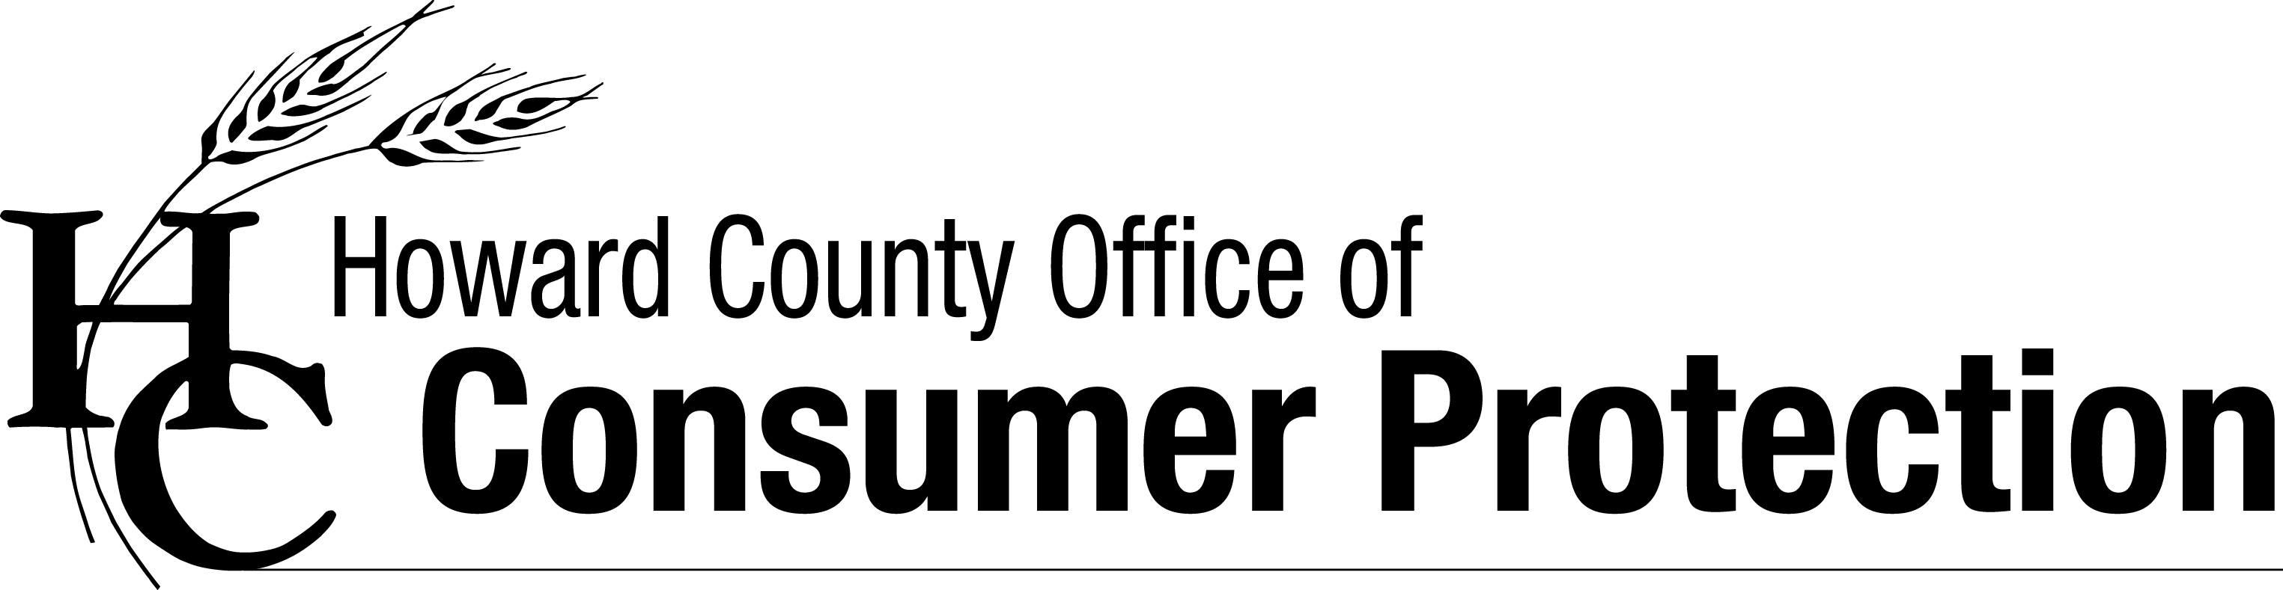
5 Tips to Make Your Tax Time Less Taxing
FILE EARLY - Identity thieves try to steal money from the IRS by filing returns using stolen social security numbers. This also results in a lot of hassle and delayed refunds for tax payers. By filing early, you can reduce the odds of becoming a victim.
CHECK OUT YOUR PREPARER - All tax preparers, whether working individually or as part of a national tax preparation chain, must be licensed by the Maryland Department of Labor, Licensing, and Regulation. Make sure your preparer is properly licensed by going to DLLR’s web site: http://www.dllr.state.md.us/pq/. In addition, ask about fees. Some tax preparers do not fully disclose all their fees up front. So to avoid surprises, ask for a list of all charges and potential fees before your taxes are prepared.
AVOID REFUND ANTICIPATION LOANS - Many tax preparers offer to provide your refund immediately in the form of a refund anticipation “loan” (aka Refund Anticipation Check). If you take this option, however, fees and interest on that loan will be deducted from your refund. Instead, choose to get your refund directly deposited into your bank account. The deposit is usually made in just a few days, and you will get the full amount of your refund.
STAY ALERT FOR IRS IMPOSTERS - The IRS does not call taxpayers who owe back taxes. Hang up on callers who claim that you will be jailed or imported if you don’t immediately pay money using credit cards, prepaid debit cards, gift cards, back account debits or wire transfers.
GET HELP - If you made less than $53,000 in 2014 and need assistance with tax preparation and filing, you can obtain free tax preparation services through:
- Making Change – this Howard County non-profit organization offers free tax prep and filing through its Volunteer Income Tax Assistance (VITA) Program. Visit www.makingchangecenter.org or call 410-880-5917 for details.
- AARP Tax-Aide Program offers its services at a number of 50+ Centers and other locations around the County. Visit www.aarp.org/taxaide for more information.

While you can’t avoid paying your taxes you can take steps to avoid being taken by con artists who falsely offer tax preparation assistance, pretend to be IRS employees or steal your identity to claim a refund in your name. Learn how by visiting the Howard County Office of Consumer Protection’s website at: www.howardcountymd.gov/consumer.

