How to register on the MAC website, micounties.org

Step 1
Point your Web browser to www.micounties.org. (Be sure to bookmark it while you are there, too.)

Step 2
Click on “Member Login” button. (See image below)
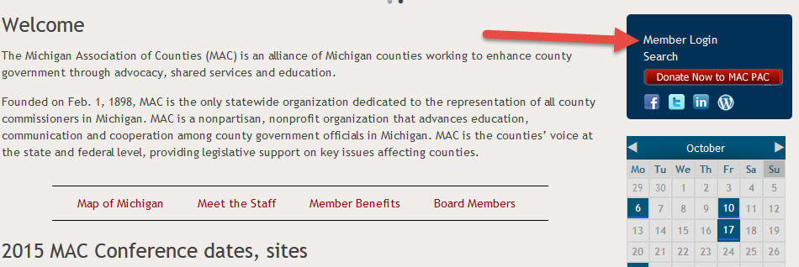

Step 3
Click on “Don’t have an account?” (See image below)
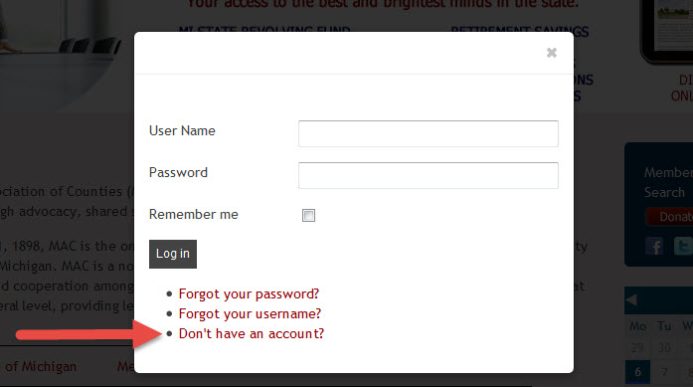

Step 4
Fill out all of the required information on the registration page. (Be sure to save your password somewhere so that you can always access your account.)

Step 5
Click “REGISTER” button.

That’s it. You will receive an email notification that your registration is pending activation. At that point, the system will alert me and I will activate your account.

