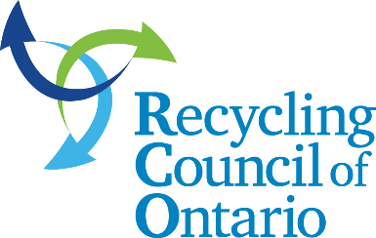
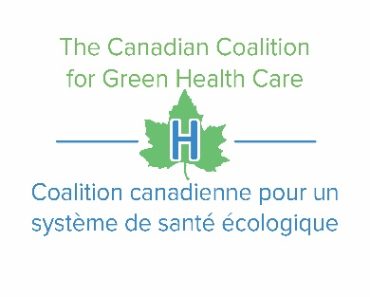
The Canadian Coalition for Green Heath Care (CCGHC) and the Recycling Council of Ontario (RCO) are pleased to announce the second in our series of collaborative webinars that examines resource efficiency and waste reduction in Canada’s health care sector

Updating Procurement Practices to Drive Diversion
Tuesday, June 27, 2018
11a.m. – 11 p.m.
Featured guest: Lisa James, President and CEO, Environmental Advisory Group Inc. (EAG), a boutique consultancy specializing in the healthcare field.
We are currently reaching out to health care sector stakeholders to gain an understanding of current procurement practices and how procurement is currently being used to drive waste reduction. Stakeholders we want to hear from, include:
- Drug Manufacturers/Distributors
- Hospitals
- Industry Associations
- Long-Term Care Facilities
- Non-Government Organizations
- Retailers
Please share your experience by June 6, 2018 to help improve sustainability in health care by responding to the following questions and sharing your responses with jodi@rco.on.ca and dan@greenhealthcare.ca. Your feedback will help us develop content for our next webinar:
- Does your organization use procurement to influence sustainability? If yes, how?
- What does ‘sustainable procurement’ mean to you?
- What are some of the obstacles to linking procurement with sustainability?
- Has your organization implemented some kind of sustainable procurement strategy? If yes, what outcomes have you achieved?
- Does your company have a specific policy outlining desirable sustainability procurement practices? If yes, do new employees get introduced and/or trained on how to apply the procurement policy to their role in the organization?

Sponsorship Opportunity
If your organization has strong ties to the Canadian health care sector and/or would like to improve your visibility, our second collaborative webinar presents a unique opportunity to support sustainability efforts while aligning your organization with our webinar series. To learn more about sponsorship opportunities, please contact jodi@rco.on.ca. Sponsors also have an opportunity to speak during the webinar if their subject matter expertise aligns with topic discussions. We look forward to hearing from you. Please express your interest by June 6, 2018.
Future Webinars
- Food and food waste – In October during Waste Reduction Week
- Auditing and meeting compliance – At the end of November

Webinar 1 – April 24, 2018
On April 24 we held our first collaborative webinar: Mercury, Lamps, Recycling, and Retrofits, where we highlighted why organizations should recycle mercury-containing lights, how health care facilities can drive waste reduction through procurement, and provided an overview of the many financial opportunities for stakeholders including rebates, partnerships, regulations, and developments within the marketplace. More than 75 stakeholders from across Canada joined the webinar, and their feedback was extremely positive.

Message from Previous Sponsor – Mercury, Lamps, Recycling and Retrofits Webinar
“It was a pleasure to work with RCO and CCGHC on the Mercury, Lighting and Retrofits webinar. We were able to connect with healthcare facilities across the county and raise awareness of the benefits of switching to more energy efficient lighting, while increasing recognition of Lighting Plus Wholesale as a committed partner to meeting lighting needs”. Frank Hunt, President, Lighting Plus Wholesale.

