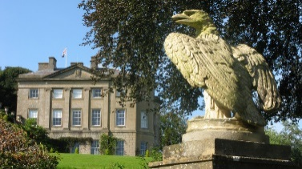
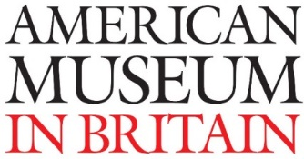
Pathways into Volunteering
Mentored Induction into Volunteering
Information for participants

This opportunity is for people who are interested in developing the confidence, knowledge and skills to become Museum volunteers. People with lived experience of mental health issues, social isolation or homelessness are invited to apply.
The American Museum in Britain is the only museum devoted to American decorative arts outside of the United States. It has a remarkable collection of textiles, Native American pieces, folk art, and furniture, many of which are displayed in period rooms, as well as extensive gardens.
We have over 150 volunteers who run events, welcome and guide our visitors, and look after the collection. Our volunteers are at the heart of the Museum’s work. Volunteering at the American Museum provides many opportunities for personal and professional development, whether learning new skills, meeting people or working as part of a diverse team.
Mentored Induction into Volunteering
What will you do?
- Be paired with a trained mentor who is an experienced museum volunteer
- Meet weekly with your mentor at the American Museum
- Complete a creative project (with the support of your mentor) – researching an object or area of the collection you are interested in
- Have access to museum records and archives to help you find out about the collection
- Have time with an artist to help you think about the collection creatively
- Prepare a short tour or presentation on your chosen area and present this at a celebration evening
The course will run between 26 September and 10 November 2017.
Once you have successfully completed the course you will be awarded a certificate and will have the opportunity to join the regular American Museum volunteering team.
For more information contact: Louise Campion Learning and Community Engagement Officer
Direct line: 01225 388566
l.campion@holburne.org

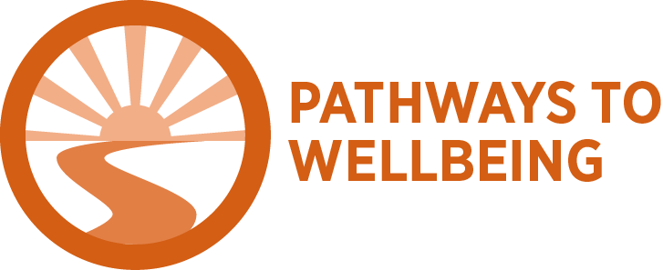

Pathways into Volunteering: Application Form
Details of person applying (these will be treated as confidential)
First name: _____________________ Surname:_______________________
Address: ______________________________________________________________
Post code: ________________________
Telephone: ___________________ E-mail: _____________________
Date of birth: ___ / ___ / ___
Do you have a key worker/ support worker who you would be happy for us to contact?
Name: ______________ Service: _____________ Contact number/e-mail ___________

How did you hear about Pathways into Volunteering?

We have a responsibility to provide a safe and supportive environment for all our volunteers, staff and visitors. Is there anything we should know that would help us (and your mentor) to support you? (e.g. disabilities, additional needs)

Is there anything else we should know that would affect your participation in this project? (e.g. anxiety/ depression/ drug use) This will be treated as strictly confidential.

Help with transport/ transport costs may be available, please tick the box if you’d like to know more

Emergency contact:
This is the person we will contact in an emergency. (This could be your support worker, family member or friend)
Name: Contact details: (include a telephone number)
Relationship to you:

What knowledge, skills or experience would you like to gain as a result of participating in Pathways to Volunteering?
____________________________________________________________________________________________________________________________________________________________________________________________________________________________________________________________________________________________________________

Before the course starts-
Please think about what you hope to gain from participating in this project.
Through this project I would like to: | Yes | No | Not applicable
Increase my skills
Increase my knowledge
Increase my confidence
Increase my sense of relaxation
Feel less worry or anxiety
Increase my sense of motivation
Increase my energy and feel less tired
Feel less lonely or isolated

Please e-mail or send completed application form to:

Jon Ducker
Jon.ducker@americanmuseum.org

Visitor Experience Manager
The American Museum in Britain
Claverton Manor
Bath BA2 7BD

Office Use DATE RECEIVED

