Click here to take the FREE ONLINE ETHICS CLASS from NAR
Click on Code of Ethics NON-CE Version FREE (blue box on right)

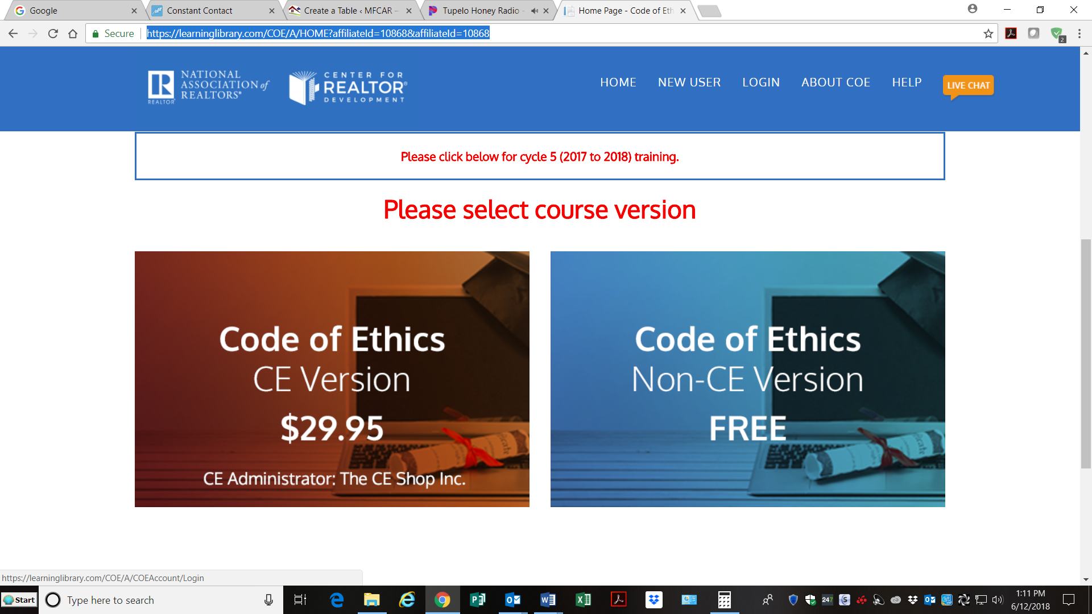
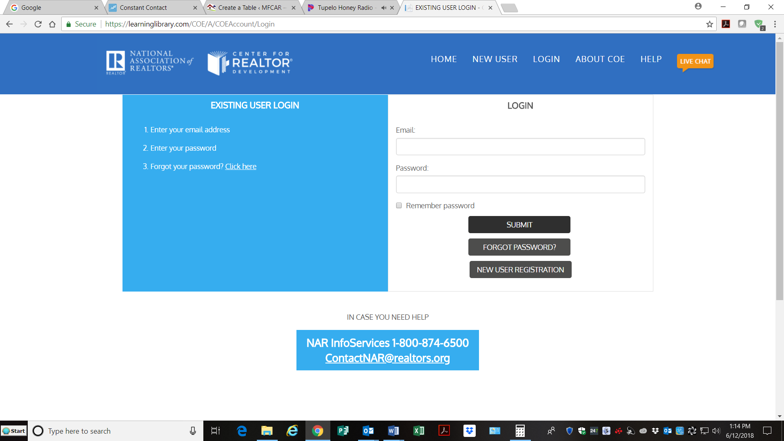
- New Users register for an account.
- Existing Users Login with your email & password.
- Issues with login call NAR InfoServices at 1-800-874-6500.

