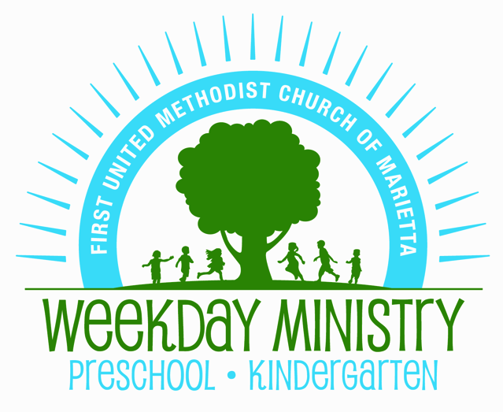
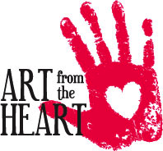
2018 Art From the Heart
Sponsor Levels

Masterpiece Sponsor $4,000
Customized Plaque
Promotional Material Displayed at Event
Special Recognition in Program
Eight event tickets

Canvas Sponsor $2,000
Promotional Material Displayed at Event
Special Recognition in Program
Six event tickets

Paint Sponsor $1,000
Special Recognition in Program
Four event tickets

Brush Sponsor $500
Special Recognition in Program
Two event tickets

Family Sponsor $100
Two event tickets

Auction Item Donated
Tax-deductible contribution
* All sponsor levels receive exposure to the entire school audience via our weekly internal “Friday Flyer” email where sponsor names/logos are displayed for the entire school year providing repeated exposure for your business.

Please return to the weekday office or e-mail weekdayafth@gmail.com. Thank you for your support of and generosity towards Weekday Ministry.

Name: ________________________________________________________________________________
Company: _____________________________________________________________________________
Address: ______________________________________________________________________________
City, State, Zip: _________________________________________________________________________
Telephone: __________________________________Email: _____________________________________
Level Preferred:
Masterpiece _______ Canvas _________ Paint ________ Brush __________ Family _________

Auction Item Donation: _____________________________________________________ Value: __________

