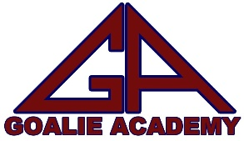
The Five Keys of Goaltending

In today’s world of modern goaltending, many goalies and goalie coaches alike tend to get caught up in the minute details rather than focusing on the fundamentals. The goal of this article is to provide the five most important aspects of stopping the puck.

Squareness
Goaltenders especially at an early age hear this all the time, “you’ve got to be square to the puck!” Although this seems extremely basic, I see goaltenders every day, who struggle with the concept. Being square to the puck means that you are keeping your nose to the middle of the puck, or in other words that you are keeping the puck between your shoulders. You must stay square to the puck by utilizing a shuffle; the distance of your shuffle depends on how much the puck moves side-to-side. The puck is always moving and changing angle. It is crucial that every time the puck moves, the goalie adjusts to that puck movement; you are always moving making minor adjustments. The other situation, where goalies often lose squareness, occurs when the puck carrier travels down the side. Many goalies often back up, which is a huge mistake. When you back up you are losing squareness and depth. Maintain your depth, pivot, and shuffle down the side keeping up with the players’ speed.

Depth
A goaltender’s depth is how far out of the crease they are. Depth does NOT depend on where the puck is. Depth is situational, and depends on the various threats in the zone and around our net. The visual below displays different situations, and where a goaltender should be based on those varying situations. Also, managing our depth is key. Many goaltenders do not understand the importance that each foot makes. Each foot that we come out places the goalie closer to the puck increasing the chance of the puck hitting us, which is a save nonetheless. If you watch professional and collegiate goaltenders, you will notice that they often begin the rush two or three feet out of their net depending on the situation, and are quick to regain depth when they are able.
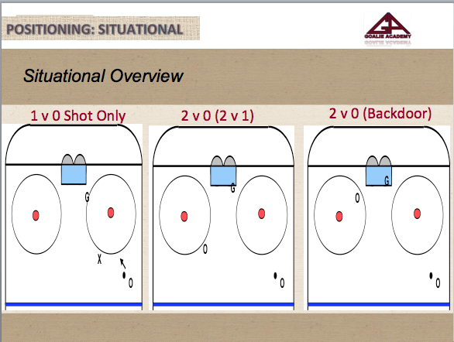

Awareness
Along the same lines of depth is awareness. Too many goalies are too focused on the puck. Be aware of the different threats. Is there a player backdoor? Is there a one-time option? Is there a player in front of the net? How do teams set up on the powerplay? These are important not only since you must adjust your depth according to the threat, but you also must communicate these threats to your teammates. When explaining awareness, I often compare it to a quarterback stepping back in the pocket and surveying their options. What if a quarterback had no awareness of the blitz or which receivers are open!

Tracking
Tracking the puck or simply watching the puck into your glove, blocker, stick, chest, etc. appears to be a no brainer. However, I cannot tell you the number of times I see a goaltender regardless of skill level struggle with this. Often times a goalie will not turn their head, watching the puck all the way into their save. The same holds true for any low shot as well. A goaltender must watch the puck as it travel towards them tucking their chin while looking down on top of the puck. As discussed in previous articles, the best way to improve your tracking abilities and to train your eyes is through various hand-eye exercises. Ask one of your Goalie Academy coaches about some hand-eye exercises.

Hockey IQ
The final key component to stopping the puck is overall hockey IQ. Hockey IQ is similar to awareness, but takes it a step further into the tactical side of goaltending. Hockey IQ in my mind equates to immersing yourself in the game and your overall knowledge of the game. Perhaps the most significant aspect of this is anticipation, or seeing the play before it happens, so that you are one step ahead of the play. Seeing different players moves, understanding varying situations, and what players tend to do in these situations. Is the player a lefty or a righty? Have they stopped skating? What is their blade showing? These are just a few examples of tactical awareness that a goaltender must notice. In order to be successful, you must become a student of the game. Watch more hockey not just limited to NHL, but NCAA as well. Watch the different tactics of these goaltenders and players. Immerse yourself in your craft!

I hope these five keys of goaltending help in the development of you and your goaltender. It is easy to get caught up in the small details of your game. However, take time to revisit these components especially as we enter playoff season. Making these minor adjustments can have a huge impact on your game!

Zack Minsk

