- The Tap Competition will be held Saturday, October 27, 2018 at 8:30 p.m.
- Competitors must be registered for the Festival.
- Judges for the Competition will be master tap dancers and professional artists.
- Categories and competition fees are:
Solo (1 performer) $15 per dancer
Duo/trio (2-3 performers) $10 per dancer
Group (4-8 performers) $10 per dancer
Production (9 and more) $ 5 per dancer
- Trophies will be awarded to the best performance in each category. Certificates and ribbons will be given to all participants.
- A $500 cash prize will be awarded to the “Best of Show” in the Junior and Senior divisions. Awards are given at the start of the Tapology Concert, Sunday, at The Whiting – 6:30 pm.

Performance Guidelines
- All participants must be registered for the festival.
- There are a limited number of entrees. Acceptance to compete in the Tap Competition will be on a first come first served basis.
- Performances will be judged on choreography, technique, staging, showmanship, costumes, musicality and originality.
- Each performance must be less than 3 minutes.
- All music must be submitted on ONE CD. Each CD and case must be labeled with:
    - Studio and or Group Name
    - Teacher’s Name
    - Choreographer’s Name
    - Number of each Track
    - Title of Each Track - Exactly as Registered • *Music must be received by the festival committee by Friday, October 26, 2018

Applications, music or money will not be accepted after the deadline -* NO EXCEPTIONS*

To Enter
- To reserve a space for your performance: Fill out a “Tap Competition Application – pg 2 of this form.” The application is also located on the website and included inside brochure mailings.

- Return the application to: By Mail: Or Email:
Tapology Festival tapman88471@gmail.com
Attn: Tap Competition copy to: sherrybradley@tapology.org
P.O. Box 5040 Flint Mi. 48505 Include both email addresses
- Applications will be accepted until Monday, Oct. 15, 2018
We reserve the right to stop taking applications earlier if the maximum numbers of entries are reached prior to October 09, 2017.

For any questions, please call 810-787-0197

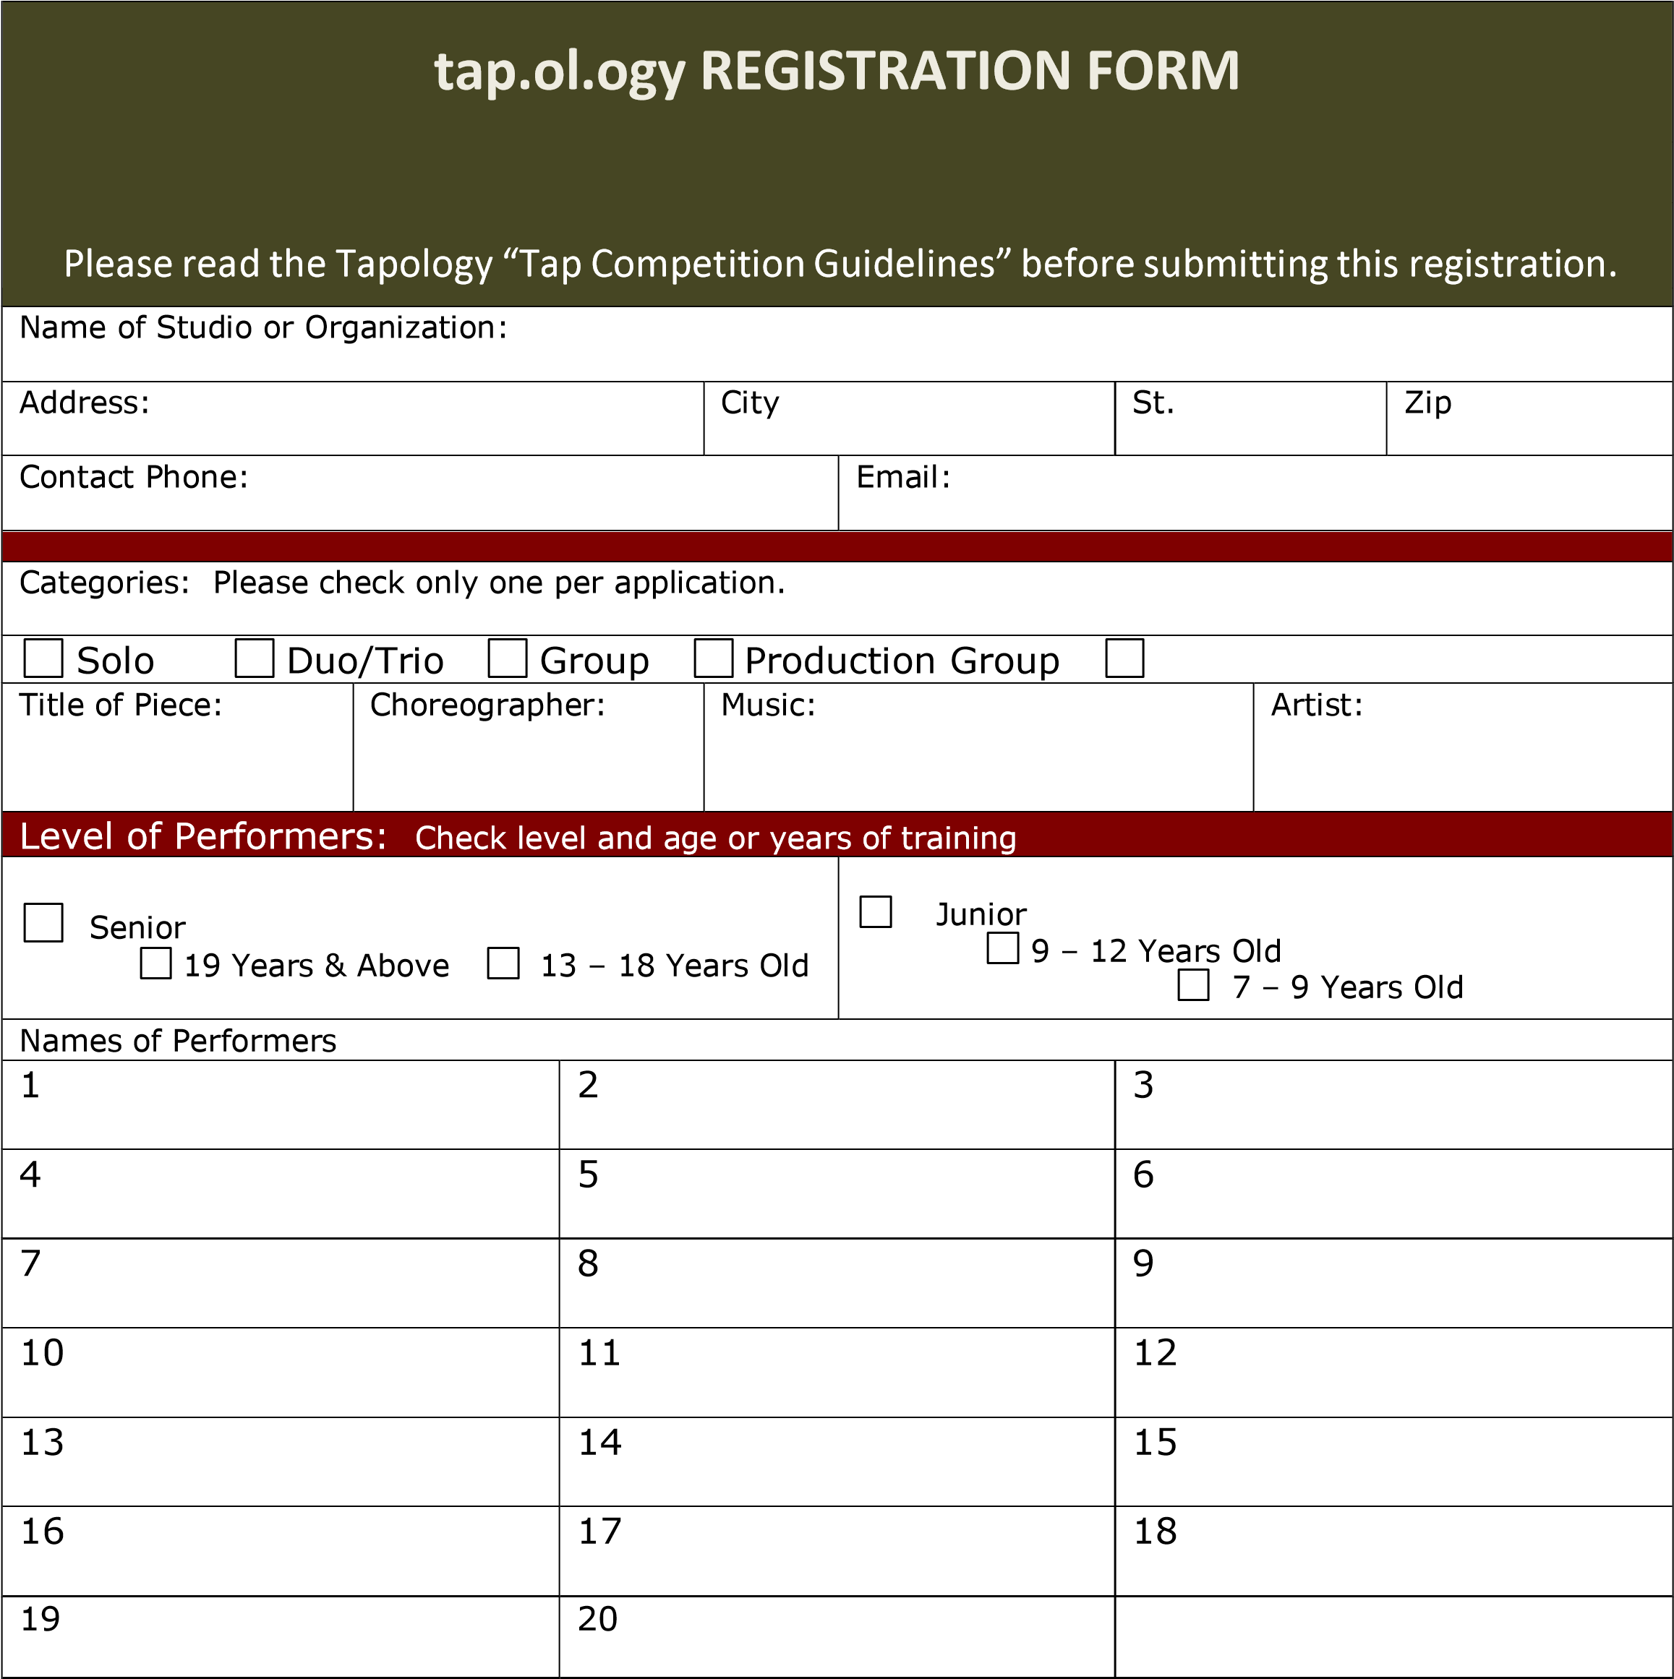
Keep a copy of all materials submitted to the competition!
PRINT form and mail to:
Tap Competition
Tapology
P.O. Box 5040, Flint, Michigan 48505

The Tapology web is located at: www.tapology.org
Deadline: October 15, 2018
Rev. 8 /2018

