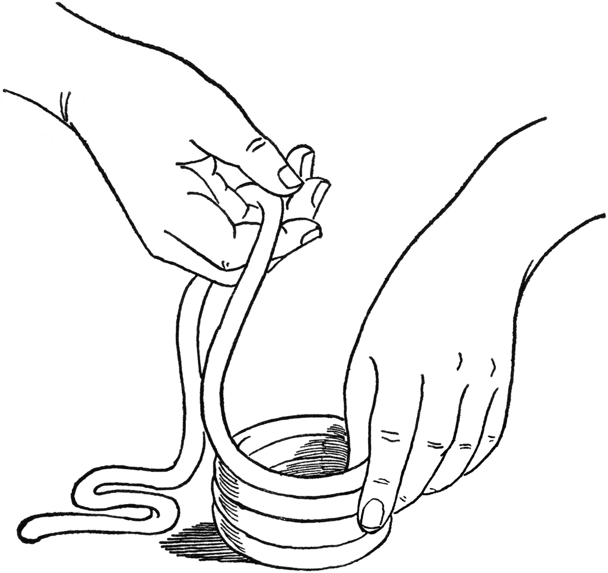
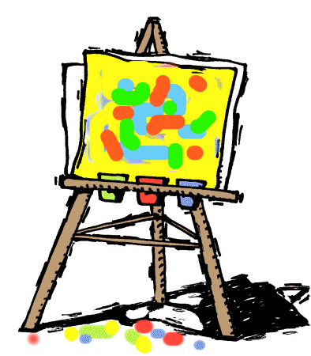
brams
A

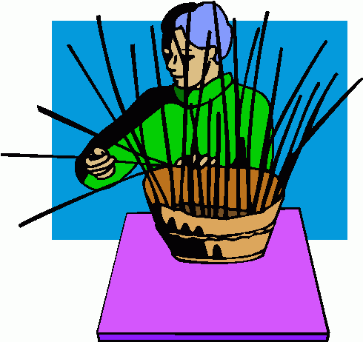
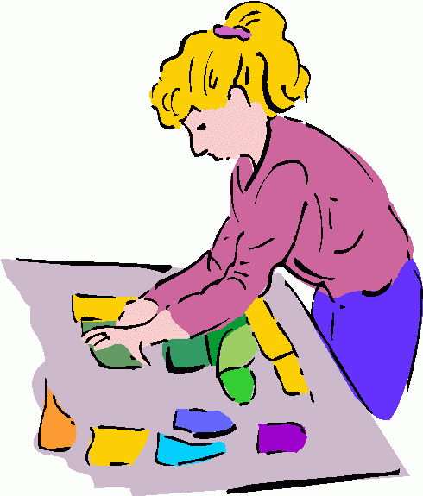
A
rt
A
fter-School
We will explore different medium such as clay, paper making, string art, painting, snow globes, beading, and weaving. We will work on projects that are impossible for me to do in a classroom setting. Smocks are highly recommended. Please send an extra snack with your child. For more information you can contact me at artdonnam@netscape.net or at (609)605-3073
Dates: Monday Afternoons (8 classes)
Jan. 22, 29, Feb. 5, 12, 26, March 5, 12, 19
Time: 3:30-5pm
Place: Abrams Hebrew Academy
Cost: $100
Registration Form
Name:________________________________________

Grade:___ EmergencyPhone #_____________________

Anything I need to know?

Make checks payable to Donna Moskowitz
Check out my website at artdonnam.wix.com/art-by-donnaor on Facebook at Art by Donna
By
Donna Moskowitz

