July 19, 2018

Dr. Howard Zucker
Commissioner
NYS Department of Health
Corning Tower
Empire State Plaza
Albany, NY 12237

Re: Setting Maximum Containment Level for Perfluorooctanoic Acid “PFOA” and
Perfluorooctanesulfonic Acid “PFOS”

Dear Commissioner Zucker and Members of the NYS Drinking Water Quality Council:

On behalf of the New York State Association of Counties (NYSAC) and the New York State Association of County Health Officials (NYSACHO), we respectfully request that the New York State Drinking Water Quality Council recommend the establishment of a MCL for 1-4 Dioxane, PFOA and PFOS and that the NYSDOH and NYSDEC establish an enforceable MCL.
Establishing a MCL for these chemicals is vital to protecting the health, safety, and welfare of New Yorkers. Exposure to 1-4 Dioxane, PFOA, and PFOS has been linked to kidney cancer, testicular cancer, pre-eclampsia, thyroid disease, developmental defects in fetuses, liver tissue damage, and immune system impairments, among other potentially life-threatening conditions. Additionally, a report recently released by the federal Agency for Toxic Substances and Disease Registry (ATSDR) finds that human health risks may occur at levels significantly lower than the current federal recommendations. ATSDR’s report recommends setting a MCL to protect the 16 million Americans in 33 states whose drinking water systems are contaminated by PFAS. New York State has an obligation to provide for the health and welfare of its own residents by setting a state MCL that limits exposure to these dangerous chemicals.
We recognize the significant efforts by New York State to address the dangers associated with these chemicals in our landfills, drinking water, surface water and environment. The Governor and affected agency commissioners are to be commended for their care and ongoing concern. Establishing an enforceable MCL is the logical next step for our state to take, as the federal government is not likely to establish a MCL in the near future, especially with the recent resignation by the US EPA Administrator Pruitt creating a bureaucratic obstacle.

Our border states have acted in this regard, and it is our hope that New York State will also act to keep New Yorkers safe.

Sincerely,
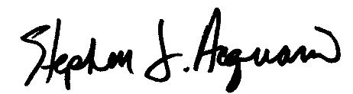
Stephen J. Acquario
Executive Director
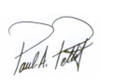NYS Association of Counties

Paul A. Pettit
President
NYS Assoc. of County Health Officials

Sarah Ravenhall
Executive Director
NYS Assoc. of County Health Officials

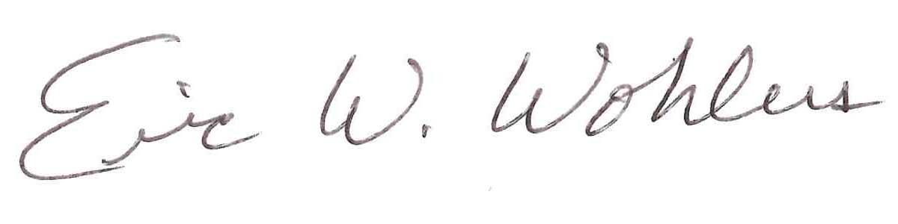
Eric W. Wohlers
President
NYS Conference of Environmental Health Directors

