DOCYouthVoice Newsletter

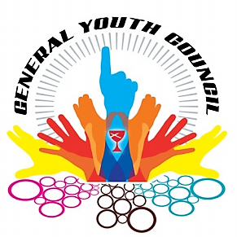The General Youth Council helps to plan, implement, and evaluate the total general youth ministry program for the Christian Church (DOC)

# **Benchmark goals**

1. Major youth events
2. Each cluster have a representative on GYC
3. Help set up regional youth councils where there is none.
4. Mission day
5. Increase number of applicants
6. Leadership curriculum/ leadership events
7. Actively maintaining social media accounts

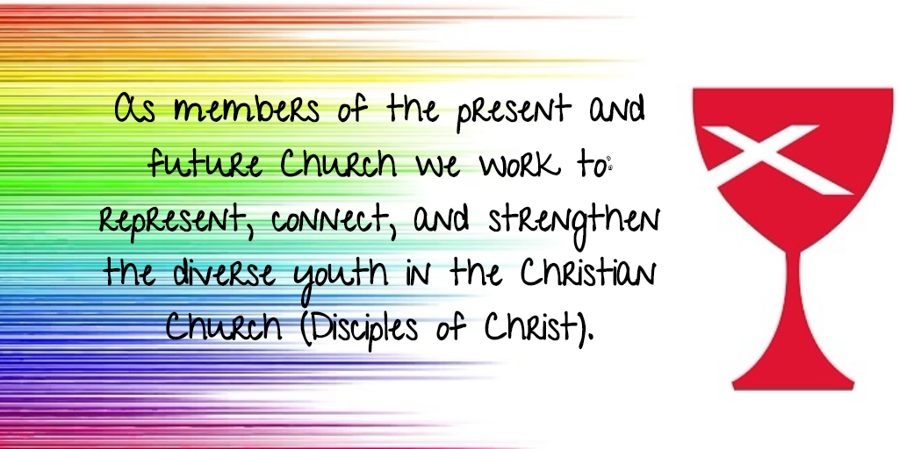

Who is The General Youth Council? Watch this video:

<https://www.youtube.com/watch?v=ho1YxzwEjxs&feature=youtu.be&a>=

**Who is The General Youth Council?**

**Adults:**

Born at a very young age in Norman, Oklahoma, Jeff Champeau is in his second year as a General Youth Council adult.  He is an IT Consultant and elder at First Christian Church in Norman and, in true Disciple fashion, has served on numerous congregational, regional, and general church committees.  Inspired by the wisdom, grace, and creativity of today's youth, Jeff values the opportunity to serve on GYC and is grateful for the leadership and passion he sees in his fellow GYC members in their service to God, church, and neighbor.

Stephanie Sager is a member of Saguaro Christian Church in Tucson, Arizona. She is currently studying at Eureka College in Eureka, Illinois where she is set to graduate with a Bachelor of Science in Psychology with a minor in Philosophy and Religion in May 2018. After graduation, she will be participating in the XPLOR program through the NBA. She loves singing, playing, and listening to music, knitting, reading, and is very excited to be working with the GYC as an adult sponsor for the 2018-2019 year!

Eliud currently a youth director for his church, Iglesia Cristiana Emanuel, and assistant director for The Hispanic Convention in the Southwest. He loves leading praise and worship with his band. He also is a trainer for The Anti Racism Pro Reconciliation Ministry in his area.

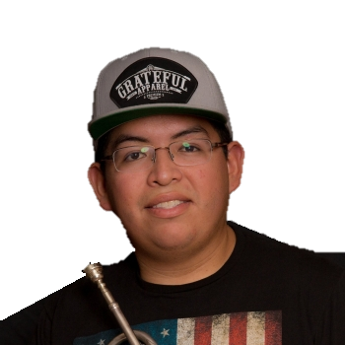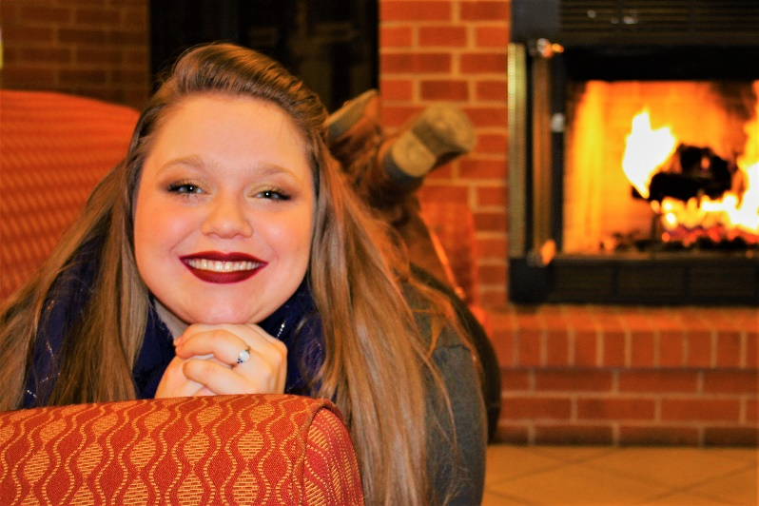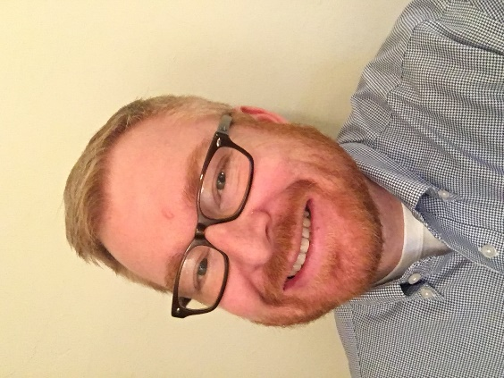

**Youth:**

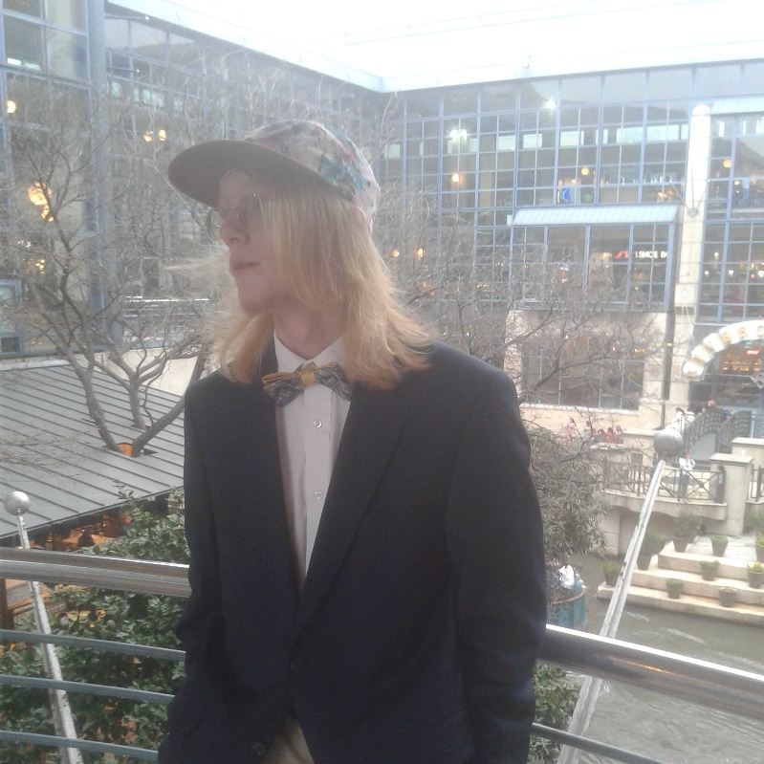

Emily is serving her second year on GYC this year. She is a Senior at her high school from Illinois in a small rural town. She is a very outgoing person who almost never has a free second during the school year. National Honor Society, Drama Club, Science Club, Key Club, Soccer, Bowling, and GYC are part of Emily’s everyday life. She is also a diaconate in her church that her father is the minister. Emily and her church family also put together a small community garden a few years ago that has made a difference in their small town. Her church is always trying to ways to improve their family as well as the community around them.

Blake is a member and section leader of his school's choir. He enjoys practicing guitar and listening to blues, folk, and classical music. His favorite subject is History, with Computer Science close behind. Blake is a member of his church's praise band and discipleship team, as well as a leader within his youth group. This is his second and final year on the General Youth Council.

Maddie Berry is 16 and lives in Fort Worth, TX. She is a member of the music honor society(Tri-M) at her school. She enjoys playing guitar and quilting with her grandma.

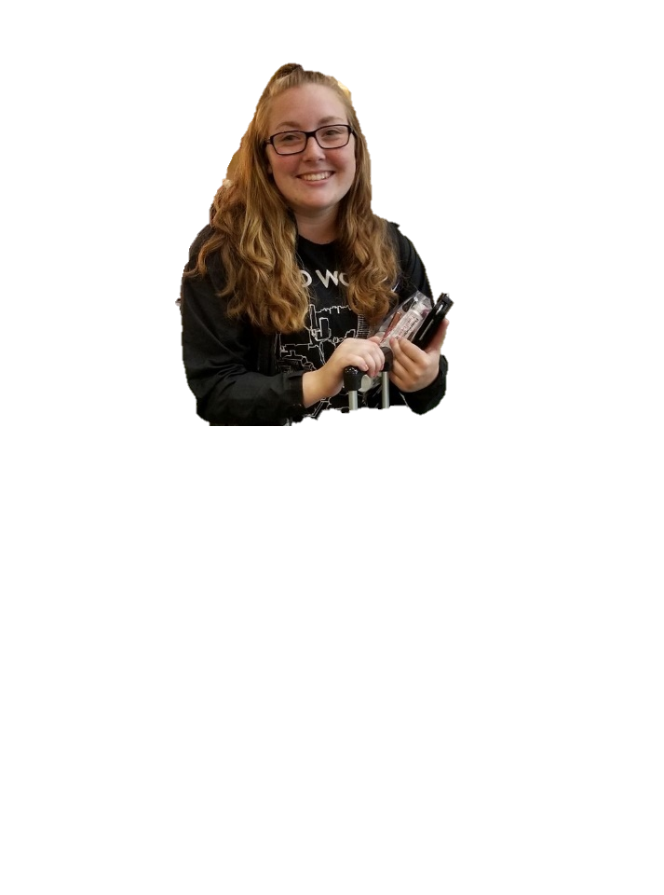**Youth:**

Kendall Weir is a Junior at West Albany High School. Her favorite activities in school are competitive cheer, soccer, and band. As an active member in her church, she is involved as a deacon, and as a member on various committees which better the church and her community. Kendall is excited to be a member on GYC to represent all Disciples of Christ youth. She has joined us from the Oregon and SW Idaho region.

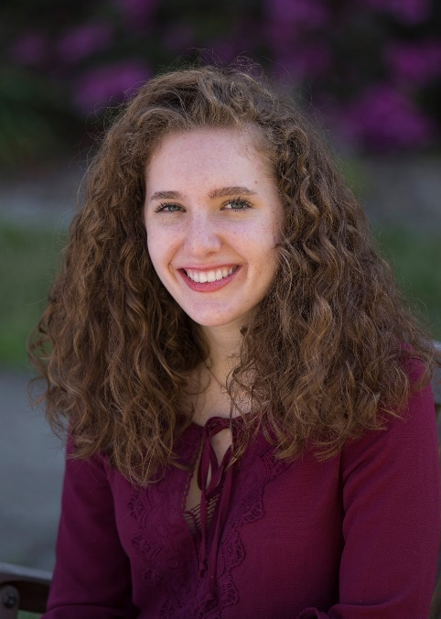

Sophie Won is a member of the Pacific Southwest region. She enjoys painting with watercolors, calligraphy, reading, and hanging out with her friends. Sophie also enjoys kickboxing and cooking. She helps out as much as she can at her church, Saegil Christian Church, with their mission projects and smaller youth group projects.

Katie Varon is a Junior at Douglas Anderson School of The Arts in Jacksonville, Florida. She is a Violinist, An Activist, and an animal lover. She attends Riverside Avenue Christian Church where she participates as a deacon, acolyte leader, and a member of the praise band. She is excited to be a member of GYC and to be able to be a voice for all DoC Youth.

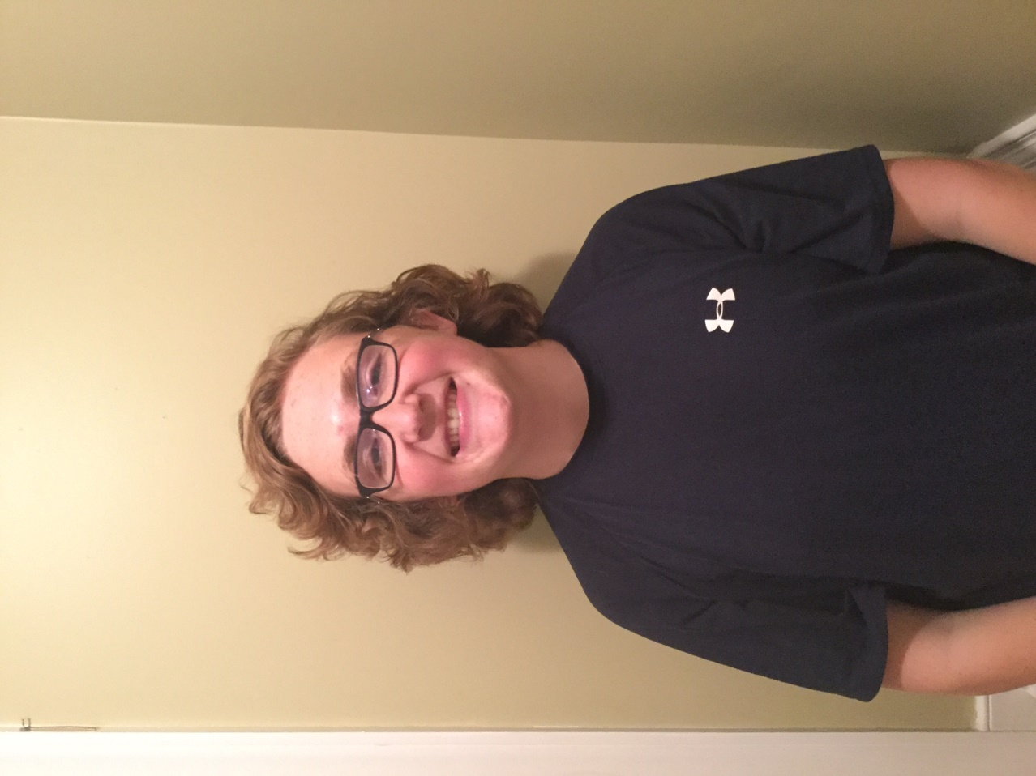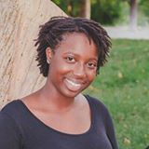**Youth:**

**Come Follow us on:**

**Instagram:** <https://www.instagram.com/docyouthvoice/>

**Facebook:**  <https://www.facebook.com/DOCYouthVoice/>

**Twitter:** <https://twitter.com/DOCYouthVoice>

Patrick McCarthy is 16 from Raleigh, North Carolina. Among his activities he enjoys are running both Cross Country and Track, Boy Scouts where he is a soon to be Eagle Scout and is an avid Boston Red Sox fan. He is actively involved in his church, both locally and regionally as he serves on the North Carolina RCYW. In his home church of Saint Paul's Christian Church in Raleigh. North Carolina he is an active member in the youth group and helps with anything from Sunday School for little kids to playing in the Hand Bell Choir. He looks forward to serving you all in the next few years as the current Vice Moderator of GYC.

Shalom Cobb is one of five new members of the General Youth Council for 2018-2019. She represents the North Carolina region. Shalom is from Charlotte, N.C and attends the North Carolina School of Science and Mathematics in Durham, N.C. Shalom is a member of Agape Christian Church in Columbia, S.C where her grandmother Rev. Susie H. Cobb is the pastor. Shalom is the daughter of Rev. Dr. Dara Cobb Lewis and Michael Lewis. Shalom is very involved with Christmount Christian Assembly participating in various retreats and attending as both camper and volunteer at summer camps. Shalom is also a member of her school's gospel choir known as Colors which serves the community through song and outreach.