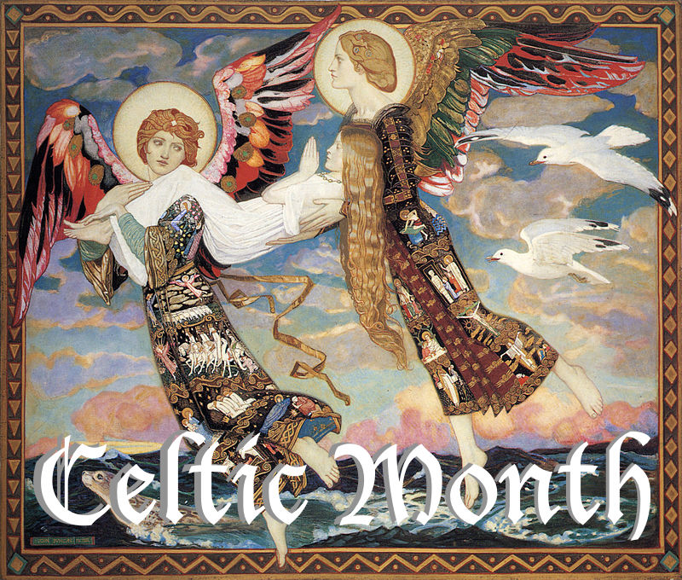
Saint Bride (1913) by John Duncan (National Galleries Scotland).

Celtic month at St Andrews: July 2018.

Throughout July St Andrews Episcopal church, Newcastle will be hosting a series of special service and events exploring Celtic Christianity. Our Sunday liturgies will be drawing from our sister church, the Scottish Episcopal Church and from the Northumbria Community, with readings taken from the Gaelic oral tradition. We will lead a walking pilgrimage, have talks and movies to discover Celtic faith and history, oh and there will be music! Yes lots of Celtic music! For full details of event see below.
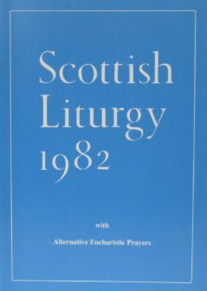
Celtic month schedule of event:
All event start and end at St Andrews Church Newcastle.

Sunday July 1st

10:00am: A celebration of Eucharist according to Scottish Liturgy 1982 Prayer I, with Celtic music and readings.

9:15 am and 11:30am: Meet the Celtics: This talk is an introduction to the world of Celtic Christianity by Ben Cooke, former Warden of Bishop’s House on the isle of Iona. Celtic is a word with many meanings, so where does it come from and why do we use it to talk about a particular style of worship? Join us to find out.

Sunday July 8th

10:00am: A celebration of Eucharist according to Scottish Liturgy 1982 Prayer II, with Celtic music and readings

11:30am: Walking Pilgrimage: Pilgrimage is a key part of the Celtic expression of Christian faith. On this short guided walk (1 mile) you will be introduced to the Celtic imagining of life as pilgrimage through reflection and meditation drew from the Iona community.

Sunday July 15th

10:00am: A celebration of Eucharist according to Scottish Liturgy 1982 Prayer V, with Celtic music and readings.

11:30am: Movie: Sermon in Stone. This documentary by the Iona Community tracts the history of the Community’s founding in the early 21st century, through its peek in the 1960/70’s. The Community’s concerns and ideology have profoundly shaped the modern perception of the Celtic Church and will continue to do so for the foreseeable future. A lunch will be served at this event.

Sunday July 22nd
10:00am: A service celebrating Creation. There are many stories of creation told in the Celtic tradition, all revealing their profound connection to the divine within nature. The service will bring the Celtic world of radiant creation to us through readings, poetry and music performed by Castlebay.

11:30am: Movie - Secret of Kells. This sometimes scary, animated family movie follows the adventures of Brendan, a young monk of Iona, trying to save his island’s greatest treasure, their gospel book, from marauding Vikings. A lunch will be served at this event.

Sunday July 29th

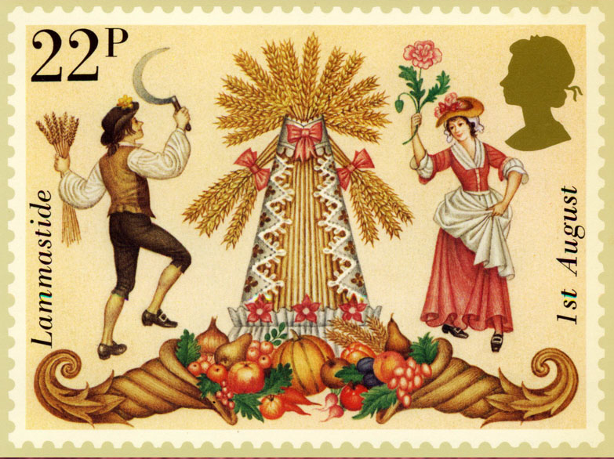

10:00am: A Lammastide service. Lammas is the celebration of the first harvest in Scotland and northern England. It is also one of the quarter services, a high festival for the agricultural Celtics. Music for the service will be performed by Castlebay. Part of the service is the blessing of the first bread of the year, which will be blessed and eaten after the service.

11:30am: Ceilidh. This traditional community party includes music, dance and storytelling to celebrate the end of our Celtic month. Blessed bread, lunch and dessert will be provided!

