OSHA Training Toolbox Talk:
Basic Electrical Safety - The Dark Side of Electricity
One of the most significant advances in the history of the mankind has to be the harnessing of electricity for power. Initially, electricity was generated and used to light up homes, and soon after distributed to power factories, offices and other work-sites. It also powers heaters and air conditioners that keep us comfortable year-round, life-saving medical devices used in hospitals and clinics, and the computers and similar infrastructure necessary for the expansion of the digital age. And in the not-too-distant future, perhaps, it could be the primary power source for all our vehicles.
But electricity is not without its drawbacks; unintentional contact with electrical current can cause severe injuries or death, as can the arc flash created by an electrical short. Here are some of the ways electricity can cause injuries and fatalities:
• Electricity generates heat as it travels through body tissues. This heat can actually cause external burns on your skin where the electrical current enters and exits your body. The heat can also cause internal burns and other major damage to muscles and other internal tissues.
• Electricity flowing through your body can replicate or interfere with the signals being carried through your nervous system. In some cases, this can paralyze your muscles for the duration of contact with the electrical current. As a result, you could lose your balance and fall off of a ladder, scaffold or other elevated working surface and suffer an injury.
• Electrical current running through your body can also restrict your ability to breathe normally, because it can paralyze the muscles used to expand your lungs. And in some cases, it can even interfere with the nerve signals that regulate the rhythm of your heart, which can then cause your heart to fibrillate (or beat irregularly) or go into cardiac arrest.
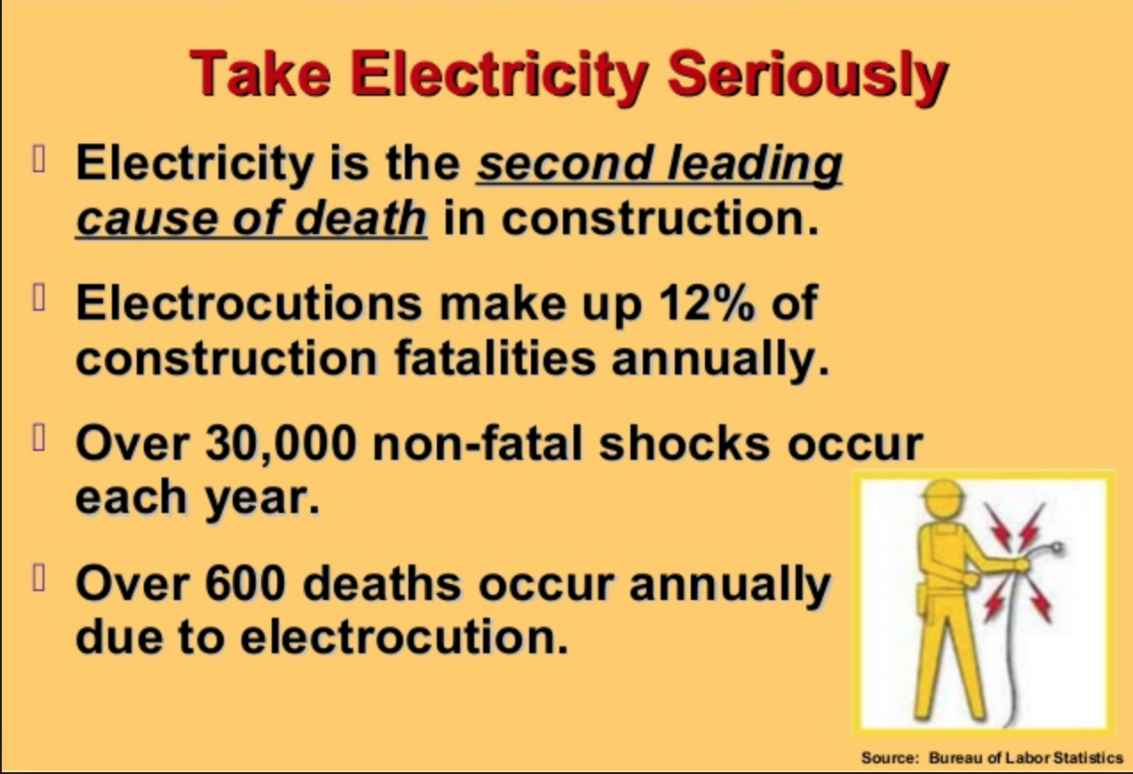
• An electrical arc flash, which occurs as electricity travels through the air as an electrical short occurs, heats the air in the immediate area to super-hot temperatures. This arc flash can severely burn on your skin, as well as sear the inside of your lungs if you inhale the super- heated air. The extreme temperatures generated by an electrical arc flash can even melt metal, plastics, and other materials, sending molten particles spewing through the air.
These are certainly not the only examples of how inadvertent contact with an electrical current or the occurrence of an electrical arc flash can cause us to be injured or killed. But these examples do drive home why it is extremely important to follow basic precautions when we are working with or near electrical lines, circuits, and equipment.
So, during the next several monthly toolbox talks, we will cover specific safe work practices we must follow, as well as hazardous conditions to avoid, so we can prevent electrocutions and electrical burns. And just as importantly, these precautions will not only help us protect ourselves at work, they can also help protect us and our family members at home and everywhere else electricity is present.

