****OSHA Training Toolbox Talk:

**Seven Things You Should NEVER Do With A Portable Ladder**

We’ve held several toolbox talks about the proper selection and use of various types of portable ladders, and well as actions and conditions to avoid when using a ladder. But something we haven’t talked about too much are some of the ways that people misuse a ladder in ways that it was not designed. So here is a quick list of seven things you should never do with your portable ladder.

* •  Never use your portable ladder as a make-shift scaffold stand or scaffold board. Setting up two step-ladders and placing a walk-board horizontally from one ladder to the other is an invitation to a fall. So is laying an extension ladder horizontally across two saw horses or other surfaces to use as a walking or working surface. One other thing to avoid? Setting your ladder up to serve as a ramp so you can walk up and down from one level to another.
* •  Do not climb up the back side of a step ladder. The cross braces on back of your portable step ladder are just that; braces. They are not designed to support your weight, the spacing between the braces is too far apart to climb safely, and they are not treated to prevent your foot from slipping off. (You may wish to point out that this rule does not apply to specialty ladders designed by some manufacturers to be climbed on both sides, if applicable).
* •  Do not use your portable ladder as a tool or equipment rack. Hanging or laying a tool or something similar on the side-rail or on a rung of your ladder is an invitation to an accident. Someone who does not know, or forgets, it is there might accidentally step on it as they climb up or down the ladder, or it may interfere with them grasping a side rail or rung.
* •  Do not tie two ladders together to make a longer one. I really don’t need to list all of the things that could go wrong if we did this, do I??
* •  Never set up your ladder in the back of a truck bed, on top of a trailer, or in the bucket of a front end loader or other vehicle. Even though we would like to believe there is no way the vehicle could move and cause your ladder to fall, unintended things do happen on occasion.
* 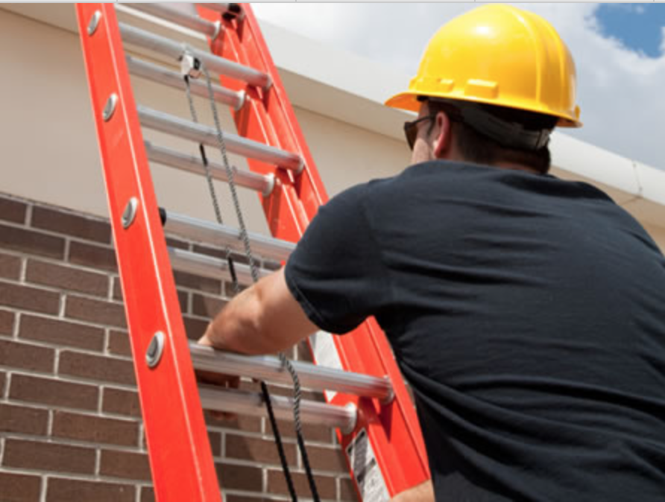•  Do not salvage and use unbroken sections of a broken ladder. If one part of the ladder is damaged or broken, take the entire ladder out of service. Do not separate the “good” section to use for climbing or other purpose. It should also go without saying that making any kind of structural repairs or modifications to broken ladders in the field must not be done either.
* •  Last but not least, do not allow two or more people to climb or work from a ladder at the same time. This usually results in too much weight on the ladder, and also makes the ladder less stable than when used by only one person. In addition, this practice is typically prohibited by ladder manufacturers. Of course, this does not apply to specialty ladders designed to be used by two people at one time.