IISE Connect
Society for Health Systems Community How To’s
How to Log-In:
- Type https://connect.iise.org in your web browser
- Click “Sign In” on the top right-hand corner of the web-page.
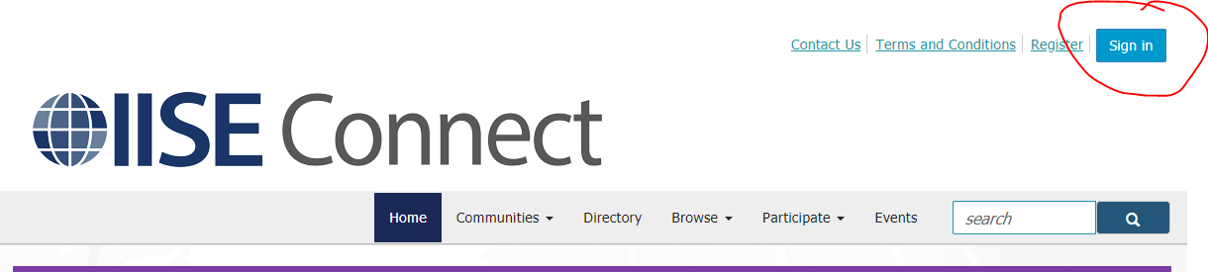

- Log-in using your IISE membership account username and password
- Click on the “communities” button across the top ribbon
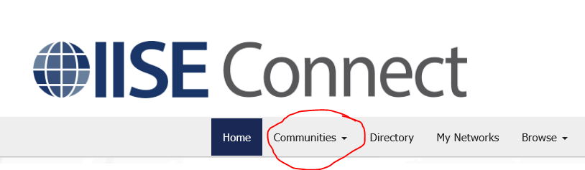

- Select My Communities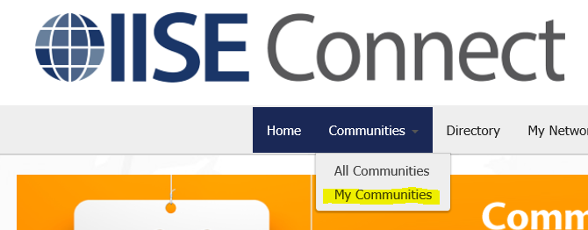

- You will be taken to a page that lists all communities you have been assigned to. You can also select “All Communities” from the drop down and search for other groups you might be interested in. If you are an SHS member you will see “Society for Health Systems (SHS)” Listed on your page of “My Communities”
- Click on “Society for Health Systems (SHS)” and you will be taken to the home page for our community 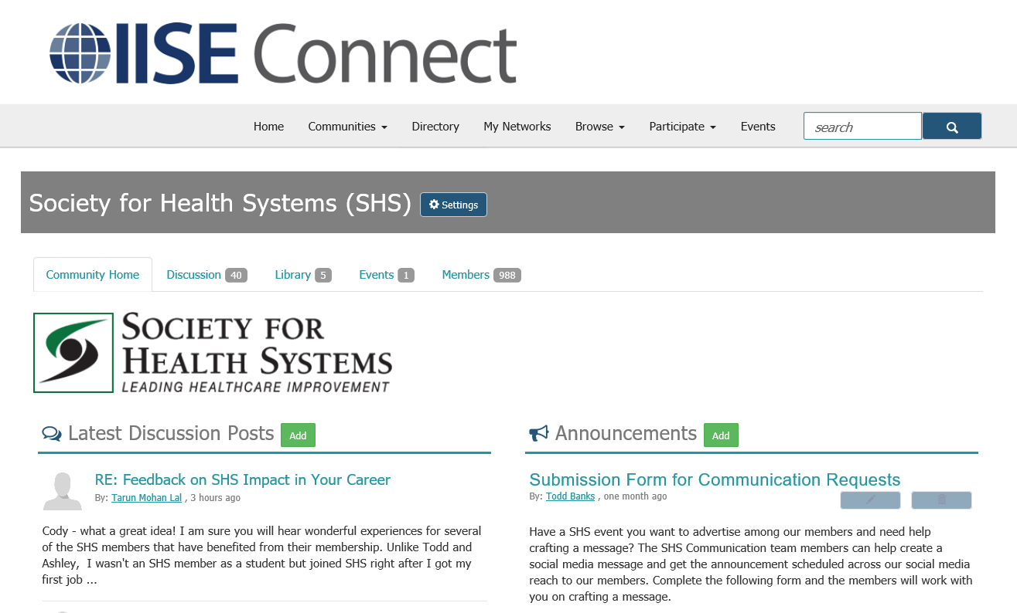
- From this page you can:
  - Review and contribute to the discussion board
  - View the upcoming society sponsored events and announcements
  - Connect with all SHS members
  - Access member shared documents, including member articles and board meeting minutes
- If you have trouble accessing any of the pages listed in these steps, click on the “Contact Us” link at the top of the page and a member of the IISE Connect team will be able to help you.

How to Manage E-Mail Preferences for the SHS Community Page
We recommend that our members enroll in a Daily Digest email option to ensure you are receiving up to date information on the community postings and member discussions. To view and edit your current preferences, follow these steps:
- From the SHS Community Home page, click on the “Settings” button next to the community name at the top of the page. 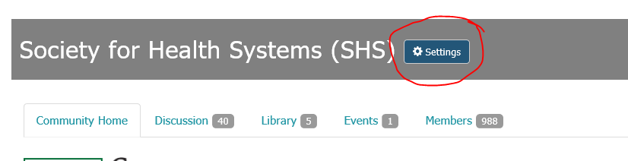
- This button will pop open a box on the same page and you will see a section labeled “E-mail Notifications.” Within this section, you should see your email address associated with your account. If you’d like to adjust the email address where you want notifications sent to, click the “change” link.
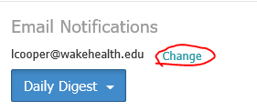
Your email address here
- The blue box under your email address indicates your current subscription level. If you click on the arrow you will see the following options
  - Real Time: You will receive an email each time something is added to the community page
  - Daily Digest: You will receive an email between midnight and 1am with a summary of the activity for the previous day
  - No Email: You will not receive any emails of the activity on this page and will have to log-in to review any new discussions or content.
We recommend that our community members select the “Daily Digest” option to stay up to date on community activity.
When you receive the daily email, you will have the option to reply to the discussion through your email and will not need to log-in to the community page to participate.

