As many of you know, SportsWareOnLine uses floating licenses. This allows you to share a license between athletic trainers if they are not using the program at the same time. In some situations, SportsWare was not correctly checking the number of logged-in users against their license count. The current release corrects this. The following document will walk you through the steps to ensure you have forced user logout rights and what will happen when a user is forced out.

Note – only account administrators have the ability to enable access to this feature.

Within the User Account screen, you will see a checkbox that allows the administrator to assign forced logout rights to any users currently in the system. This is the last checkbox under Program functions.

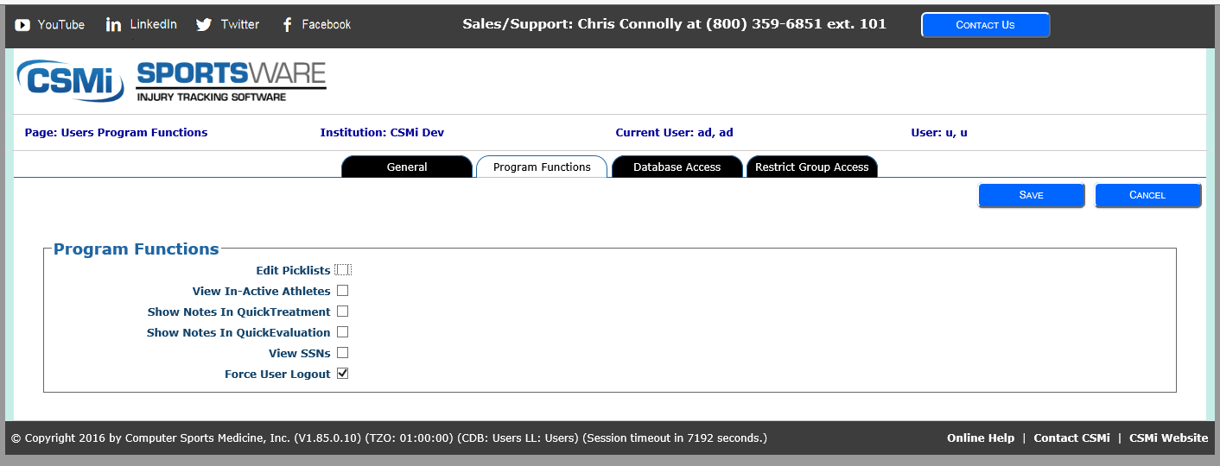

At the dashboard screen you will see the users that are currently logged in, along with the time they have been idle. Only the admin or a user the admin has given forced logout rights to will see the “Force Logout” in the first column.

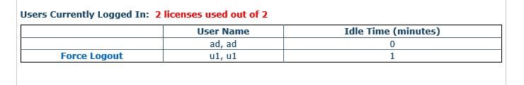

If you are forced out by an admin, you will see a notification message. Don’t worry, your work will be saved.
