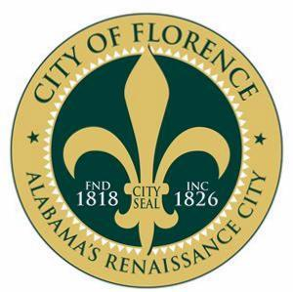
Press Release
------------------------------------------------------------------------------------------------------------
City of Florence • P. O. Box 98 • Florence, AL 35631 • (256) 760-6400 • Fax (256) 760-6388

FOR IMMEDIATE RELEASE

DATE: February 15, 2018
CONTACT: Mayor’s Office
PHONE: (256) 760-6400
FAX: (256) 760-6388

Florence Celebrates Bicentennial
with Birthday Party for the City

FLORENCE, Ala. – 200 years! That’s how old the City of Florence, Alabama, will be in March 2018; and to celebrate, everyone is invited to the City’s Birthday Bash!

The celebration will take place March 12, at 3:30 p.m., at Wilson Park in downtown Florence.

Founded March 12, 1818, Florence was recognized as a potential prosperous settlement by the Cypress Land Company, and the City has been going strong ever since. Florence earned its name from the Italian Surveyor Ferdinand Sannoner, who chose to name it after the famed city of Florence, Italy, which now serves as the City’s Sister City. Florence is also known as the Alabama Renaissance City and is the largest city in the Florence-Muscle Shoals MSA.

Shortly after incorporation Florence grew, adding centers for commerce, banking and retail, among other things. The City became a seat of higher education in 1854, when Florence Wesleyan University moved to town. That University is now known as the University of North Alabama.

Starting with the birthday in March, each month will have a theme related to the City. April’s theme will be local architecture, whereas May recognizes the arts and June is Frontier Days. The themed months will run through November 2018, with more information being released as the events draw closer.

For more information, go to: www.florence200.org; https://www.facebook.com/florencebicentennial/ or https://www.facebook.com/events/147567779233422/

