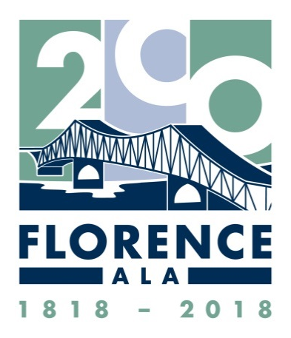
City of Florence, Alabama
Founded March 12, 1818
Bicentennial Celebration Committee

Schedule of Events
As of February 6, 2018
(Note that some themed events will be held during other
times of the year than the month in which they are listed.)

MARCH – Theme: Birthday Celebration
- Friday, March 2, 5:00 to 8:00 PM – FIRST FRIDAYS – Bicentennial Kick-off in Downtown Florence
- Monday, March 12, 3:30 PM – CITY’S BIRTHDAY PARTY in Wilson Park: The party will include the Mayor reading the proclamation, the time capsule dedication, recognition of former Mayors, performances of music/choirs, birthday cake, dedication of historical marker
- Monday, March 12 – TROWBRIDGE’S 5-CENT ICE CREAM CONES for its 100th Anniversary
- PARADE – Date to be determined

APRIL – Theme: Local Architecture
- Saturday, April 7, 10:00 AM – WALKING TOUR OF WILSON PARK and surrounding buildings including the Federal Court Room. Meet in front of the KD Art Center.
- Saturday, April 14, 10:00 AM – WALKING TOUR OF UPPER NORTH COURT STREET AND SEMINARY STREET. Meet in front of Roger’s Hall at UNA.
- Saturday, April 21 10:00 AM – WALKING TOUR OF WALNUT STREET. Meet at the corner of Hermitage Drive and Walnut Street.
- Saturday, April 28, 10:00 AM – WALKING TOUR OF FLORENCE CEMETERY. Meet inside the cemetery on Tennessee Street.
- Saturday, May 5, 10:00 AM—FORKS OF CYPRESS PLANTATION SITE & CEMETERY TOUR
- Sundays in April – ROSENBAUM HOUSE TOURS—All events begin at the Richards Center next to the Rosenbaum House Admissions and Gift Shop. Enter through double doors.
- Sunday, April 8, 2:00 PM—KEN BURNS DOCUMENTARY FILM ON FRANK LLOYD WRIGHT
- Sunday, April 15, 1:30 PM—HISTORICAL MARKER DEDICATION followed by talks with the Rosenbaum Family
- Sunday, April 22, 2:00 PM— BOOK SIGNING, RANDY HENNING, author of book on Aaron Green

The Kennedy-Douglass Center for the Arts Portrait Gallery will feature 17 paintings of our founding fathers and historic leaders throughout the month of April. Open Monday-Friday, 9:00 AM to 4:00 PM.

MAY – Theme: Arts
- May 5 – FABRIC – Event will highlight our history of fabric, quilting, and cotton
- May 12 – WOOD – Event will highlight our history of woodworking craftsmanship
- May 19-20 – ARTS ALIVE FESTIVAL
- May 26: CLAY – Event will highlight our history of clay as an art form

Continued on Back

JUNE – Theme: Frontier Days
- February 15-17 – SPANISH-AMERICAN WAR EXHIBIT at Pope’s Tavern marking the 120th anniversary of that War and the sinking of the USS Maine
- June 2 – JOHN COFFEE CEMETERY Dedication Ceremony (Coffee’s birthday)
- June 2-3 – FRONTIER DAYS at Pope’s Tavern
- June 23 – KOREAN WAR VETERANS MEET & GREET at Pope’s Tavern
- November 3-4 – BATTLE OF FLORENCE – Re-enactment of the first Battle of Florence with infantry, artillery, and cavalry units at McFarland Park
- November 8-10 – WORLD WAR I DISPLAY at Pope’s Tavern for 100th Anniversary of the end of the war
- December 7 – “EVERY LIGHT A PRAYER FOR PEACE” PROGRAM at Pope’s Tavern, with “Pearl Harbor” display

JULY – Theme: Music
- July 4 – FOURTH OF JULY – Fireworks and Entertainment – McFarland Park
- July 20-29 – W. C. HANDY MUSIC FESTIVAL

AUGUST – Theme: Education
- Overall Goal: To celebrate the fact that, since 1820 (just two years after its founding), Florence has been known for its commitment to the education of its citizens
- School activities throughout the year
- Saturday, August 18 – ROAD RALLY – a community scavenger hunt to area historical sites
- ARCHIVES IN COLLIER LIBRARY at UNA open Monday-Friday, 8 a.m. to 4 p.m. throughout the month

SEPTEMBER – Theme: Native American Heritage
- Art exchange involving Native American tribes in Oklahoma
- Sundays, September 9 and 23 – NATIVE AMERICAN PRESENTATIONS held at the Library
- Sundays, September 16 and 30 – NATIVE AMERICAN PRESENTATIONS held at the Indian Mound Museum
- Educational resource package for teachers in the 4th and 10th grades for use in their classrooms
- Traveling Museum

OCTOBER – Theme: Florence Homecoming
- Saturday, October 20 – REUNION AT THE RIVER - a family event – McFarland Park
- Saturday/Sunday, October 27-28 – ALABAMA RENAISSANCE FAIRE

NOVEMBER – Theme: Faith/Churches
- Sunday, November 18 – COMMUNITY CELEBRATION, Shoals Theatre
- Area historic churches will hold anniversary celebrations throughout the year

In addition to these events, the Florence-Lauderdale Public Library has developed an extensive online historical timeline exhibit detailing events that shaped and molded our community. It includes the above topics as well as a music timeline and an industry/agriculture/farming timeline for Lauderdale County. These timelines will be available throughout the year and for future generations.

