Clear The Shelters RELEASE – ANNOUNCE THE RETURN OF CTS

FLORENCE- LAUDERDALE ANIMAL SHELTER TEAMS UP WITH WAFF 48 NEWS TO HOST THIRD ANNUAL PET ADOPTION DRIVE – CLEAR THE SHELTERS – ON THURSDAY, AUGUST 17TH, FRIDAY, AUGUST 18TH, AND SATURDAY, AUGUST 19
FLORENCE,AL – (August 9, 2017) – Florence-Lauderdale Animal Shelter today announced that it will join with WAFF 48 News to host NBCUniversal Owned Television Stations’ Clear the Shelters third annual nationwide pet adoption drive on Saturday, August 19. On this day, Florence-Lauderdale Animal Shelter will offer fee waived pet adoption fees as part of the nationwide Clear the Shelters initiative that seeks to help families find and adopt homeless pets. Since 2015, Clear the Shelters has resulted in more than 70,000 pet adoptions nationwide.
WHAT: Florence-Lauderdale Animal Shelter to participate as an official Clear the Shelters partner alongside WAFF 48 News. Florence-Lauderdale Animal Shelter will offer fee waived pet adoption fees to help families find and adopt a new pet.
WHEN: Thursday Friday and Saturday- August 17th,18th,19th from 10 AM to 7 PM.
WHERE: At the FLAS, 702 East College Street Florence, AL 35630
INFO: Audiences can visit ClearTheShelters.com to access more information about Clear the Shelters, including the full list of local participating animal shelters.

ADOPTION: A real-time pet “Adoption Tracker” – posted on ClearTheShelters.com – will record the total number of pets that are adopted across all participating markets.

SOCIAL: Use the hashtags s#ClearTheShelters and #LoveMyPet to post photos of your favorite pets on your social media networks. Also, follow the effort on Twitter, Facebook and Instagram. Clear the Shelters-themed Snapchat filters will be activated on August 19.
For more information about the national pet adoption drive, visit ClearTheShelters.com. You can also follow the effort on Twitter, Facebook and Instagram by using the hashtags #ClearTheShelters and #LoveMyPet. To access information in Spanish, please visit DesocuparLosAlbergues.com and follow #DesocuparLosAlbergues and #AmoAMiMascota.

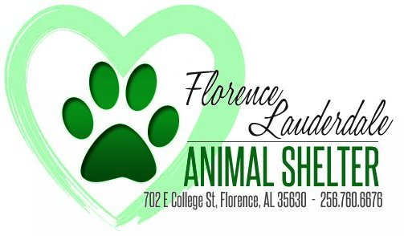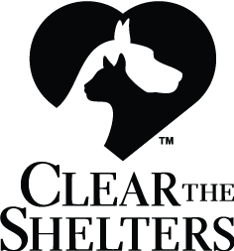

MEDIA CONTACT
Name Leah Fox
Email lfox@florenceal.org
Phone 256-7185170

