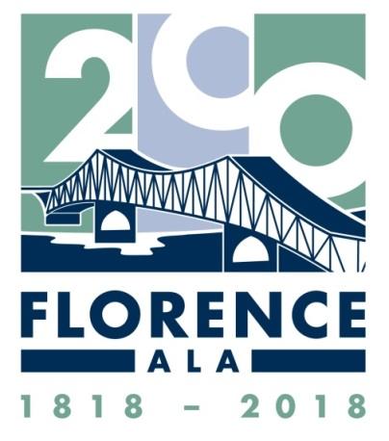

Celebrating our
City’s Bicentennial in 2018…

Our Sincere Appreciation to
all of our Sponsors!

PLATINUM SPONSOR – $20,000
City of Florence
KISS 102.7
TNT Fireworks

GOLD SPONSOR – $10,000
Bank Independent
BBVA Compass Bank
University of North Alabama

SILVER SPONSOR – $5,000
Anonymous Donation
Florence Federal Credit Union

JOHN COFFEE SOCIETY – $2,018
Pat Burney, Bicentennial Committee Chair
C & H Cooling & Heating
Constellium
Create Architects
Darby Doors
First Southern Bank
Irons Electric
Mitchell-Hollingsworth Nursing & Rehab Center
Rosie's Mexican Cantina
Shoals Chamber of Commerce
Shoals Kidney Hypertension Center
Tennessee Valley Surgery Group
TMT America
Watkins Johnsey Professional Group

FERDINAND SANNONER SOCIETY – $1,818
Abstract & Title Company of Florence
Alabama Land Services
Anonymous Donation
J. Smith Lanier & Co.

FLEUR DE LIS SOCIETY – $312
Abroms & Associates
Bigbee Steel Buildings
Brinks Apartments
Ronnie Campbell's Collision Center
CB&S Bank
Connolly Animal Clinic
Hendrix Glass Service
NW AL Regional Airport
Deborah Bell Paseur & Thomas V. Greene, Jr.
Patterson, Prince & Associates, CPA
Pounders & Associates
Security Lock & Key
Senators Coaches
Shoals Flight Center
Shoals Hearing Clinic
Tennessee Valley Surgery Group
Jesse Wisdom Insurance
Ye Ole General Store

BICENTENNIAL CLUB – $200
M. J. Carter Insurance
Craig Construction Company
Enterprise Rent-A-Car
Five Guys Burgers & Fries
Florence Rotary Club
Goodman Sports
Heritage Christian University
Mayor & Mrs. Steve Holt
Mr. Keith Jones
King Realty & Auction Co.
Legends Steakhouse
Harold & Tricia Lewis
Dr. Michael McLeary
Neese Real Estate
E. A. Nelson Company
Sam Newton Insurance Agency
North American Lighting
Norvell & Associates
Peck Ace Hardware, Inc.
Pettus Mechanical & Plumbing Services
Ray Miller Buick-GMC
Ringers Garage Door Company
Ms. Jeannie Rogers
Shoals Area Association of REALTORS
Shoals Engineering
Shoals Homebuilders Association
Sons of the Confederate Veterans - Camp #478
South Tennessee Oil Co. DBA/Quik Mart
Tennessee Valley Gastroenterology
Valley Credit Union
Sylvester White
Wilks Tire and Battery of Florence

OTHER SPONSORS
ALABAMA 200–Alabama Bicentennial Commission
Blue Cross and Blue Shield of Alabama
Chick-fil-A
Coleman Group
Courier Journal
Florence-Lauderdale Public Library
Lamar Advertising
Pam McKinney, Geiger
Pat Slusher Corporate Gifts
Printers & Stationers
Quad Cities Daily
Signature Cabinets & Doors, Inc.
TimesDaily
WAAY-TV 31 ABC

