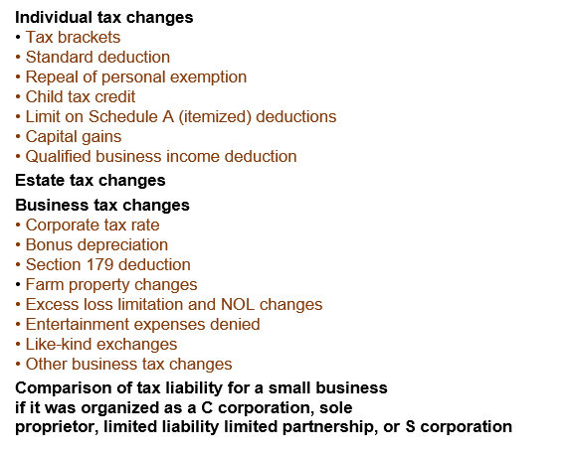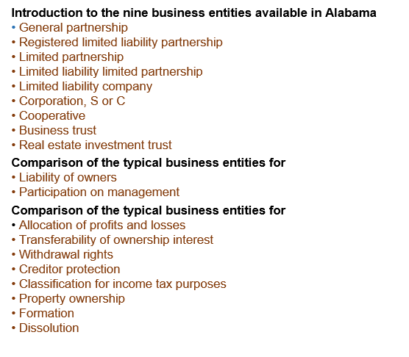

# Register online at [www.aces.edu/business-entity](http://www.aces.edu/estate-planning-for-farmers)

# 

*You and your father are raising cattle on halves or farming the family land together. Are you a business entity? By default, you are a general partnership. If your father's employee is hurt working the cattle/farm, you are probably liable. If you are liable the Court could take not only business assets but personal property as well.*

*The Tax Cuts and Jobs Act made significant changes to the income tax liability of both individuals and businesses. Many of those changes will be discussed during this program.*

# Register online at [www.aces.edu/taxes](http://www.aces.edu/estate-planning-for-farmers)

# 

# 

Ag Business Management Workshops

Sept 11, 2018

# **Location: Lauderdale County Extension Office, 802 Veterans Drive, Florence, AL (256) 766-6223**

For more information and to register go to: <http://www.aces.edu/agriculture/business-management/index.php>

Workshop 1:30—4:30 p.m. Workshop 6—9 p.m.

**Cost:** for individual is $15 for each session ($30 for both sessions). **Cost:** for accountants who will receive approximately 3 hours of CPE is $60 each ($120 for both sessions). Please register and pay separately for each session at the link shown above for each workshop.

The Alabama Cooperative Extension System (Alabama A&M University and Auburn University) is an equal opportunity educator and employer. Everyone is welcome! © 2017 by the Alabama Cooperative Extension System. All rights reserved.