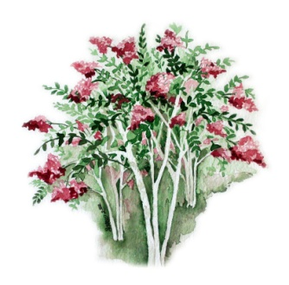
Beautification Board
City of Florence
P. O. Box 98
Florence, AL 35631

WILSON PARK BENCHES

The Florence Beautification Board has worked with the City to effect an upgrade of the landscaping in Wilson Park; including the removal of the old wooden benches to be replaced by metal ones.

Benches “In Honor Of” or “In Memory Of” or “Donated By” may be purchased from the City. The cost is $875.00 and includes the bench, an engraved plaque, and installation. The benches are six feet long with an armrest in the center. They are constructed of powder coated metal, green in color, and have a curved back.

HOW TO PURCHASE:

Check to: City of Florence Beautification Board
Re: Wilson Park Bench

Cost: $875.00 per bench (tax deductible)

Mail to: The letterhead address above

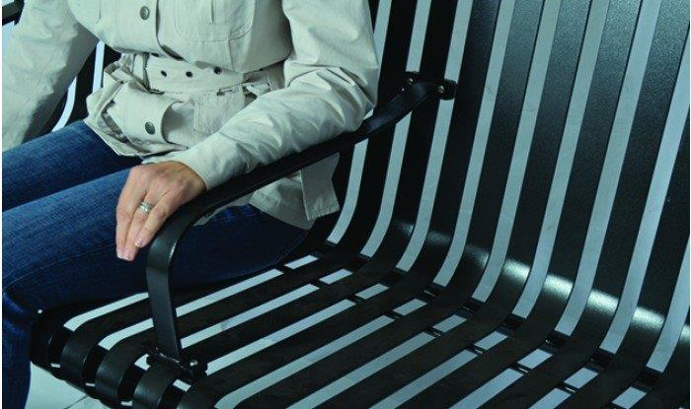
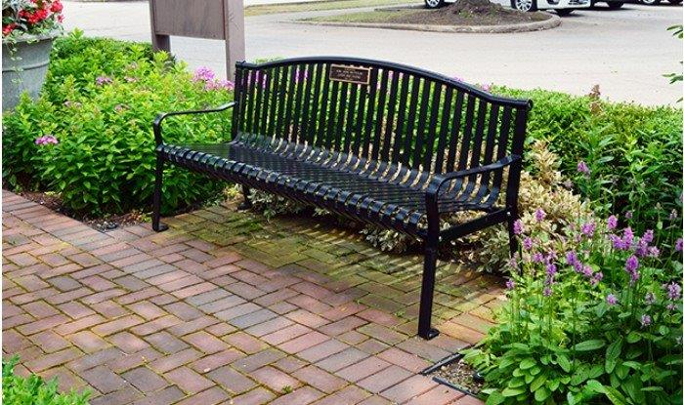

WORDING FOR THE PLAQUE (PLEASE PRINT):

In Honor Of * In Memory Of * Donated By
Plaque is 10.5” W x 3” H – Four lines, 24 characters per line

_____________________________________________________________________________________

_____________________________________________________________________________________

SUBMITTED BY:

NAME/ORGANIZATION: ______________________________________________________

ADDRESS: ____________________________________________________________________

CITY, STATE, ZIP: _____________________________________________________________

TELEPHONE: ___________________ E-MAIL: _____________________________________

